HACKATHON 8.0 — TESSERACT FRONTIER



Bridging Hearts, One Ritual at a Time

A Guided Family Ritual Platform · Parent-Child Bonding Experience Design
TEAM 3 — T3_05 MASTER CASE STUDY
UX Design · Research · Prototype · May 2026

Section 01 — Project Overview

1.1 Project Introduction
Modern families are spending more time together physically but less time connecting emotionally. Dual-income parents often return home mentally exhausted after work, leaving little energy to plan engaging activities with their children. As a result, evening hours are frequently occupied by individual screen time rather than meaningful family interactions.

This project aims to strengthen parent–child relationships by creating simple, engaging, and ready-to-use interaction experiences that fit naturally into the daily routines of working parents and children. The solution focuses on reducing barriers to quality family time and enabling emotional connection through structured, low-effort activities.

1.2 Problem Statement
Working dual-income parents of children aged 8–15 struggle to initiate meaningful parent–child interaction during weekday evenings (6–10 PM at home) because of mental fatigue and the lack of low-effort, ready-to-use activity options. This leads to increased reliance on screens, reduced quality time, and weaker emotional bonding between parents and their children.

1.3 Team Information

The interdisciplinary design and research framework for this study was spearheaded and executed by the following specialists from Team 3:
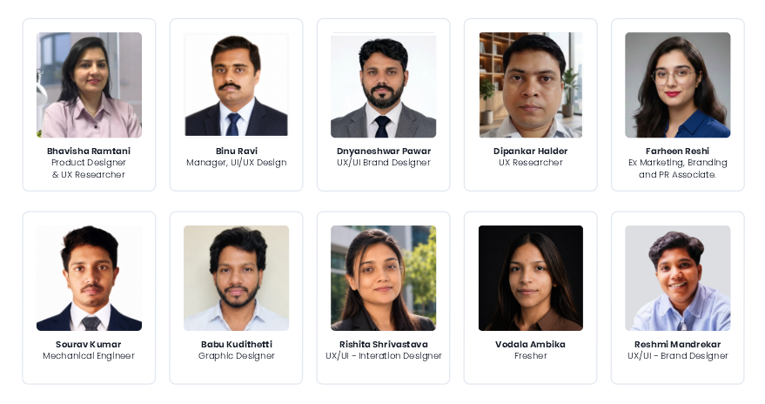

Bhavisha Ramtani : Product Designer & UX Researcher

Binu Ravi : Manager, UI/UX Design

Dnyaneshwar Pawar : UX/UI Brand Designer | AI & Interaction Design

Dipankar Halder : UX Researcher

Farheen Reshi: Ex Marketing, Branding and PR Associate. Ex Systems Engineer

Sourav Kumar : Mechanical Engineer

Babu Kudithetti : Graphic Designer

Rishita Shrivastava : UX/UI Designer, UX Researcher, Visual and Interaction Designer

Vodala Ambika : Fresher

Reshmi Mandrekar : UX/UI - Brand Designer
1.4 Vision Statement
"A world where every child feels connected, heard, and valued through meaningful moments shared with their parents every day."

Section 02 — Opportunity Discovery

2.1 Problem Exploration
Understanding people before designing anything — the foundation of the entire project.
The starting question
"How might we improve the emotional well-being of families in their busy life?"
This is a "How Might We" (HMW) framing — a standard UX research trigger. It's intentionally broad so the researcher doesn't jump to solutions before understanding the problem space.

Who was interviewed | Research methods used
- Working parents (primary users)  - Children aged 8–15 (secondary users)  - Teachers (contextual experts)  - Young professionals | - One-to-one interviews  - Contextual discussions (natural settings)  - Observation of evening routines  - Follow-up conversations over time

What parents said | What children said
- Mentally drained after work every weekday  - Feel guilty about not spending enough quality time  - Use phones to keep children occupied (coping, not choice)  - Want meaningful interaction but lack ideas or energy | - Want parental attention — not gifts or screens  - Feel parents are always busy or distracted  - Default to YouTube / games in evenings  - Genuinely enjoy playful time when parents initiate

The core insight (synthesis)
Quality time is NOT limited by love. It is blocked by mental fatigue, lack of structure, decision fatigue, digital distractions, and busy routines.
This is the single most important finding. It reframes the design problem from "make parents care more" (wrong) to "remove the friction that stops caring parents from acting" (right).
Problem statement
Working dual-income parents of children aged 8–15 struggle to initiate meaningful parent–child interaction during weekday evenings (6–10 PM at home) because of mental fatigue and lack of low-effort, ready-to-use activity options, which causes increased reliance on screens and reduced emotional bonding with their children.
A well-formed problem statement names who (dual-income parents), when (weekday evenings), what (can't initiate interaction), and why (exhaustion + no ready activities). AWIANA's statement checks all four boxes.

2.2 Market Scan
Mapping what already exists — to find what doesn't.
Good UX design doesn't start from scratch. Before designing anything, you need to understand what's already been tried, what works, what fails, and where the real white space is. This prevents you from building something that already exists — or worse, something that was tried and failed for a known reason.
How existing categories measure up against AWIANA's core needs
- Family activity apps  - Wellness / meditation  - Habit tracking apps  - Educational apps  - Communication tools | - Fun ideas, no daily habit  - Individual only  - Task-focused, not emotional  - Academic, not relational  - No meaningful interaction

✅What the market solves well  - Academic learning for children  - Individual stress and mindfulness  - Messaging and remote communication  - Screen time tracking and limits | ❌What no product solves yet  - Guided, low-effort daily bonding rituals  - Activities that fit 15–20 min windows  - Reducing parental decision fatigue  - Co-use by parent AND child together

The market gap
Most products are built for individuals, not families. The few family-focused apps require long setup, high commitment, or constant screen usage — exactly the things busy parents don't have. The 15–20 minute low-friction ritual space is genuinely unclaimed.
This gap directly maps back to what parents said in research: they don't lack love or intent — they lack a low-effort, ready-to-go structure. AWIANA is designed to be exactly that.

2.3 Opportunity Selection
Combining research + market insights to choose the right problem to solve
Instead of solving a technology problem, the team chose to solve a behavioral problem — friction removal, not feature addition.
This is a critical UX mindset. Many products fail because they solve for "what feature should we add?" instead of "what behavior are we trying to change?" AWIANA's framing is behaviorally grounded from the start.
AWIANA — Guided family ritual platform
15-minute guided daily activities, conversations, storytelling, and shared experiences. Fits busy weekday schedules, removes decision fatigue, builds a sustainable ritual — not more screen dependency.

❤️Value for parents  - Easy-to-follow activities — no planning needed  - Quality interaction in a short, fixed window  - Guilt reduced — they showed up and it worked | 😀Value for children  - Feel heard, seen, and valued  - Playful learning alongside a parent  - Stronger emotional bond over time
⭐Why AWIANA wins the opportunity evaluation

Fits real life  15 min ritual works within the actual available window parents have | Solves the root cause  Targets decision fatigue directly — no planning required by the use | Builds a habit  Daily guided ritual creates long-term bonding, not a one-time interaction

Section 03 — Research

3.1 Research Objectives
This research was conducted to investigate why working, dual-income parents of children aged 3 –15 in urban and semi-urban India struggle to initiate meaningful interaction with their children on weekday evenings, and to understand the role that mental fatigue, time pressure, and screen reliance play in this gap. The study combines quantitative survey data, qualitative interviews (including a child's perspective), and an academic literature review to build a triangulated, evidence-based foundation for design.

What This Research Set Out to Validate
Before fieldwork began, the team identified five core assumptions that needed validation, along with a central behavioral contradiction worth investigating directly.
• Do parents genuinely want daily bonding, or are they primarily compensating on weekends?
• Is mental fatigue, rather than lack of time, the real barrier to engagement?
• Will parents commit to a structured, low-effort system if the activation cost is near zero?
• Are children willing to engage when a parent initiates, or does resistance run deeper?
• Is a “ready-to-use” system more valuable to parents than open-ended activity suggestions?
A central contradiction the team wanted to resolve through primary research: do parents really lack time, or do they lack mental bandwidth? This distinction has direct design implications: a time-poor parent needs efficiency, while a bandwidth-poor parent needs simplicity and decision removal.

Research Questions
1. What does the 6–10 PM weekday window actually look like inside Indian working-parent households, who is present, what competes for attention, and how much of that time is genuinely engaged versus passive co-presence?
2. How severe is parental mental fatigue, and is it the primary driver of low engagement, or one factor among several (time scarcity, decision fatigue, child resistance)?
3. What role do screens play, for the parent and for the child, in displacing or enabling bonding time?
4. Is there genuine demand for a ready-made bonding solution, and if so, what format (app, physical, hybrid) and what level of trust exists toward such solutions today?
5. What activity types, rituals, or interaction patterns are already working informally for parents, and can these be systematized?

Research Methodology Overview
To build a credible, triangulated evidence base, three independent research layers were run in parallel and cross-validated against one another:
Layer | Method | Sample
Secondary | Academic and industry literature review across pediatrics, psychology, and behavioral design | 5 peer-reviewed / institutional sources
Primary — Quantitative | Structured online survey, 15+ questions covering demographics, time use, barriers, screen behavior, and solution readiness | 68 respondents
Primary — Qualitative | In-depth interviews with working parents and one child respondent | 8 interviews (incl. 1 child)
Where all three layers point to the same conclusion, an insight is treated as confirmed. Where two layers agree, it is treated as strong. Where only one layer supports a claim, it is flagged as exploratory and earmarked for further validation.

3.2 Secondary Research
To ground the problem in existing evidence before collecting primary data, the team reviewed five academic and institutional sources spanning pediatric language development, family screen-time behavior, and behavioral design. These sources were selected to test , not just support, the working problem statement, and several findings meaningfully sharpened the team's thinking.

Sources Reviewed
Source | Focus
Pew Research Center — Auxier et al., 2020 | Parenting Children in the Age of Screens (US, nationally representative)
Frontiers in Pediatrics — Wan et al., 2025 | Parent and child screen time, and parent-child interaction, vs. language development delay
Journal of Occupational Therapy — Ho, Yu & Brown, 2024 | Relationship between children's screen time and play engagement
PMC7503915 — Lauricella et al. | Parent and child screen time and quality of the home environment
BOLD Science — Alonso & Wolf | Relevance of parental and family engagement in children's education; SMS-based nudge interventions

Key Findings From the Literature

Finding 1 — Parents Are Distracted, Not Just Tired
Pew Research found that a majority of parents are at least sometimes distracted by their own phones while spending time with their children, and over half admit to spending too much time on smartphones themselves. This reframes the problem: physical presence and engaged presence are not the same thing, and parents are aware of the gap.

Finding 2 — The Parent's Screen Time May Matter More Than the Child's
The Frontiers in Pediatrics study found that both fathers' and mothers' own daily screen time independently predicted language development delay in children — even after controlling for the child's own screen exposure. This supports a “displacement hypothesis”: when a parent is on a device, the verbal back-and-forth exchanges that build language and connection simply stop occurring.

Finding 3 — Storytelling Outperforms Generic “Activities”
Across the Frontiers dataset, storytelling emerged as the single strongest protective factor against language delay — a stronger effect than reading, singing, outdoor play, or unstructured play. Storytelling naturally embeds question-and-answer exchange, vocabulary stretch, emotional context, and space for the child's own voice, suggesting that design should anchor on narrative ritual rather than an open “activity menu.”

Finding 4 — Parents Already Believe Parenting Is Harder Now, and Blame Technology
A majority of Pew respondents said parenting is harder today than 20 years ago, with technology, social media, and early tech exposure cited as the top three reasons. This is a useful signal: parents do not need to be convinced that the problem is real — they are already primed to want tools that help them push back against digital encroachment.

Finding 5 — The Type of Screen Time Matters More Than the Total Amount
The Ho, Yu & Brown (2024) study found that weekday social screen time alone explained a substantial share of variance in reduced social play, while passive and educational screen time predicted active-play loss differently. The practical implication: framing the problem as “reduce all screen time” is likely to fail. Framing it as “rebalancing passive consumption” is more actionable.

Finding 6 — Low-Cost Behavioral Nudges Outperform Heavy Content Libraries
BOLD's research with Sharon Wolf showed that simple SMS-based nudges sent twice weekly — with no new content, time, or money provided to parents — measurably reduced school dropout rates by shifting how parents felt about engagement. This is one of the more consequential findings for product direction: the lowest-effort intervention, not the richest one, produced behavior change.

Finding 7 — Frequency of Interaction Beats Duration
Frontiers data showed that interacting more than three times per week was a stronger predictor of healthy child development than the length of any single session. Brief, repeated, high-quality interactions outperformed occasional long ones — directly validating a “daily micro-ritual” design direction over a “weekend deep session” model.

Finding 8 — Interaction Quality Mediates Screen-Time Harm
The PMC and Lauricella research found that the negative effect of high screen time on children was partially explained by reduced parent-child interaction quality, rather than screen exposure itself. In other words, screens are not inherently the problem — the interaction loss that often accompanies them is. This reframes the entire design space away from screen elimination and toward interaction protection.

Cross-Source Validation Pattern
Three patterns repeated across geographies and methodologies, lending them unusual credibility for a single design hackathon's evidence base:
• A parent's own device use appears to harm child outcomes more than the child's device use, observed across studies conducted in China, the United States, and multi-country samples.
• Frequency and quality of brief interactions outperform occasional long sessions, observed across studies conducted in Côte d'Ivoire, China, and Australia.
• Storytelling and narrative ritual are uniquely high-leverage activities supported by multiple independent sources using different methodologies.

Strategic Implications for Design
Implication 1 — Design for the Distracted Parent, Not the Free Parent
Because a majority of parents are distracted by their own phones during family time, any solution will be used in fragments of attention. Interactions should be completable quickly, tolerate partial attention, and actively redirect the parent's phone out of the moment rather than deeper into it.

Implication 2 — Anchor on Narrative, Not on a Generic Activity Library
Storytelling's outsized protective effect suggests the product should function as a story-prompter — short, daily, child-led narrative rituals — rather than a library of disconnected activity ideas.

Implication 3 — Protect the Interaction, Don't Fight the Screen
Since interaction-quality loss (not screen presence) drives the harm, the more durable design opportunity is to keep some screen moments but make them co-engaged — for example, a shared show becomes a conversation starter rather than a wedge between parent and child.

3.3 Primary Research & Interview Insights
Designing for Parent-Child Bonding in Dual-Income Households
Survey: 68 Respondents · Interviews: 12 Participants (10 Parents + 2 Child) · India, May 2026

68  Survey Respondents | 12  Interview Participants | 75%  Cite Mental Fatigue as #1 Barrier | 85.3%  Open to Ready-Made Solutions

Project Context
Working dual-income parents of children aged 8–15 struggle to initiate meaningful parent-child interaction during weekday evenings (6–10 PM) because of mental fatigue and a lack of low-effort, ready-to-use activity options — which causes increased reliance on screens and reduced emotional bonding with their children.

To understand this problem from every angle, the research combined a broad quantitative survey with deep, one-on-one qualitative interviews — including a direct interview with a child, an often-skipped but essential perspective in parenting research.
Method | Scope | Purpose
Quantitative Survey | 68 respondents, 18 questions, India-based, May 2026 | Validate problem scale, surface statistical patterns and barriers
Parent Interviews (10) | Sudhir, Anoop, Nimish, Radhika, Sabahat, Atif Mir, Afshan, Sunimma Rajatkumar, Hiteshi, Poonam Jeshnani, + Arav (child) + supporting child participant | Empathy mapping across different family stages and child ages, Deep-dive on daily rituals, fatigue, and child's own voice

1. Survey Insights

A 68-respondent survey was run with working parents across India to size and validate the bonding gap before going deep with interviews. The sample skews toward urban, full-time working parents — the exact target segment for this problem.

1.1 Respondent Profile
The survey captured working parents primarily in the 36–45 age band with children spanning all key developmental stages — toddler, school-age, and early adolescence.
70.4% are full-time employed — confirming the survey squarely captures the dual-income parent most affected by weekday fatigue. The 36–45 age band (53.7%) represents parents at peak career-pressure years, when balancing professional and parenting demands is hardest.

1.2 Time & Energy at Home
Parents arrive home mentally depleted, yet the evening is their only real window for bonding — creating the core tension at the heart of this problem.
75% of parents score 3 or above on mental exhaustion (Q6). 17.6% have only 15–30 minutes of weekday time with their child, and the commonly reported 'more than 1 hour' (55.9%, Q7) likely includes passive co-presence rather than engaged interaction.

1.3 Barriers to Quality Time
Barrier (Q11) | % of Responses | Signal
Feeling mentally tired | 27.9% | #1 Barrier
Lack of time | 23.5% | Top 3
Lack of energy | 14.7% | Top 3
Child prefers screens | 13.2% | Child-side barrier
Don't know what to do | 10.3% | Decision fatigue

The top three barriers — mental tiredness, lack of time, and lack of energy — together account for 66% of all responses. 60%+ of parents report at least moderate difficulty simply deciding what to do in the evening (Q8). This is decision fatigue compounding exhaustion.

1.4 Screen Behaviour & Child Response
When asked to stop using screens, children most often respond with crying/meltdowns, visible irritation, or bargaining for '5 more minutes' — patterns consistent across age groups (Q16). Open-ended responses (Q17) clustered into recurring themes:
• Time constraints & exhaustion — work, meetings, and chores leave no energy for engagement.
• Child resistance to study & bedtime — daily friction over homework, study time, and routines.
• Lack of engagement ideas — kids are bored, parents lack readymade tools, screen requests fill the gap.
• Discipline & behaviour — disobedience and hyperactivity recur as management challenges.
• Daily logistics — feeding, energy management, and mobile screen addiction.

1.5 Solution Readiness
This section reveals whether parents are ready to adopt a structured solution — and on what terms. The data tells a story of strong latent demand held back by a trust gap.
85.3% of parents are open to ready-made activity ideas, yet only 5.9% have ever used a parenting app and 39.7% report low trust in ready-made solutions. There is strong latent demand — but a real trust and credibility gap that any solution must bridge.

1.6 Top 5 Survey Insights

1 | Exhaustion is the #1 invisible barrier  75% score 3+ on mental fatigue; the evening window is narrow and depleted, so any solution needs near-zero activation cost.

2 | Decision fatigue compounds exhaustion  60%+ struggle to decide what to do, which defaults tired parents to screens.

3 | Demand is real, trust is the gap  85.3% want ready-made ideas, but app adoption (5.9%) and trust (39.7% low) lag far behind.

4 | Screen resistance is a child-side barrier too  Children meltdown, bargain, or ignore requests to stop — alternatives must be screen-worthy, not just restrictive.

5 | Parents want both bonding and learning  77.9% refuse to choose one over the other; the solution must deliver both.

2. Consolidated Interview Research

Twelve one-on-one interviews were conducted across two rounds — six with parents across different family stages and contexts, and one directly with a child. This section presents all interview data as a single unified pool, then segments it by pattern and context.

2.2 All Participants — Interview Snapshots

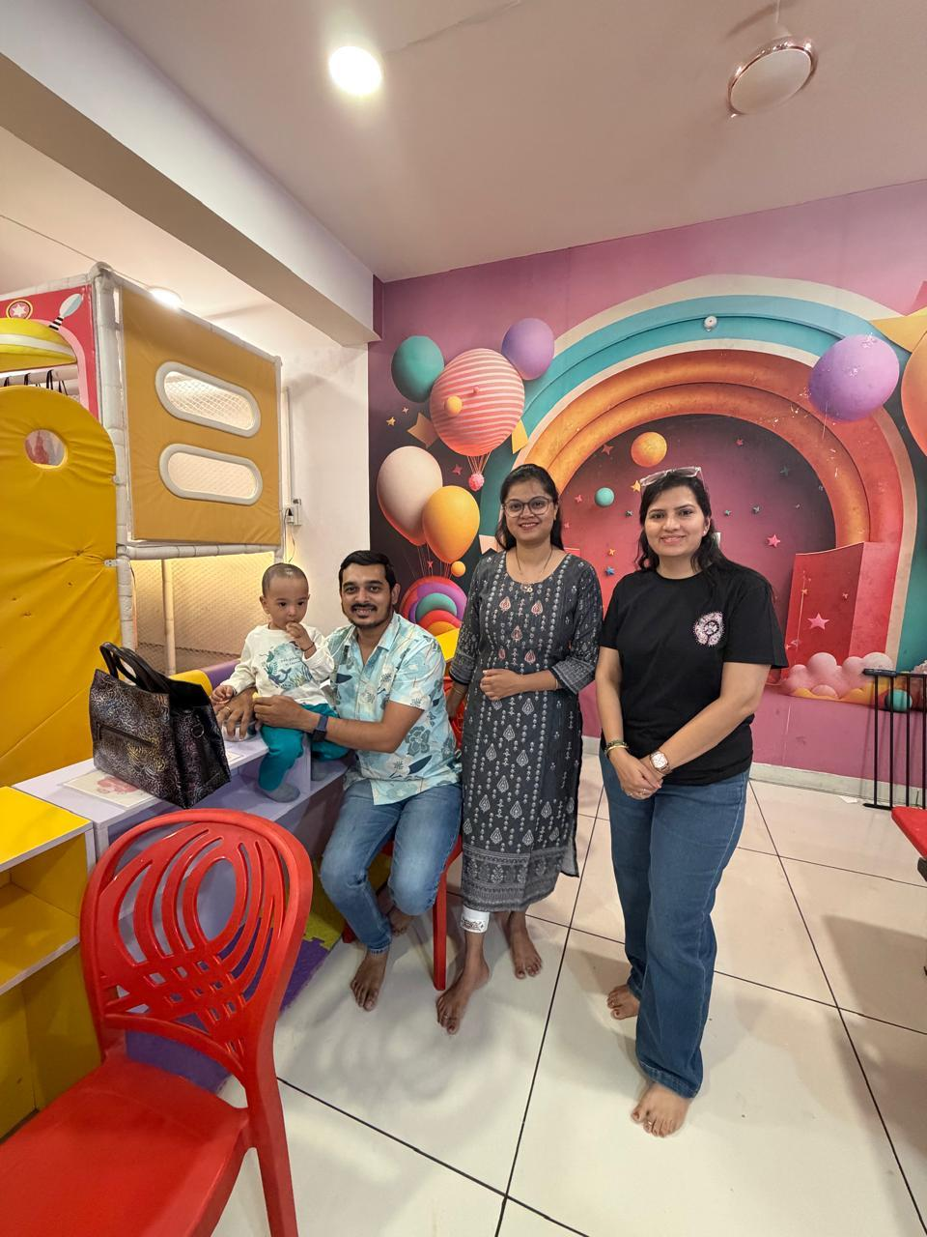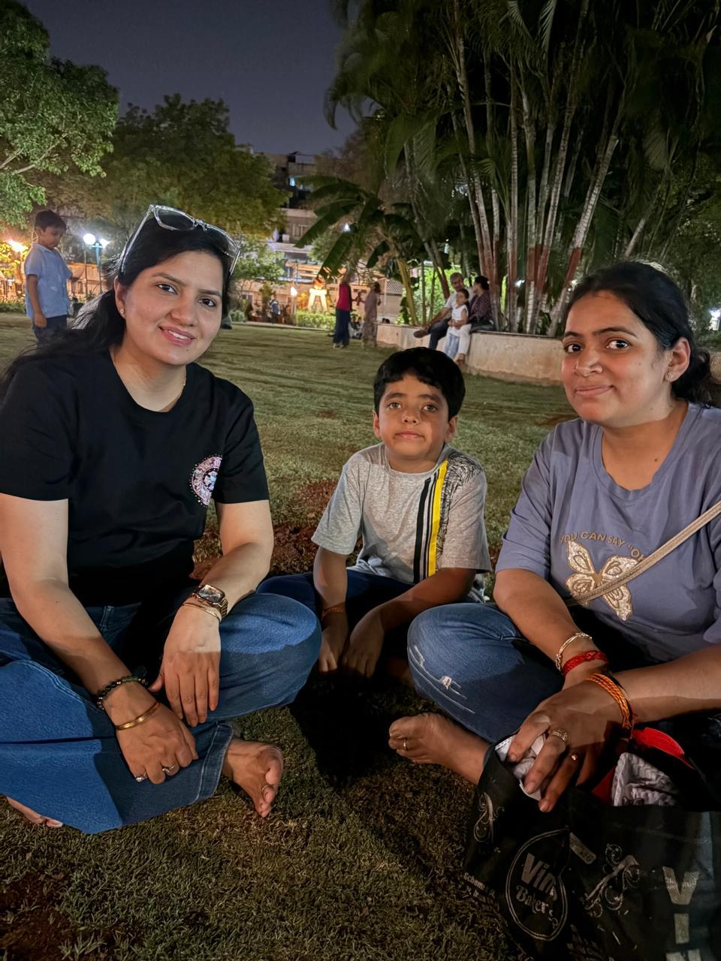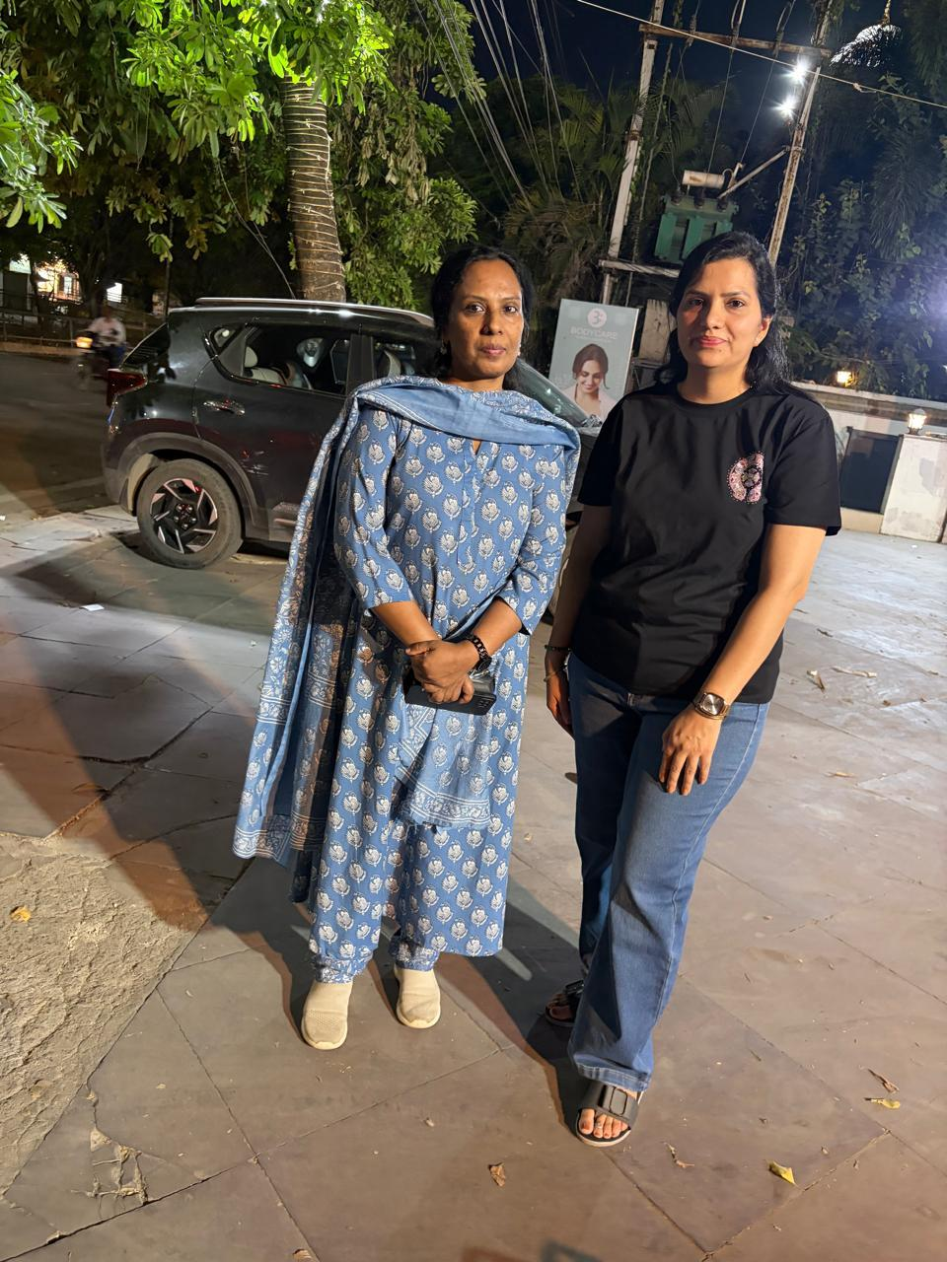
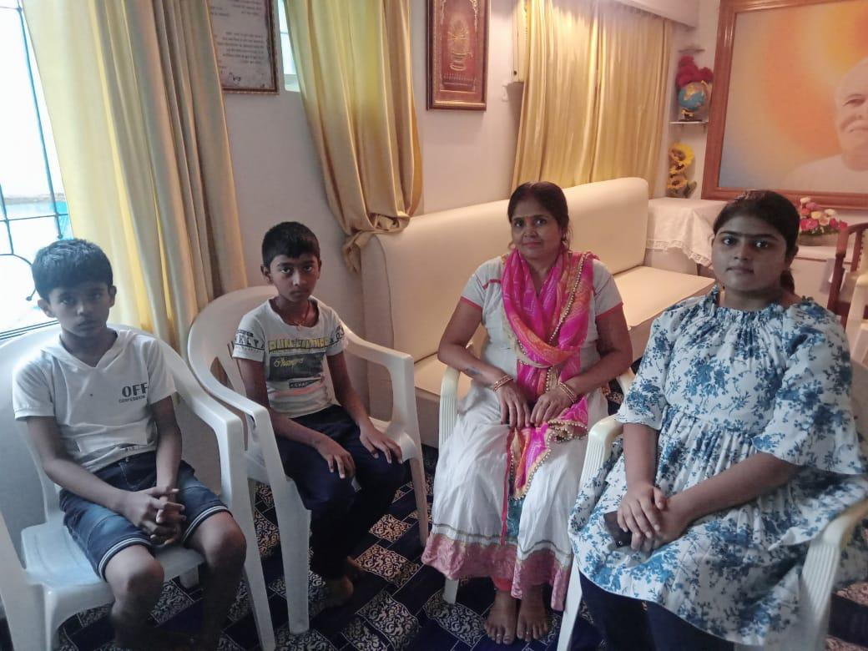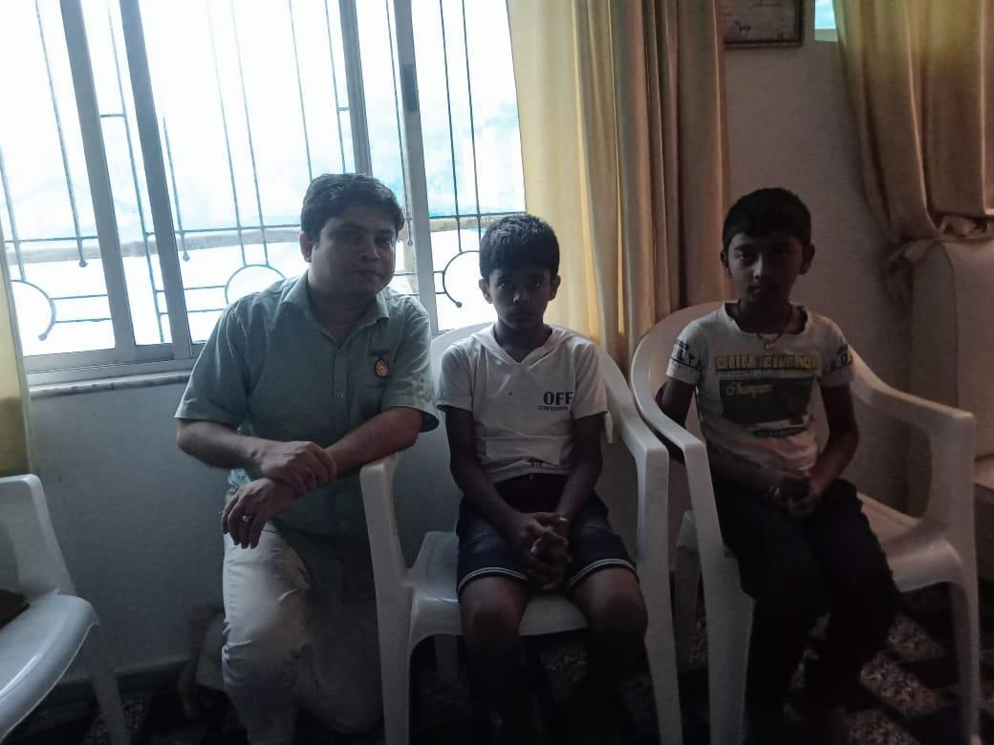

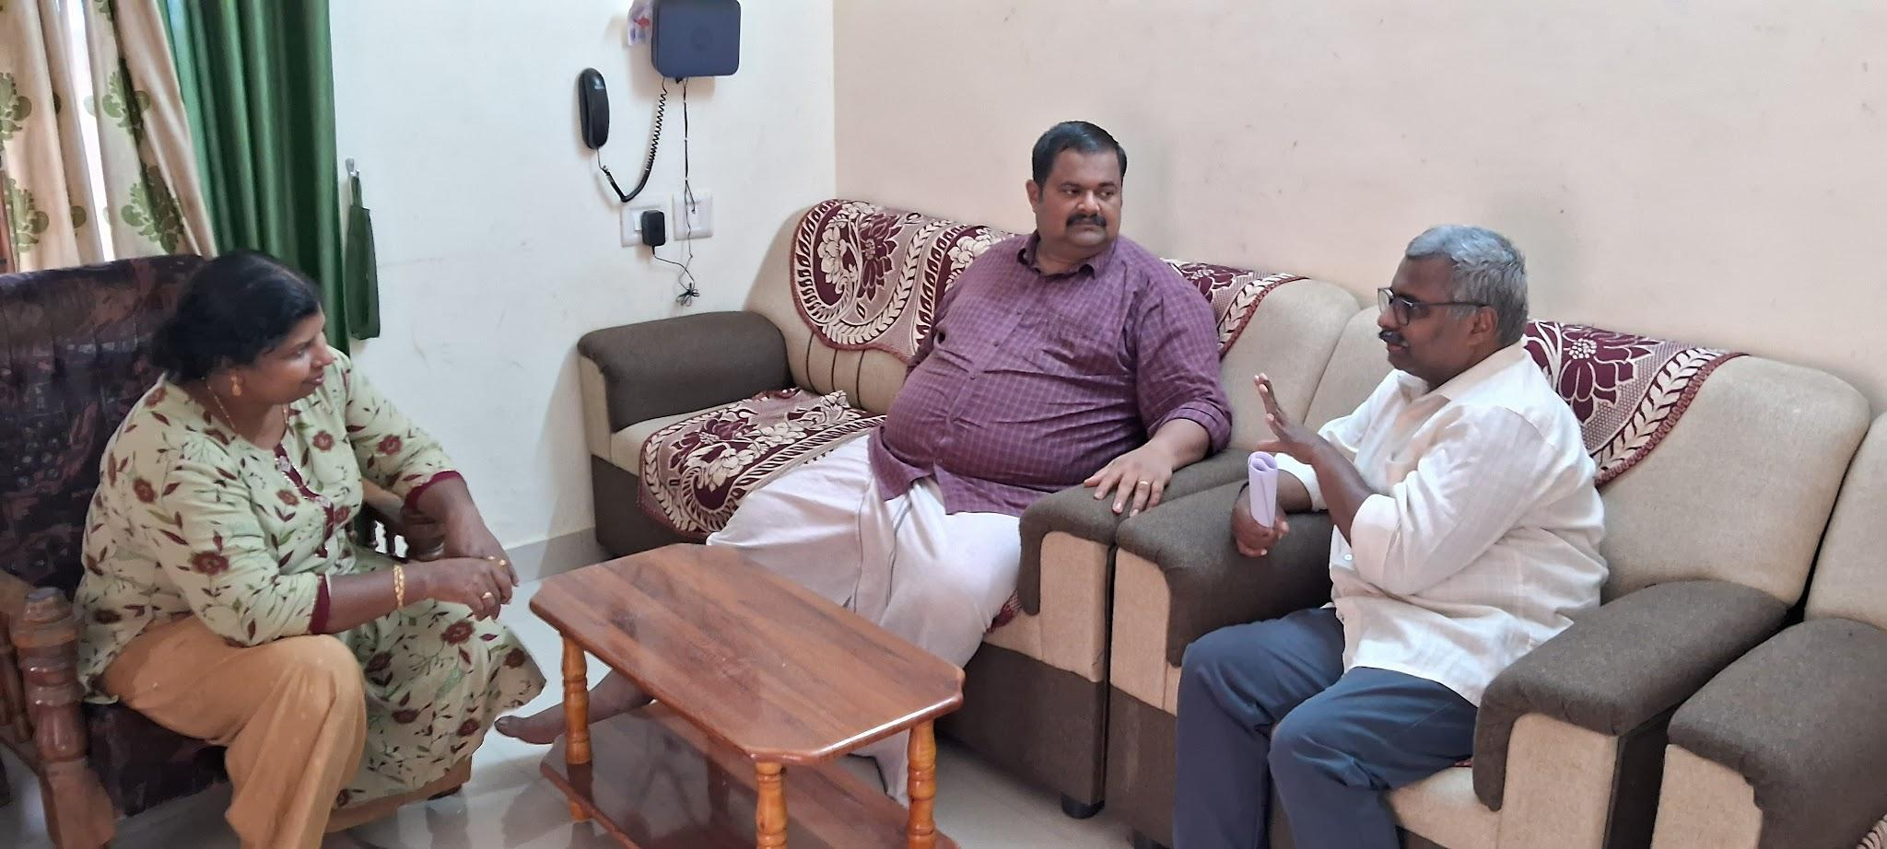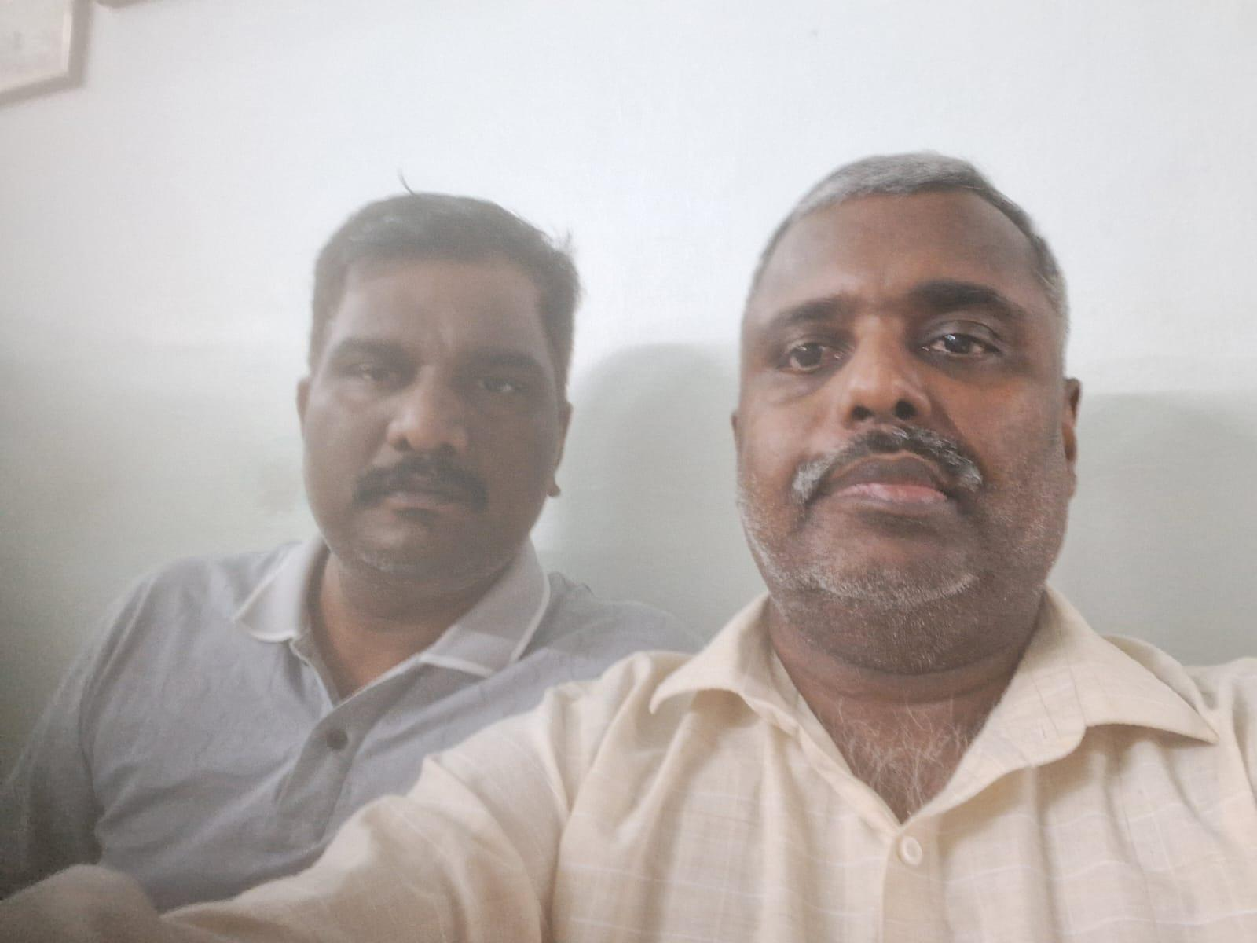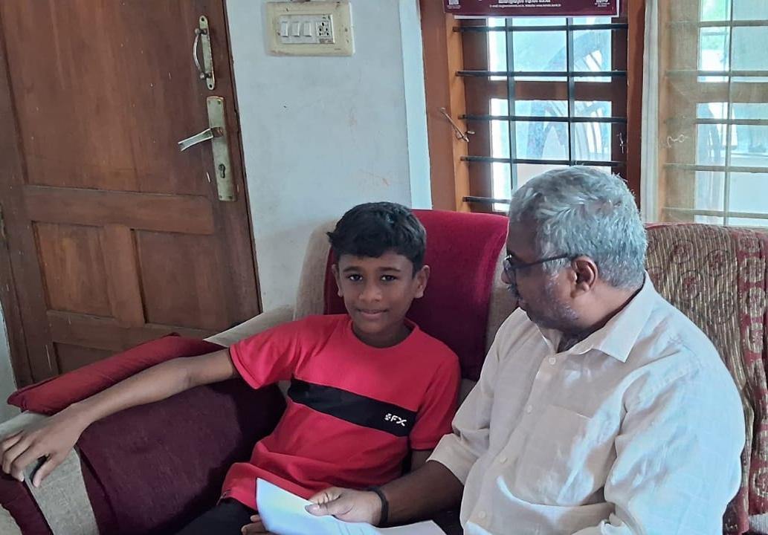
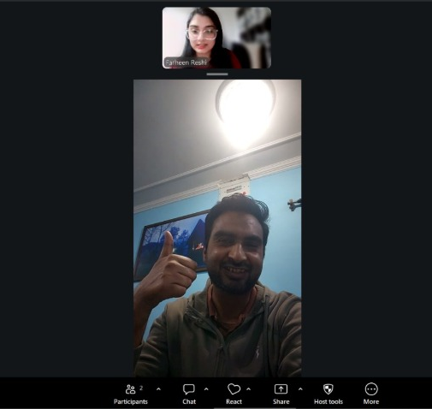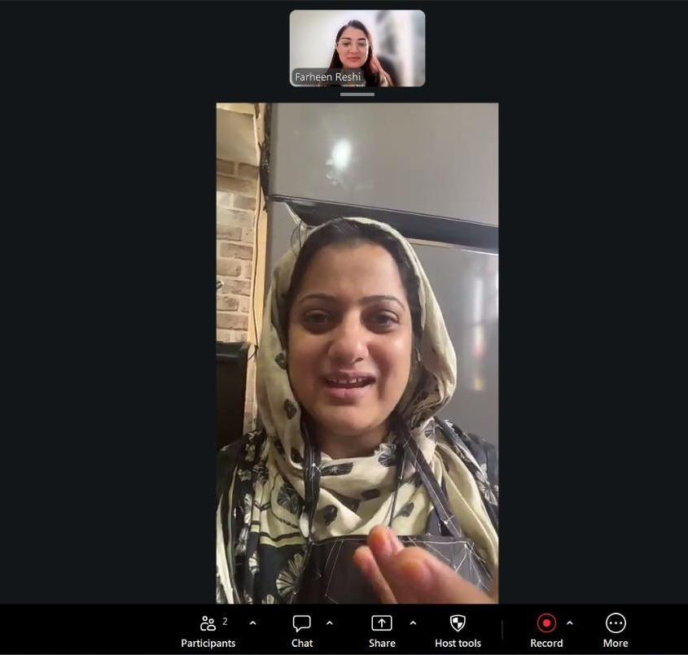
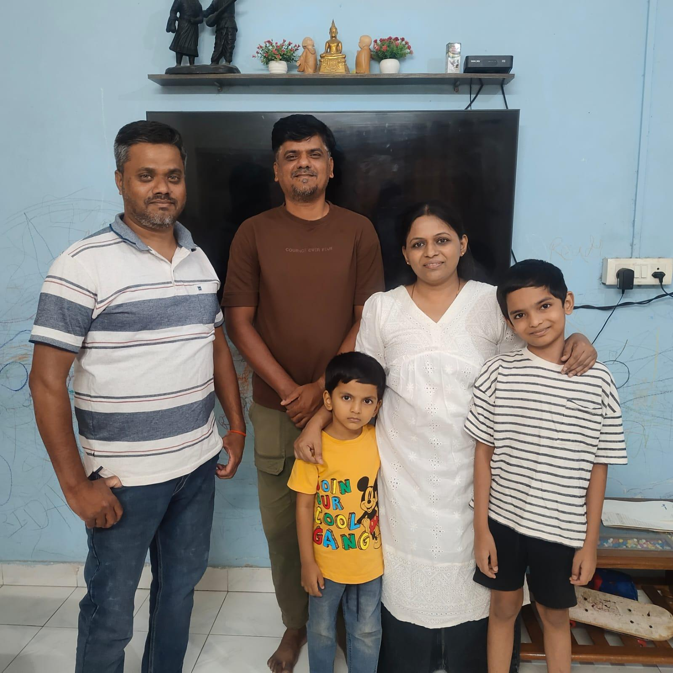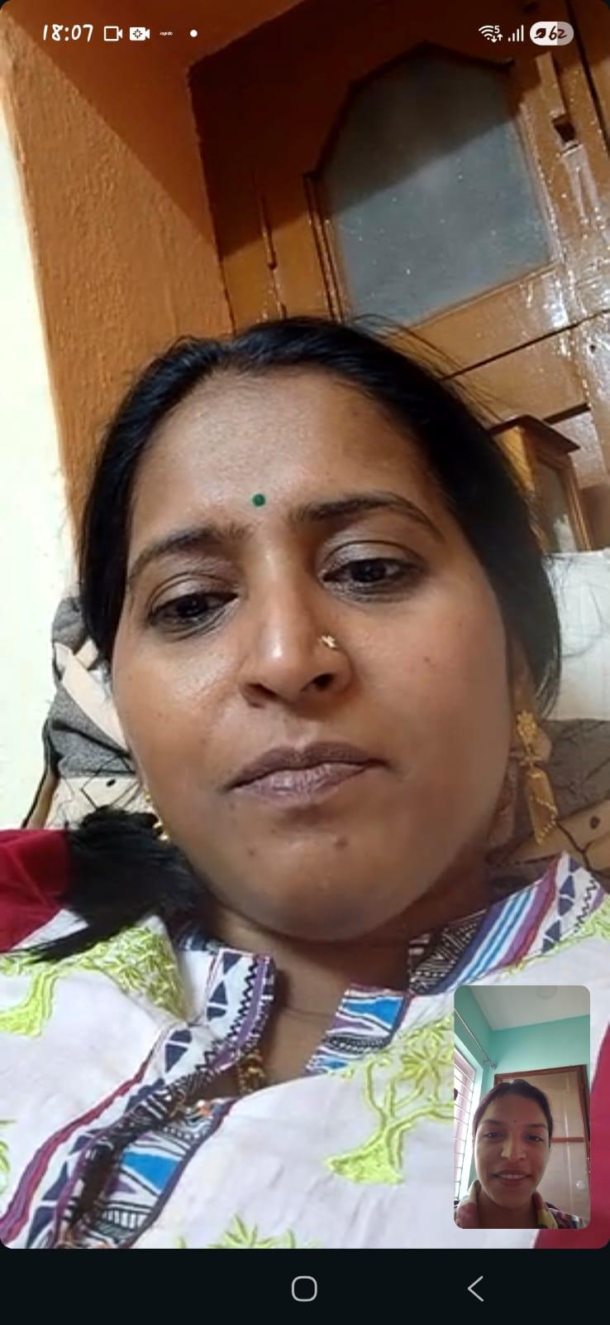

2.1 All Participants — Complete Interview Pool
Participant | Child Age(s) | Profile & Context | Core Pain Point | Observed Behaviour | Actionable Insight
Sudhir | School-age | Working parent, arrives home around 8:30 PM | Limited quality time after work | Encourages children to spend evenings in shared family spaces instead of separate rooms | Design should encourage family rituals in common spaces, making it easier for parents and children to reconnect after work.
Anoop | Teenager | Parent of a teenager | Screen-time conflict and resistance | Restricting screens alone failed; replacing them with shared outings proved more effective | Design should replace screen time with attractive, engaging alternatives instead of simply restricting device usage.
Nimish | School-age | Working parent seeking better routines | Fatigue affects parenting quality | Wants structure rather than more activity ideas; easily distracted after work | Design should reduce decision fatigue by providing structured, guided rituals requiring minimal effort.
Radhika | School-age | Working parent balancing professional and family life | Mental presence is harder than physical presence | Uses a symbolic laptop-closing ritual before family time | Design should help parents transition mentally from work mode to family mode through intentional rituals.
Afshan | 11 & 13 years | Mother of two; grandparents actively involved in caregiving | Balancing children's independence with family connection | Children spend time studying, cycling, and with grandparents; structured family bonding is infrequent | Design should create simple shared rituals that fit naturally into existing family routines.
Sabahat | 7 years & 4-year-old twins | Homemaker in a joint family | Managing attention across multiple children | Coordinates routines across children of different ages with support from extended family | Design should support flexible activities that engage multiple children simultaneously across age groups.
Atif Mir | 2.5–3 years & 5 months | Healthcare professional in a dual-income household | Limited time and energy due to demanding work schedules | Parenting responsibilities are shared but largely dictated by work commitments | Design should accommodate unpredictable schedules through short, flexible activities.
Arav (Child) | Approximately 9–11 years | Child participant | Wants more focused attention from parents | Notices missed evenings and phone distractions; values even five minutes of uninterrupted attention | Design should prioritize short, distraction-free moments that maximize emotional connection.
Sunimma Rajatkumar | 13 years | Assistant Professor & Psychologist; working mother in a nuclear family | Meaningful conversations with a teenage child become difficult after work | Conversations remain functional and rarely deepen despite good intentions | Design should provide conversation starters, reflection prompts, and age-appropriate interaction for teenagers rather than play-based activities.
Hiteshi | 19 months | Pediatric Physiotherapist running her own clinic | Exhaustion and unpredictable work reduce interaction time | Avoids screens, prioritizes pretend play and developmental activities, restructures work around parenting | Design should provide instant, zero-preparation activities that parents can begin immediately.
Poonam Jeshnani | 4 & 8 years | Dentist with structured routines and strong family support | Work disruptions create guilt and inconsistent quality time | Plans activities in advance and maintains strict routines; children react when routines break | Design should help parents recover quickly from disrupted routines with ready-to-use activities.
Child Interview (Primary User) | Approximately 8–13 years | Child from a working-parent household | Parents are busy after work, reducing opportunities for active play | Uses screens when parents are unavailable but prefers active games when parents participate | Children do not simply want less screen time—they want enjoyable, shared experiences that are quick and easy to start together.

3. User Segments

Analysing all 12 participants together — across both rounds — reveals four distinct behavioural segments defined not by demographics but by the type of barrier they face and the kind of solution they need.
Seg. | Name | Participants | Core Barrier | Design Need
A | The Late Returner | Sudhir, Anoop, Nimish, Sunimma Rajatkumar, Poonam Jeshnani | Time + energy scarcity; 45–90 min window | Micro-rituals that require zero setup
B | The Engaged-but-Strained | Radhika, Atif Mir, Hiteshi | Present physically, absent mentally | Transition tools + emotional reset support
C | The Overwhelmed Homemaker | Sabahat | Competing domestic demands, no respite | Low-effort activities, not more chores
D | The Teen Parent | Afshan, Anoop | Peer competition + teen autonomy | Conversation triggers, shared-interest discovery

4. User Personas

Four research-backed personas derived from the consolidated interview data. Each persona anchors to a real participant cluster, a direct quote, and a specific design implication.
The Late Returner  Segment A | "45 minutes is all I have — it has to count."  Core Pain: Arrives home 8:30 PM; after dinner and homework, has only ~45 min before bedtime. Energy near zero.  Core Need: A micro-ritual that begins automatically — no thinking, no deciding, just doing.  "Get the children to spend most of their time in the living room rather than their own room." — Sudhir, Round 2

The Engaged-but-Strained  Segment B | "My body is here but my mind is still at work."  Core Pain: Physically present but mentally occupied with unfinished work; needs a transition, not an activity.  Core Need: A ritual that signals to both her and her child that work is done and family time has begun.  "I'm closing my laptop, now it's our playtime." — Radhika, Round 2

The Overwhelmed Homemaker  Segment C | "If household work were less, I could spend more time with them."  Core Pain: Home all day yet stretched thin; chores and online courses compete with parenting. Guilt is constant.  Core Need: Ready-to-use, low-effort activities that don't feel like another task on the list.  "I want a mindful upbringing for my children." — Sabahat, Round 1

The Teen Parents  Segment D | "I can't compete with their phones — I need to join the conversation."  Core Pain: Teen children spend time with peers via screens; unsolicited parenting feels like intrusion.  Core Need: Conversation triggers and shared digital or physical experiences that feel peer-worthy.  "Their entire communication with friends happens via social media." — Radhika on teens, Round 2

Arav — The Child Perspective (Special Participant)
The only child interviewed in this study. Arav's responses fundamentally reframed the research.
What he wants: Short, daily presence — not long activities. 5–10 minutes, every day.
What hurts him: Parents using phones while physically present. He reads it as rejection.
What he does: Mentally tracks missed evenings and plans to remind parents of them.
"Even 5 minutes will make me happy — we can do something every day for 10 minutes. I want them to use no phone."

5. Key Insights — Backed by Survey + Interview Data

Each insight below is triangulated: survey data establishes the scale, interview quotes give it texture, and a design implication shows what it demands from any solution.
01 | The Real Interaction Window Is 45–90 Minutes, Not 4 Hours  Parents arrive home at 7–8:30 PM, not 6 PM. After dinner and homework, the actual window shrinks to 45–90 minutes. Designing for 'the evening' is designing for the wrong time unit. Survey Q7: 17.6% have only 15–30 min. Interviews: Sudhir (8:30 PM arrival), Anoop, Nimish (all late evenings).

02 | Children Want Frequency, Not Duration  Parents search for the perfect long activity. Children ask for a short, consistent presence. The real task is daily 5–10 minutes, not occasional 45-minute sessions. Arav (child interview): "Even 5 minutes will make me happy." Survey Q13: 13.2% cite 10–15 min as a realistic sweet spot.

03 | The Parent's Phone — Not the Child's — Is the Competing Screen  Children register parental phone use as rejection even when parents are physically present. The device barrier is not the child's screen but the parent's own habit. Arav: "I want them to use no phone." Survey Q11: 13.2% cite 'child prefers screens' — but child's view inverts this.

04 | Fatigue Damages Engagement in Real Time — Not Just Before It  Mental fatigue is not only a pre-engagement barrier. It actively degrades the quality of interactions that do happen — causing irritation, impatience, and emotional withdrawal. Nimish: "Sometimes I get irritated, I may lose my temper." Survey Q6: 75% score 3+ on exhaustion scale.

05 | Children Track and Remember Missed Connection Like a Ledger  Children are quietly counting. The emotional cost of missed evenings is invisible to parents but vivid and specific to children — Arav describes a plan to confront his parents about it. Arav: "I will think about the last time that they played with me, and tell them." No direct survey parallel — this is a child-only insight.

06 | Screen Restriction Without Replacement Always Fails  Every parent who tried restriction without offering an alternative failed. The design problem is not 'reduce screens' — it is filling the vacuum that screens occupy with something of equal or greater appeal. Anoop: "Simply trying to restrict screen time without offering alternative activities does not work." Survey Q11: 13.2% cite child's screen preference as barrier.

07 | What Works Is Already Known — But Not Systematic  Outings, shared meals, movies together, UNO, walks with friends visiting — parents already know what works. What they lack is a system to make these happen on tired weekdays. Round 2 cross-interview pattern. Survey Q12: 85.3% want ready-made activities — they want the scaffold, not the concept.

08 | The Transition Moment Is the Design Problem, Not the Activity  The hardest moment is not choosing what to do — it is shifting from work-mode to parent-mode and from screen-on to screen-off. Whoever designs the transition wins. Radhika's laptop-close ritual. Survey Q8: 60%+ report difficulty deciding what to do — decision friction = transition failure.

09 | Teen Screens Are Social Infrastructure, Not Entertainment  For adolescents, screens are the medium through which peer relationships exist. Treating teen screen use as identical to toddler screen use will fail. Solutions must be age-band specific. Radhika on teens: "Their entire communication with friends happens via social media." Survey Q4: 32.7% of children are aged 11–15.

10 | Parents Want Structure, Not More Ideas  The explicit request across Round 2 was for something that makes the bonding moment happen reliably — a scaffold, not an activity list. The solution is a ritual system, not a content library. Nimish: "Something that helps structure dedicated parent-child time easily, fits into a busy schedule." Survey Q12: 85.3% open to ready-made structure.

5.1 Three Hidden Truths Behind the Insights

Transition Design Problem  The hardest moment is the switch from work to family, and from screen-on to screen-off. Whoever designs the transition — not the activity — solves the real problem. | Child as Co-Designer  Arav's responses showed children have clear, mature preferences. The best solutions invite children to lead, not just follow parent-directed activities. | Parents Already Self-Designing  Radhika's laptop-close ritual, Sudhir's living-room strategy, Atif's 10-minute window — parents have discovered what works. The opportunity is to codify these patterns.

6. Design Direction & HMW Questions

6.1 What This Means for Design
The bonding gap is not caused by lack of love, time, or willingness — it is caused by the absence of a trusted, low-effort, decision-free ritual that fits inside the real 45–90 minute post-dinner window, and turns the screen from a competitor into a connection trigger.

• Design the 5-minute ritual, not the 30-minute activity — both Arav and the survey point to short, consistent, no-setup moments as the ask.
• Design the transition, not the destination — the hardest part is starting; the tool must handle the switch from work to family, and from screen to play.
• Design for the living room as the stage — anchor solutions in the shared physical space that already exists.
• Design for tired parents, not regulated ones — fatigue is not a use-case edge; it is the primary use case.

6.2 How Might We Questions

HMW | How might we help an exhausted parent transition from work-mode to parent-mode in under 60 seconds, with no decision-making required?

HMW | How might we make the 5-minute daily ritual so easy that children begin reminding parents, instead of the other way around?

HMW | How might we redesign the living room as a shared space that gently competes with bedrooms and personal screens for attention?

HMW | How might we turn parents' own working hacks — Radhika's laptop-close ritual, Anoop's friend-visits trick — into shareable patterns other tired parents can adopt?

HMW | How might we acknowledge that some screen time is non-negotiable, and design with it instead of against it?

Section 04 — Ideation

4.1 Idea Generation Process

From Problem to Possibilities
To avoid converging on a solution too early, we began with a broad exploration phase to understand the problem space from multiple perspectives. Using insights from our user research, we generated a wide range of ideas that addressed different aspects of parent-child bonding, engagement, and habit formation.
Our ideation process combined both collaborative and AI-assisted methods, enabling us to explore solutions across digital experiences, physical products, and behavioural interventions.

Methods Used
- Brainstorming sessions using "How Might We" questions
- Convergent and Divergent (AI Assisted Idea Generation)
- Affinity Mapping to identify key user pain points and opportunity areas
- Mind Mapping to explore related problem spaces
- Crazy 8's
- Impact Effort Matrix
- Concept sketching and Storyboarding combined with collaborative discussions to refine early ideas

Opportunity Areas Identified
After generating 80+ ideas, similar concepts were grouped into seven opportunity areas:
- Conversation & Emotional Bonding
- Activity-Based Bonding
- Physical Products & Games
- Micro-Bonding & Habit Systems
- AI & Smart Assistance
- Gamification & Engagement
- Experience & UX Flow
This structured approach helped us move from a large volume of ideas to a smaller set of promising solution directions.

Exploring the Solution Space
The generated ideas were grouped into seven key themes based on their purpose and user value.
Opportunity Area | Design Exploration
Conversation & Emotional Bonding | Conversation starters, gratitude rituals, storytelling prompts, emotional reflection cards, appreciation activities, bedtime check-ins, memory sharing and guided discussions.
Activity-Based Bonding | Creative arts, movement games, yoga, DIY activities, gardening, cooking, teamwork challenges and quick collaborative family activities.
Physical Products & Games | Conversation card decks, ritual kits, board games, activity jars, tabletop games, bonding wheels, challenge boards and offline engagement tools.
Micro-Bonding & Habit Systems | Daily rituals, 5-minute bonding prompts, family goals, shared responsibilities, wellness routines, habit tracking and bonding streaks.
AI & Smart Assistance | AI-generated rituals, mood-based recommendations, personalised activities, family routine planning, emotion-aware guidance and screen-time alternatives.
Gamification & Engagement | Family challenges, achievement badges, progress tracking, streak rewards, milestone celebrations and collaborative missions.
Experience & UX Flow | Phone-down rituals, work-to-home transition flows, child-led experiences, low-energy interactions, zero-preparation activities and decision-free family experiences.

Idea Generation Process and Snapshots

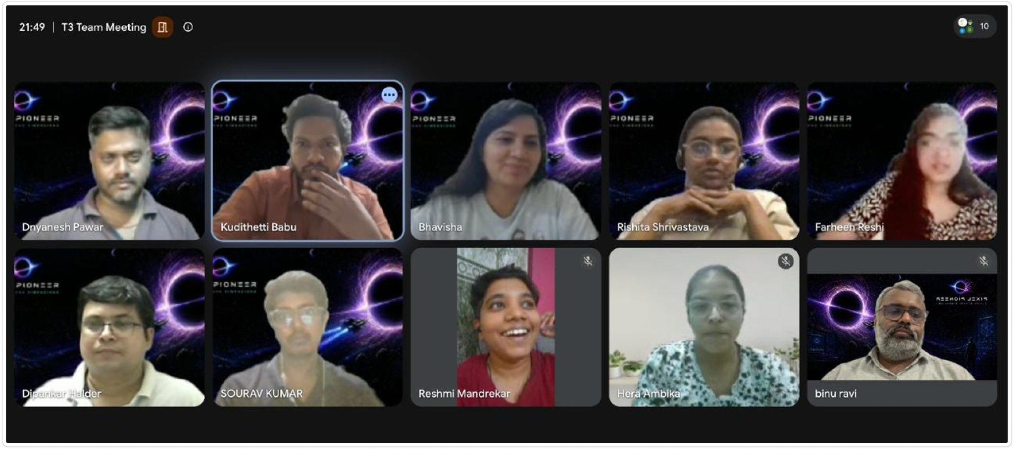
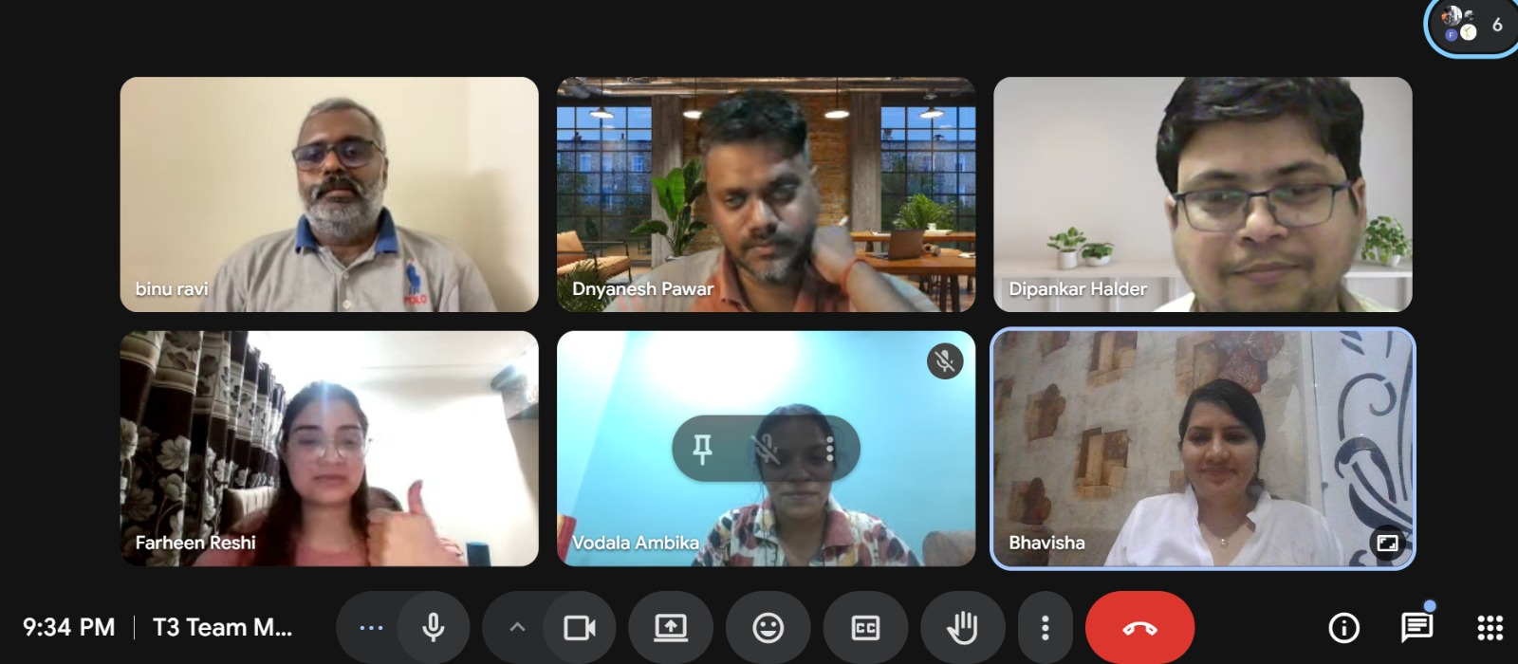
Team Collaboration
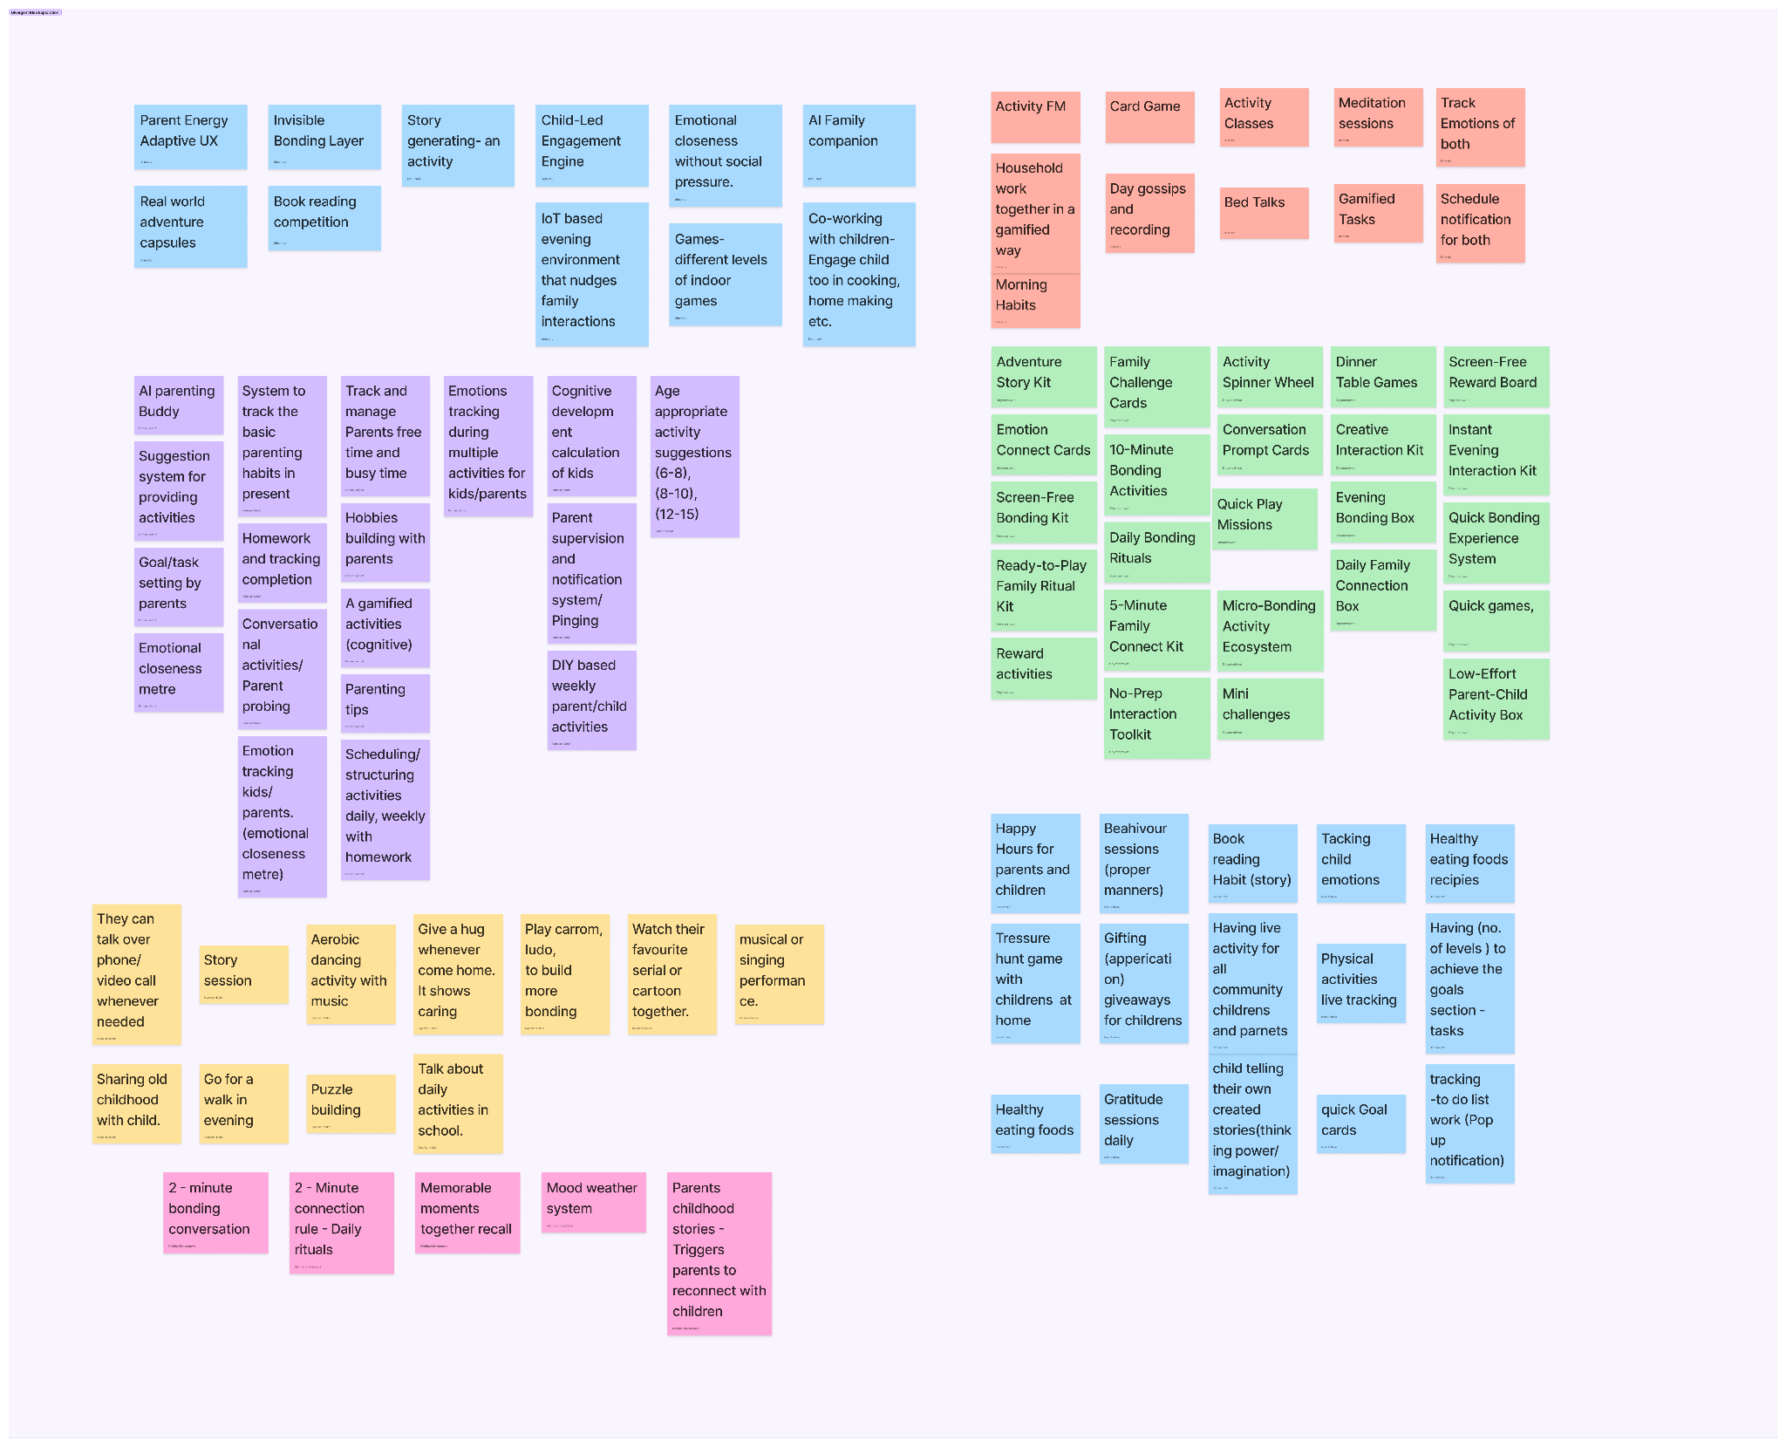
Divergent Mind-Mapping
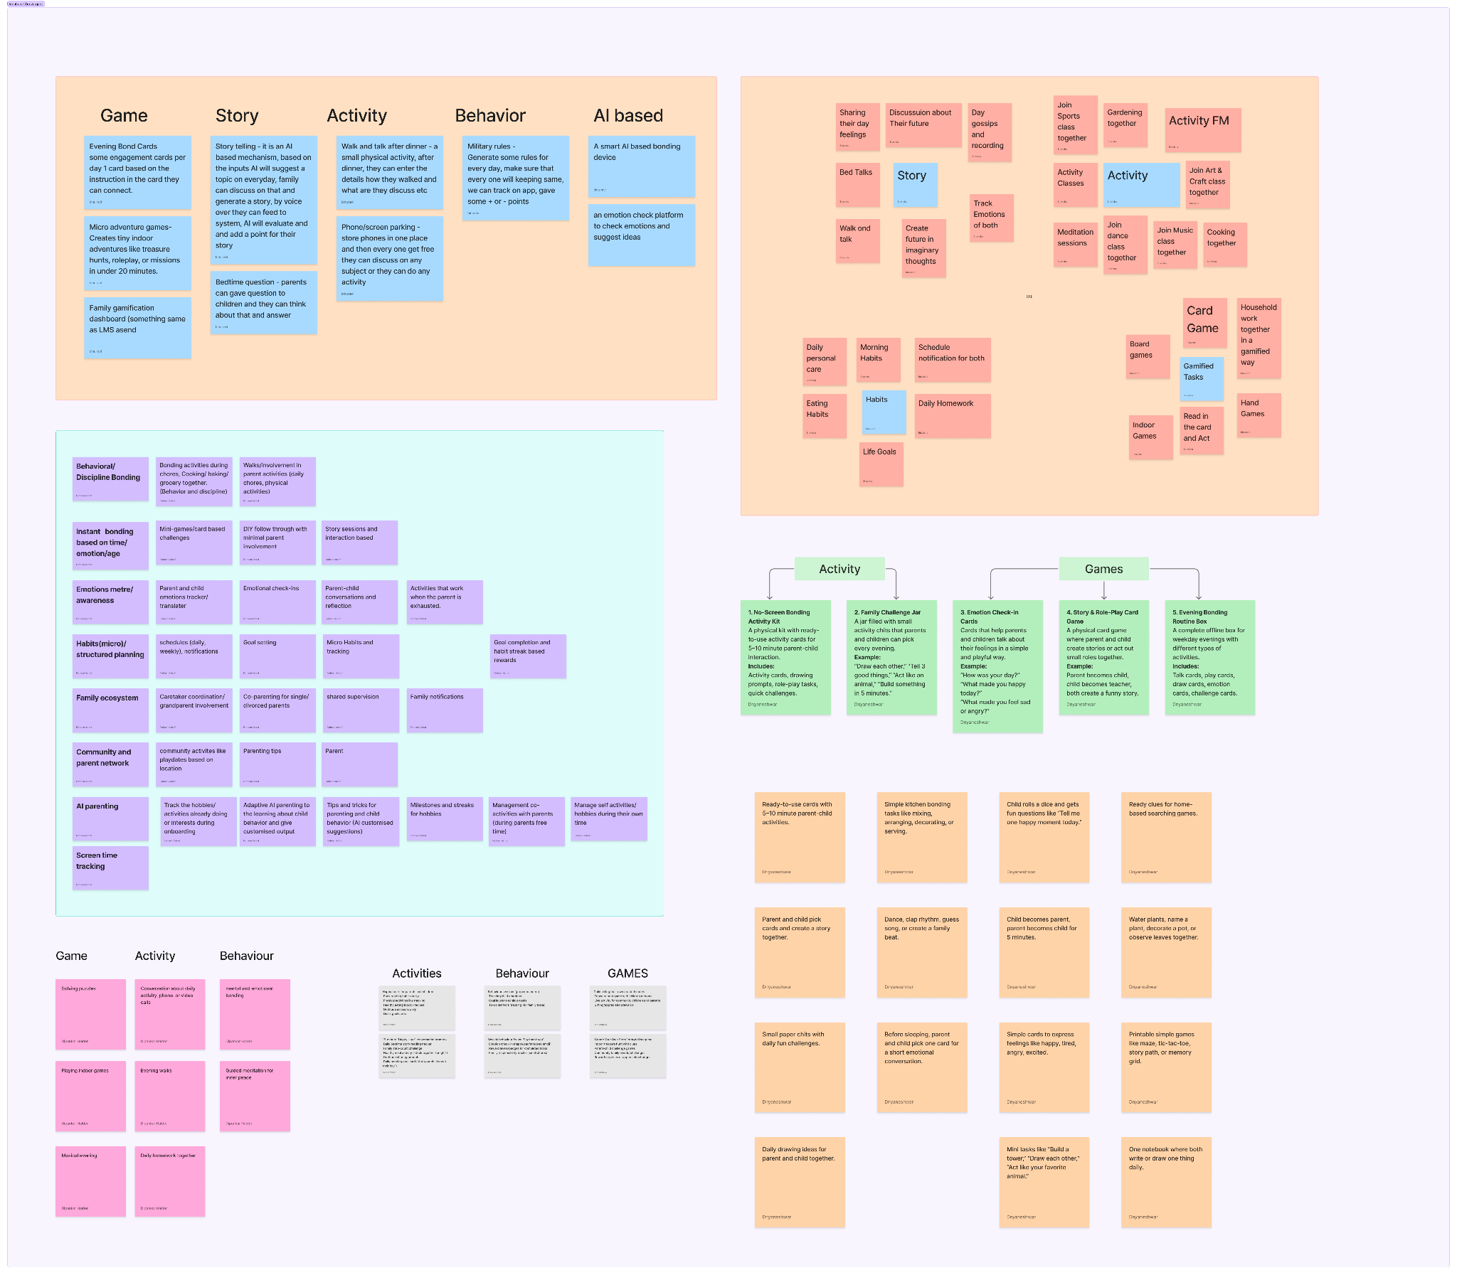
Convergent Mind-Mapping
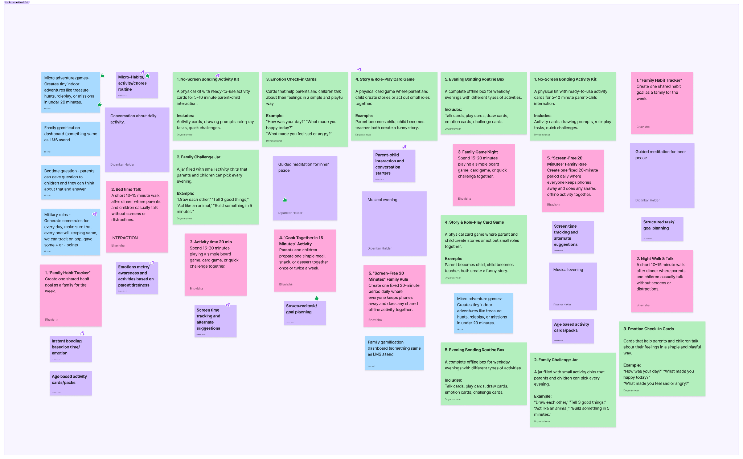
High Impact- Low Effort
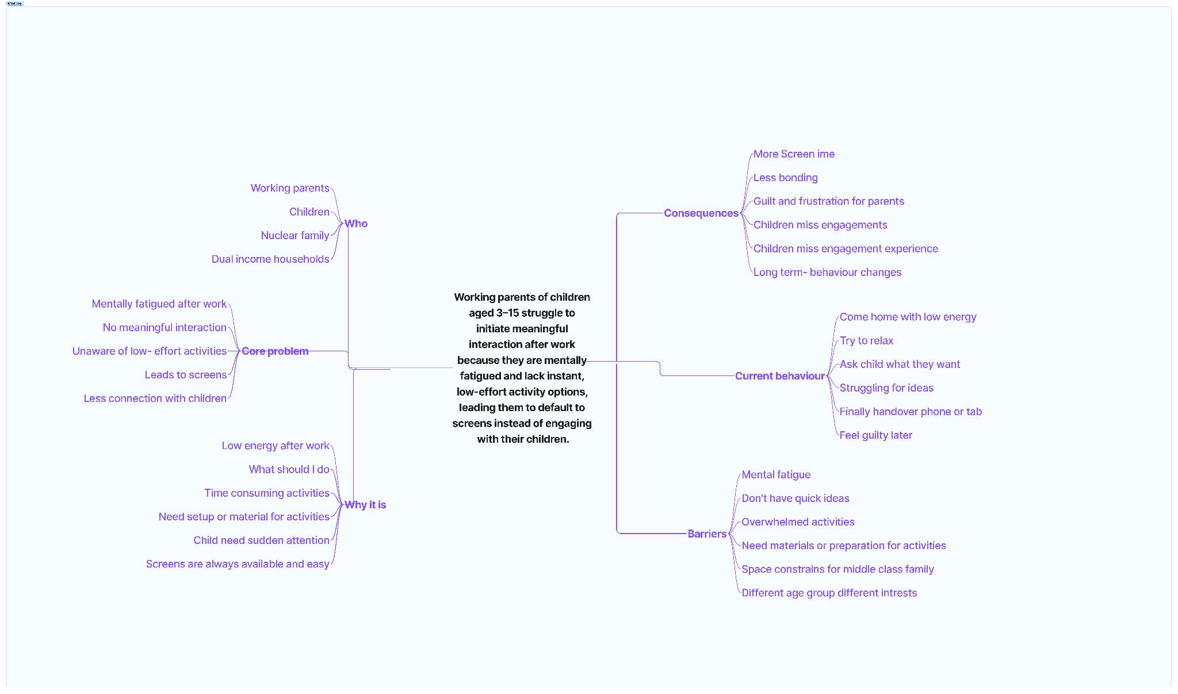

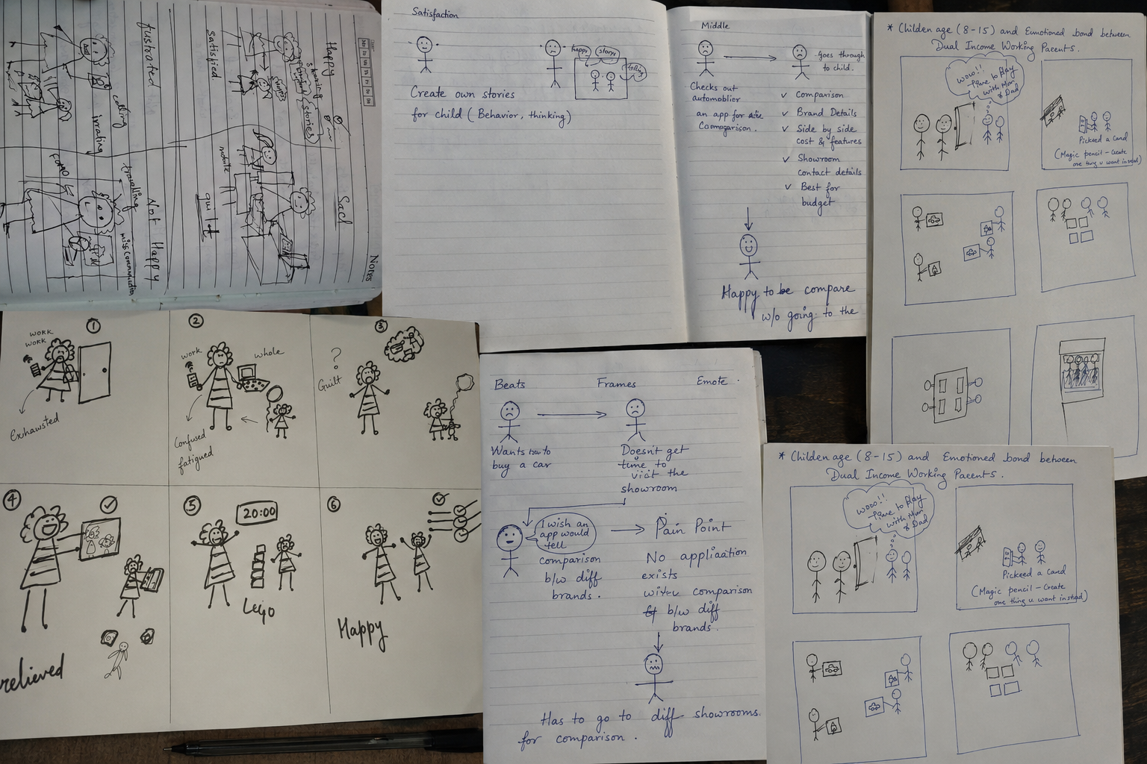
Concept Story-boarding

4.2 Concept Exploration

4.2.1 Converging Towards the Right Solution
The generated ideas were synthesised into three distinct product concepts, each addressing the problem from a different perspective. Rather than evaluating individual features, we explored complete experience directions to understand which approach best aligned with user needs.

Concept 01 — Daily Family Ritual System
A structured daily ritual that helps parents and children spend 10–20 meaningful minutes together through conversation prompts, storytelling, and quick collaborative activities.
Strengths
- Fits naturally into existing evening routines
- Requires minimal planning and effort
- Encourages long-term habit formation

Concept 02 — Storytelling & Activity Kit
A physical toolkit containing conversation cards, storytelling prompts, emotional reflection exercises, and collaborative games designed to create engaging, screen-free family interactions.
Strengths
- Highly engaging and interactive
- Encourages creativity and emotional expression
- Creates tangible shared experiences

Concept 03 — AI Family Companion
An AI-powered assistant that recommends personalized family rituals based on available time, parent energy levels, child interests, and family routines.
Strengths
- Reduces decision fatigue
- Personalised recommendations
- Easily adapts to different family contexts

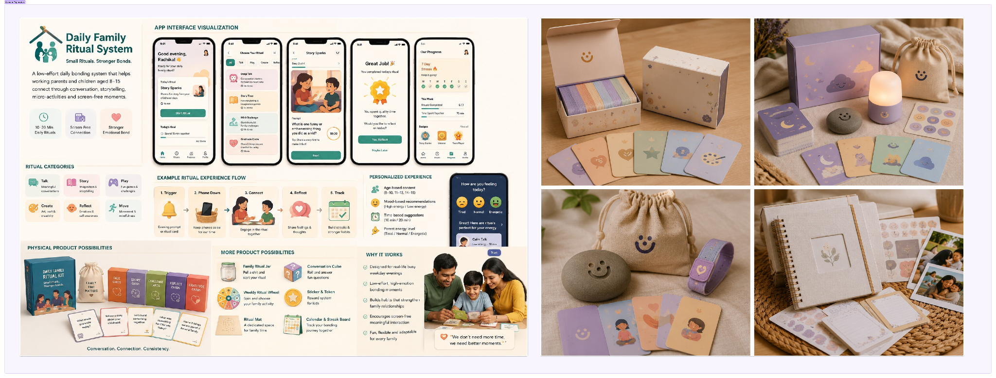
Concept Idea Exploration
Each concept solved a different aspect of the problem. Rather than selecting one in isolation, we recognised the opportunity to combine the strongest elements from each concept into a single cohesive family bonding experience.

4.3 Concept Selection Framework

4.3.1 Concept Exploration and evaluating the best direction
To identify the most impactful solution, each concept was evaluated against the insights gathered during research and the needs expressed by working parents.

Evaluation Criteria
Criteria | Focus
User Value | Does it solve the core user problem?
Ease of Adoption | Can busy parents use it effortlessly?
Emotional Impact | Does it encourage meaningful family connection?
Feasibility | Can the concept be realistically designed and tested?
Long-term Engagement | Will families continue using it consistently?

Decision Matrix
Concept | User Value | Ease of Adoption | Emotional Impact | Feasibility
Daily Family Ritual System | ★★★★★ | ★★★★★ | ★★★★★ | ★★★★★
Storytelling & Activity Kit | ★★★★☆ | ★★★☆☆ | ★★★★★ | ★★★☆☆
AI Family Companion | ★★★★☆ | ★★★★☆ | ★★★★☆ | ★★★☆☆

Final Selected Concept
The Daily Family Ritual System was selected because it addressed the core user challenge with the least friction. Rather than requiring parents to plan activities, it enabled meaningful family interactions through small, repeatable rituals that naturally fit into busy weekday evenings.

Product Vision
Help working families rebuild emotional connection through simple daily rituals that transform distracted evenings into meaningful bonding moments.

Core Experience
- Guided conversation & storytelling
- 10–20 minute bonding rituals
- Phone-down transition moments
- Emotion & reflection cards
- Screen-free family activities
- Habit tracking & family streaks

Why This Direction?
Research revealed that parents wanted to spend time with their children but lacked the energy to initiate it. The Daily Family Ritual System reduced decision fatigue while making emotional connection quick, enjoyable and sustainable.
Unlike traditional parenting apps or standalone games, the Daily Family Ritual System combines emotional bonding, habit formation, storytelling and screen-free engagement into a single experience. Rather than eliminating screen time entirely, it helps families naturally transition from digital distraction to meaningful interaction through low-effort, repeatable rituals.
Key Value Proposition
- Designed specifically for mentally exhausted working parents.
- Combines activities, conversations and habit-building in one ecosystem.
- Creates sustainable family bonding through small, consistent daily rituals.

Section 05 — UX Architecture

5.1. Information Architecture in Detail
The following site map captures every major section, screen, and sub-screen identified across the 10 design files. Navigation is anchored to a persistent five-tab bottom navigation bar.

Level 1 (Section) | Level 2 (Screen) | Level 3 (Sub-screen / State) | Notes
Pre-Auth | Splash / Landing | Animated logo + Get Started CTA | Entry point; brand impression
 | Sign Up / Sign In | Google OAuth, Facebook OAuth | Social auth only; no email/password visible
Onboarding | Step 1 of 4 – Parent Role | Mother / Father selection + language | 25% progress indicator
 | Step 1 of 4 – Child Info | Name, Age, DOB, Interests (multi-select chips) | Supports multiple children via Add More Child
 | Step 2 of 4 – Time Together | Evenings / Bedtime / Weekdays / Weekends | 60% progress indicator
 | Step 3 of 4 – Reminders | Daily / Weekdays / Weekends / No Reminders toggles | 75% progress indicator
 | Step 4 of 4 – Family Goals | Reduce Screen Time, Improve Communication, Emotional Bonding, Build Confidence, Creativity, Quality Time, Family Connection, Mindfulness | 100% progress indicator; goals highlighted on selection
 | All Set! Confirmation | Summary: Rituals daily + Goal displayed; Go to Homepage CTA | Celebration state; launches main app
Home(Tab 1) | Homepage Feed | Personalised greeting, streak counter, featured video, mood check-in | Dynamic; updates daily
 | Featured Video Player | In-line video with seek bar, duration | Embedded in feed card
 | Mood Check-in | Happy / Excited / Tired / Anxious selection | Feeds into Mood Journey in Progress
 | Recommended Rituals | Horizontal scroll cards with Start Ritual CTA | Personalised based on onboarding
 | Ritual Kits Promo Banner | Links to Ritual Kits section | Cross-sell touchpoint
Rituals(Tab 2) | Ritual Library | Daily unlock strip (Day 1, Day 2…), Premium Collections by category (Bedtime, Evening, Weekend) | New ritual unlocks daily; premium locked behind purchase
 | Ritual Detail | Category tag, duration, description, 4-step instructions, Parent Pro-Tip, Start Ritual / Try Another CTAs | Video preview at top of detail
 | Active Ritual (Timer) | Countdown timer ring, ambient music toggle, breathing guide overlay, Pause / End Early | Full-screen focused mode
 | Ritual Completed | Streak badge, mood capture (Connected/Calm/Happy/Excited), free-text reflection, Ritual Kits upsell card, Save Reflection / View Progress | Completion celebration state
Ritual Kits(Tab 3) | Kits Collection | Search bar, filter chips (All Kits / Bedtime / Weekend / Evening), product cards with rating + price | E-commerce browse screen
 | Kit Detail – What's Inside | Hero image, rating, price, description, tabbed content: What's inside / How it works? / Read Reviews | Three-tab detail page
 | Kit Detail – How It Works | Benefit icons with descriptions (Emotional Bonding etc.), Add to Cart CTA
 | Kit Detail – Reviews | Reviewer name, star rating, quote, Add to Cart CTA | Social proof tab
Cart &Checkout(Tab 5) | Cart (Step 1 – Bag) | Item list with qty controls, delete, order summary, Creating Intentional Moments message, Confirm & Pay CTA | 3-step progress indicator
 | Address (Step 2) | Saved address selector, Add new address form (Name, Street, City, State, Zip, Phone), Save & Continue
 | Payment (Step 3) | UPI / Card radio selection, order summary recap, Pay ₹499 CTA | Secure transaction note + ToS link
 | Payment Details Modal – UPI | UPI ID / VPA input, Verify button, security badges, Pay CTA | Bottom sheet overlay
 | Payment Details Modal – Card | Card tab active, Cardholder Name, Card Number, Expiry, CVV inputs, Pay CTA | Tab switches between Card and UPI
Post-Payment | Processing Loader | Infinity-loop animation, 'Securing your ritual essentials…', encrypted payment badge | 3-dot progress below animation
 | Order Confirmation | Gift box illustration, order #, ETA, Parent Pro-Tip, View Order Details / Back to Home | Celebratory success screen
 | Order Details | Order status timeline (Ordered/Processing/Shipped/Delivered), items, order summary, shipping address, payment method, Discover More Kits CTA | Real-time status tracker
Progress(Tab 4) | Progress Overview | Ritual journey stats (total rituals, current streak), screen-free time, mood trends (parent + child), achievements strip, Start New Ritual CTA | Dashboard hub
 | Weekly Streak | Bar chart of daily activity (M–S), day checkmarks, Time Together metric, Weekly Rituals checklist with Begin Ritual CTA, Next Ritual preview
 | Achievements Unlocked | Badge grid (First Ember, Family Talker, Bedtime Hero, Ritual Master), locked badges, unlock motivation copy, Start New Ritual CTA | Gamification layer
 | Mood Journey | Parent Mood Trend line chart (last 7 days), Child Mood Trend line chart, Emotional Insights cards, Weekly Reflection mood picker + free text
SuccessStories | Stories Feed | Search, sort/filter, story cards (thumbnail, title, author, excerpt), Tell Us Your Story CTA | Accessible from home or menu
 | Story Detail – Writing | Author name, date, full text, comments section (threaded comments with timestamps)
 | Story Detail – Video | Full-screen video player with controls, story title below, comments
 | Create Story | Story Title input, Writing / Video radio tabs
 | Create Story – Writing Mode | Rich text area, file upload (jpg/png/gif), character counter, Cancel / Submit
 | Create Story – Video Mode | Camera / Gallery radio, native camera (photo/video/portrait/pan mode), video preview, post-submit prompt to share more
Profile | My Profile (Menu Entry) | Avatar, name, role (Mother), level badge (LVL 18), settings links (Family Profile, Subscription, Privacy Settings, Help & Support), Logout | Accessible via hamburger or avatar
 | Family Profile | Parent + child avatars with level badges, Rituals Completed count (142), Connection Streak (12 days), Explored Activities (24) | Aggregated family stats
 | Subscription | (Detail screens not shown – navigates to subscription management)
 | Privacy Settings | (Detail screens not shown)
 | Help & Support | (Detail screens not shown)
Settings | Settings Screen | App Settings: Notification (on), Integration (off), Dark Mode (off), Reminder Timing (on), Accessibility (on); Other Settings: Subscriptions (on); Version info + Update Now; Logout | Accessible via hamburger menu
 | Reminder Timing Modal | Scroll-wheel time picker (Hour / Min / AM-PM), Cancel / Submit | Triggered from Reminder Timing toggle row

Before
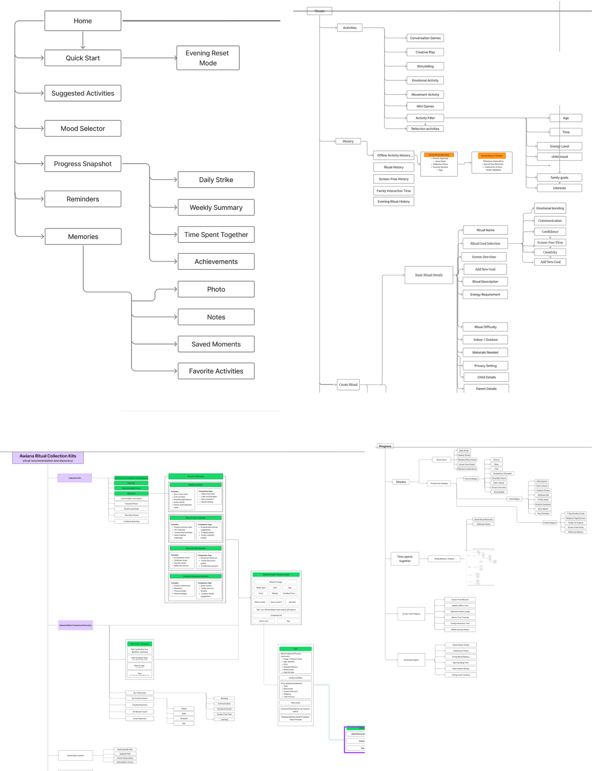

After discussions
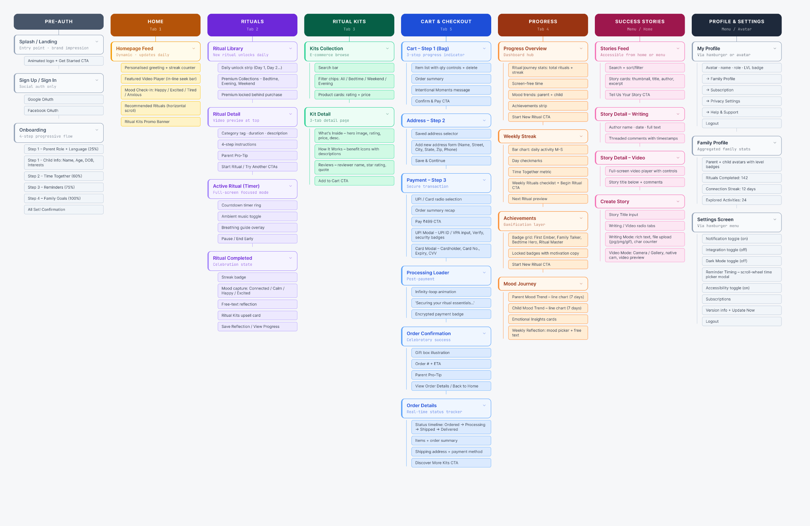

5.2. Navigation Architecture

5.2.1 Primary Navigation – Bottom Tab Bar
Persistent across all main app screens. Five tabs in order:
Tab | Icon | Label | Destination
1 | House icon | Home | Homepage Feed
2 | Moon/ritual icon | Rituals | Ritual Library
3 | Grid/kit icon | Ritual Kits | Kits Collection Browse
4 | Chart/progress icon | Progress | Progress Overview Dashboard
5 | Cart/bag icon | Cart | Cart (Bag Step 1)

5.2.2 Secondary Navigation – Hamburger Menu
Accessible via the ≡ (hamburger) icon in the top-left of every screen. Provides access to:
- Profile / My Account
- Family Profile
- Settings
- Success Stories
- Subscription management

5.2.3 Notification Entry Point
Bell icon (🔔) in the top-right of every screen. Links to notification centre (screen not detailed in designs). Notification types include ritual reminders, streak alerts, and order updates.

5.2.4 Back Navigation
Standard iOS back chevron (<) on all detail/child screens. Used consistently across: Cart → Address → Payment, Kit Collection → Kit Detail, Progress → Weekly Streak / Achievements / Mood Journey, Rituals → Ritual Detail → Active Ritual → Completed.

5.2.5 Checkout Flow (Linear Funnel)
The checkout experience is a dedicated linear flow that replaces the standard navigation pattern:
- Step 1 – Bag (Cart review)
- Step 2 – Address (shipping details)
- Step 3 – Payment (method selection + payment details modal)
- → Processing Loader → Order Confirmation → Order Details
A numbered step indicator (1–2–3) with connecting lines is shown at the top throughout the funnel.

5.3. Key User Flows

5.3.1 New User Onboarding Flow
Step | Screen | Action / Decision
1 | Splash | Tap 'Get Started'
2 | Sign In | Continue with Google or Facebook
3 | Step 1 of 4 – Parent + Child Info | Enter parent role, child name/age/DOB/interests; optionally Add more child
4 | Step 2 of 4 – Time Together | Select preferred ritual time slots
5 | Step 3 of 4 – Reminders | Configure reminder frequency via toggles
6 | Step 4 of 4 – Family Goals | Select 1+ goals from 8 options
7 | All Set! Confirmation | Tap 'Go to Homepage' → personalised feed ready
Skip option ('I'll do this later') is available on every onboarding step, allowing deferred personalisation.

5.3.2 Complete a Ritual Flow
Step | Screen | Action
1 | Home / Ritual Library | Tap 'Start Ritual' on a recommended card or browse library
2 | Ritual Detail | Review description, instructions, pro-tip; tap 'Start Ritual'
3 | Active Ritual (Timer) | Guided countdown; toggle ambient music; follow breathing guide
4 | Ritual Completed | View streak badge, select mood, write reflection, optionally explore Ritual Kits upsell
5 | Completed → Progress or Home | Tap 'Save Reflection' or 'View Progress'

5.3.3 Purchase a Ritual Kit Flow
Step | Screen | Action
1 | Ritual Kits Collection | Browse or search; filter by category chip
2 | Kit Detail | Review tabs (What's Inside / How It Works / Reviews); tap 'Add to Cart'
3 | Cart (Bag – Step 1) | Review items, adjust quantity; tap 'Confirm & Pay'
4 | Address (Step 2) | Select saved address or enter new; tap 'Save & Continue'
5 | Payment (Step 3) | Select UPI or Card; bottom sheet modal for credentials; tap 'Pay ₹499'
6 | Processing Loader | Automatic transition (2–3 seconds)
7 | Order Confirmation | View order #, ETA; tap 'View Order Details' or 'Back to Home'

5.4. Content Taxonomy

5.4.1 Ritual Content Types
Attribute | Values Observed | Usage | Notes
Category | Bedtime, Evening, Weekend | Filter chips in Ritual Kits; Premium Collections tabs | Can expand with more categories
Duration | 10 min, 15 min (observed) | Ritual Library card, Detail page, Timer
Format | Story (STORY), Movement (MOVE) | Tag on homepage recommendation cards | Additional formats likely exist
Mood Tag | Calm, Happy, Excited, Connected | Homepage video tag; post-ritual capture
Access Level | Free (daily unlock), Premium (locked) | Lock icon overlay on library grid | Unlock via Kit purchase or subscription

5.4.2 Ritual Kit Product Attributes
Attribute | Detail
Name | Product title (e.g. Bedtime Calm Kit)
Edition / Variant | Sub-title (e.g. Bedtime Bonding Edition)
Category | Bedtime, Evening, Weekend (aligns with ritual categories)
Target Age | Ages 8–12 (shown in collection card)
Price | ₹499 (INR currency)
Rating | Star rating with review count (e.g. ★ 4.9 (128))
Contents | Itemised list with icon + name + description (e.g. 52 Story Cards, Bedtime Journal)
Benefits | Heart-icon benefit tags (e.g. Emotional Bonding)
Reviews | User-generated review with name, rating, and text quote
Card Kit Count | '30 Card Kit' label at bottom of Library section

5.4.3 Progress / Gamification Content
Element | Description | Display Location
Total Rituals Completed | Cumulative count (e.g. 7) | Progress Overview, Family Profile
Current Streak | Consecutive days with a completed ritual (flame icon) | Progress Overview, Family Profile, Post-Ritual Completion
Screen-Free Time | Monthly total (e.g. 8h 30m) with % reduction vs baseline | Progress Overview
Mood Trends | Parent + Child mood line charts (last 7 days, Mon–Sun) | Progress Overview (mini), Mood Journey (full)
Badges | First Ember, Family Talker, Bedtime Hero, Ritual Master (others locked) | Progress Overview (strip), Achievements screen (grid)
Level (LVL) | User level badge (e.g. LVL 18) overlaid on avatar | Family Profile, My Profile
Emotional Insights | Auto-generated insight cards (e.g. 'Your child felt happiest during story rituals') | Mood Journey screen
Time Together | Weekly time metric (e.g. 4h 30m this week) | Weekly Streak screen
Connection Streak | Days streak in Family Profile context (e.g. 12 Days) | Family Profile
Explored Activities | Count of unique activities tried (e.g. 24 Activities) | Family Profile

5.6. Permissions, States & Edge Cases

5.6.1 Content Access Levels
Content | Free User | Premium / Kit Owner
Daily Ritual Unlock | 1 ritual unlocks per day (Day 1, Day 2…) | Access to full ritual library
Premium Collections | Locked (lock icon displayed on card) | Unlocked after purchasing Ritual Kit
Ritual Kits Shop | Browse only (no restriction) | Purchased kits visible in Order History
Success Stories | Read-only (view feed and details) | Can create and publish stories
Progress Tracking | Full access | Full access

5.6.2 Screen States Identified
- Empty state: Streak counter shows '0 Days' on fresh account (Home screen top right)
- Locked state: Premium ritual collection cards show lock icon overlay
- Loading / processing state: Payment processing loader screen with animated infinity loop
- Error state: Not explicitly designed in provided screens (implied by form validation)
- Completion state: Celebratory 'Ritual Completed' and 'Order Confirmed' screens
- Onboarding skip state: Every step has 'I'll do this later' link to defer personalisation

5.6.3 Form Validation Patterns
- Cart address form: 'Required for delivery updates' hint text on Phone Number field
- UPI payment: 'Verify' button to validate UPI ID before submission
- Card payment: MM/YY format hint on Expiry Date, *** mask on CVV
- Onboarding: 'Add more child' expands the form for multi-child households

5.7. Settings Architecture
Section | Setting | Default State | Interaction
App Settings | Notification | ON | Toggle; links to device notification permissions
 | Integration | OFF | Toggle; connects 3rd-party apps
 | Dark Mode | OFF | Toggle; switches app theme
 | Reminder Timing | ON | Toggle opens time picker modal (scroll wheel)
 | Accessibility | ON | Toggle; adjusts text/contrast/motion
Other Settings | Subscriptions | ON | Toggle / link to subscription management
App Info | Version – 01.02.48 | N/A | 'Update now' link shown when new version available
Account | Logout | N/A | Red destructive action link; clears session

5.8. Task Flows

Task flows describe the step-by-step path a user takes to accomplish a specific goal, including decision points and alternate branches. Each flow maps actions, system responses, and exit paths.

5.8.1 Task Flow: New User Onboarding
Goal: A first-time user completes setup so the app can deliver personalized rituals.
Trigger: User downloads the app and taps 'Get Started'
# | User Action | System Response | Decision Point | Next Step
1 | Taps 'Get Started' on splash screen | Displays auth options (Google / Facebook) | – | Step 2
2 | Selects Google or Facebook OAuth | Authenticates via OAuth; creates account | Auth success? | Yes → 3 / No → retry
3 | Selects parent role (Mother/Father) + preferred language | Stores parent type; progress bar at 25% | – | Step 4
4 | Enters child name, age, date of birth; selects interests | Validates required fields; enables Add more child | Add another child? | Yes → add row / No → 5
5 | Taps 'Next' to proceed to time preferences | Saves child profile(s); progress bar at 25% | – | Step 6
6 | Selects preferred ritual time slots (Evenings / Bedtime / Weekdays / Weekends) | Stores time preferences; progress bar at 60% | – | Step 7
7 | Configures reminders via toggles (Daily / Weekdays / Weekends / None) | Stores reminder schedule; progress bar at 75% | Notifications allowed? | Yes → schedule / No → skip
8 | Selects 1+ family goals from 8 options | Highlights selected goals; progress bar at 100% | Min 1 goal selected? | Yes → 9 / No → prompt
9 | Taps 'Next' on goals screen | Generates personalised ritual loop; shows 'You're All Set!' with goal + ritual count summary | – | Step 10
10 | Taps 'Go to Homepage' | Loads personalised Home feed with greeting | – | End
Alt | Taps 'I'll do this later' on any step | Saves partial data; navigates to default Home | – | Skip to Home

5.8.2 Task Flow: Complete a Ritual
Goal: A parent completes a ritual with their child and saves a reflection.
Trigger: User taps 'Start Ritual' from Home feed or Ritual Library
# | User Action | System Response | Decision Point | Next Step
1 | Taps 'Start Ritual' on a Home card or library item | Opens Ritual Detail screen with video preview | – | Step 2
2 | Reviews ritual description, instruction steps, and Parent Pro-Tip | Displays full detail; shows estimated duration | Proceed or try another? | Proceed → 3 / Try Another → library
3 | Taps 'Start Ritual' | Launches full-screen Active Ritual timer; begins countdown; optionally plays ambient music | – | Step 4
4 | Completes the ritual within the countdown period | Timer counts down to 00:00; shows breathing guide overlay | Need to pause? | Yes → pause / Timer ends → 5
5 | Timer reaches zero | Shows Ritual Completed screen with streak badge (e.g. 1 Day Streak!) | – | Step 6
6 | Selects mood from post-ritual picker (Connected / Calm / Happy / Excited) | Records mood data; links to mood journey chart | – | Step 7
7 | Optionally writes a free-text reflection | Text field available; optional — user can skip | Write reflection? | Yes → type / No → skip to 8
8 | Taps 'Save Reflection' or 'View Progress' | Saves mood + reflection; increments streak + ritual count; navigates accordingly | – | End
Alt | Taps 'End Ritual Early' during timer | Stops timer; still shows completion screen with partial credit | – | Go to Step 5

5.8.3 Task Flow: Purchase a Ritual Kit
Goal: A user discovers, evaluates, and purchases a Ritual Kit through the in-app checkout.
Trigger: User taps 'Ritual Kits' tab or a kit upsell card inside the app
# | User Action | System Response | Decision Point | Next Step
1 | Opens Ritual Kits tab; browses collection | Displays kit cards with rating, price, age range, category filter chips | – | Step 2
2 | Applies category filter (e.g. Bedtime) or searches by keyword | Filters kit list in real-time | – | Step 3
3 | Taps a kit card to open Kit Detail | Opens Kit Detail with hero image and three tabs | – | Step 4
4 | Reviews 'What's Inside', 'How it works?', 'Read Reviews' tabs | Shows tabbed content; each tab persists Add to Cart CTA at bottom | Convinced to buy? | Yes → 5 / No → back to browse
5 | Taps 'Add to Cart' | Adds item to cart; navigates to Cart (Step 1 – Bag) | – | Step 6
6 | Reviews cart; adjusts quantity or removes item | Updates subtotal and total in real-time | – | Step 7
7 | Taps 'Confirm & Pay' | Moves to Address step; shows 3-step progress indicator (Step 2 active) | – | Step 8
8 | Selects saved address or fills new address form | Validates required fields (Name, Street, City, State, Zip, Phone) | Valid address? | Yes → 9 / No → inline error
9 | Taps 'Save & Continue' | Saves address; moves to Payment step (Step 3) | – | Step 10
10 | Selects payment method (UPI or Card) | Opens corresponding Payment Details bottom sheet modal | UPI or Card? | UPI → VPA / Card → card form
11 | Enters UPI ID + taps Verify, OR enters card details | UPI: verifies ID with payment gateway / Card: validates format | Details valid? | Yes → 12 / No → error in form
12 | Taps 'Pay ₹499' | Submits payment; shows processing loader animation | Payment authorised? | Yes → 13 / No → failure screen
13 | Waits on processing screen | Shows Order Confirmation with order #, ETA, Parent Pro-Tip | – | Step 14
14 | Taps 'View Order Details' or 'Back to Home' | Navigates to Order Details with live status tracker, OR returns to Home feed | – | End
Alt | Payment fails | Returns to Payment screen with error message; user may retry or change method | – | Retry Step 10

5.8.4 Task Flow: Share a Success Story
Goal: A user creates and submits a written or video story to the community feed.
Trigger: User taps 'Tell us your story' CTA on the Success Stories feed
# | User Action | System Response | Decision Point | Next Step
1 | Taps 'Tell us your story' on Stories feed | Opens Create Story screen with Story Title input and Writing/Video radio | – | Step 2
2 | Enters story title; selects Writing or Video format | Shows relevant input area for selected format | Writing or Video? | Writing → 3a / Video → 3b
3a | [Writing] Types story content; optionally uploads image file | Character counter active; file upload accepts jpg/png/gif | – | Step 4
3b | [Video] Selects Camera or Gallery | Camera: opens native camera with photo/video/portrait/pan modes / Gallery: opens media picker | Camera or Gallery? | Capture / select → Step 4
4 | Taps 'Submit' | Validates title and content; submits post | Valid submission? | Yes → 5 / No → inline error
5 | Post submitted successfully | Shows confirmation prompt: 'Thank you for sharing your story. Are you interested in sharing more stories?' with No / Yes options | Share more? | Yes → Create Story / No → feed
Alt | Taps 'Cancel' before submitting | Discards draft; returns to Stories feed | – | Back to feed

5.9. Wireframes

Low-fidelity wireframes below document the structural layout and element placement for each key screen. Elements are represented as labelled zones — not visual design. These wireframes define content hierarchy, component position, and interaction affordances independent of colour and style.
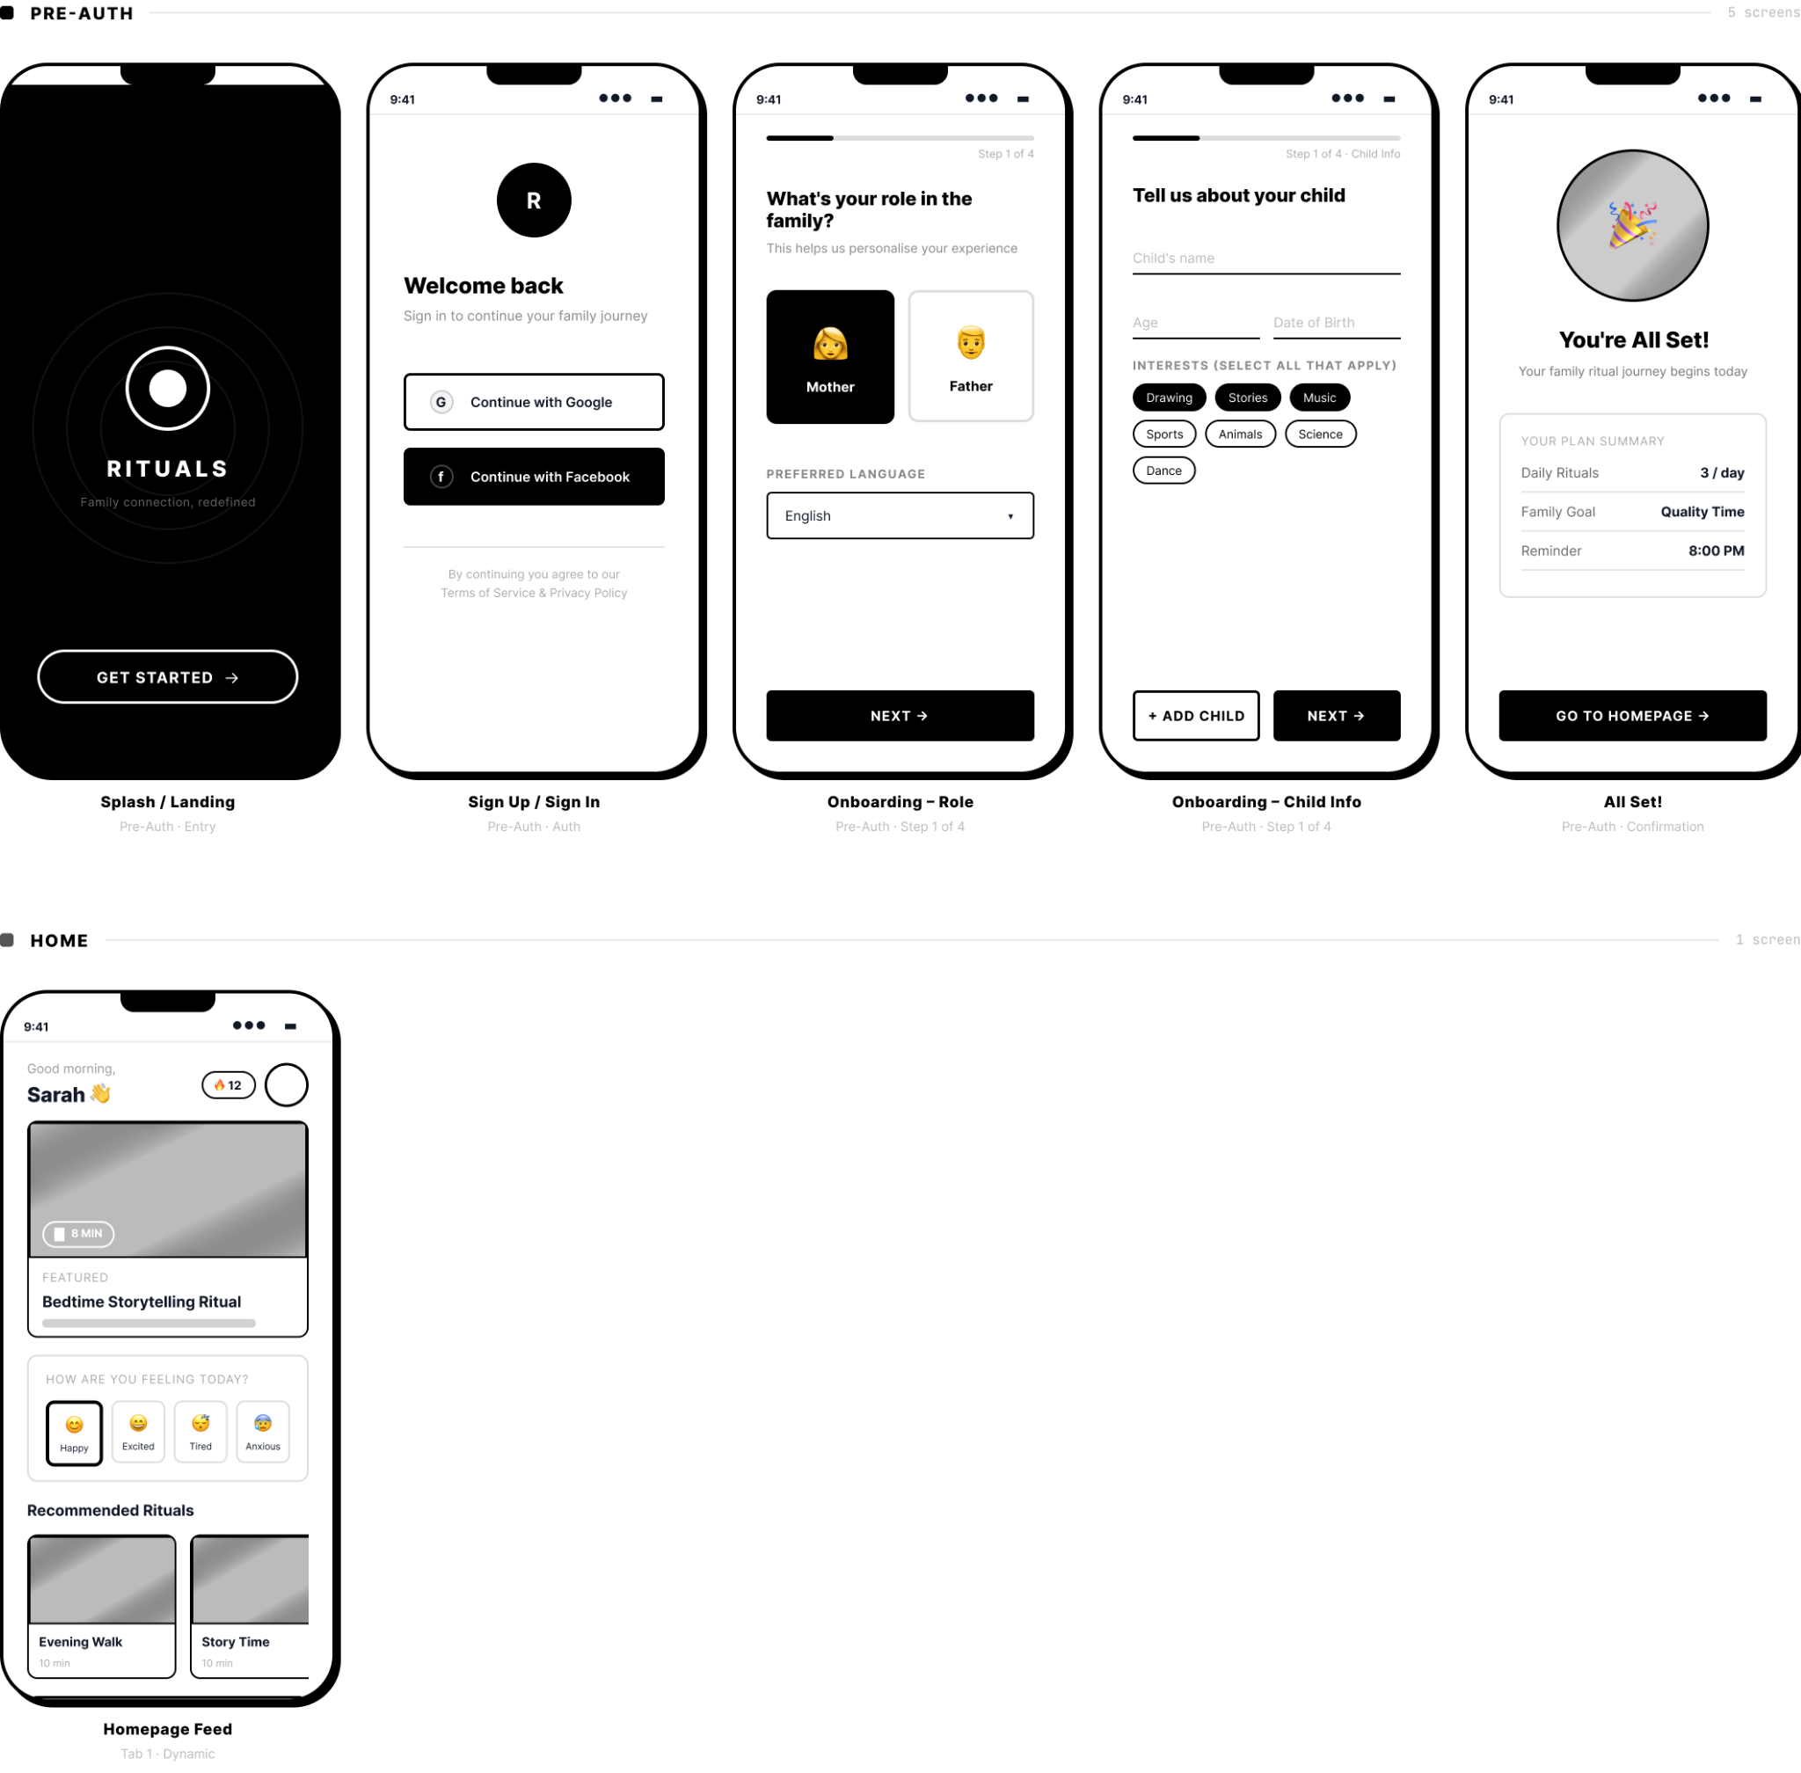

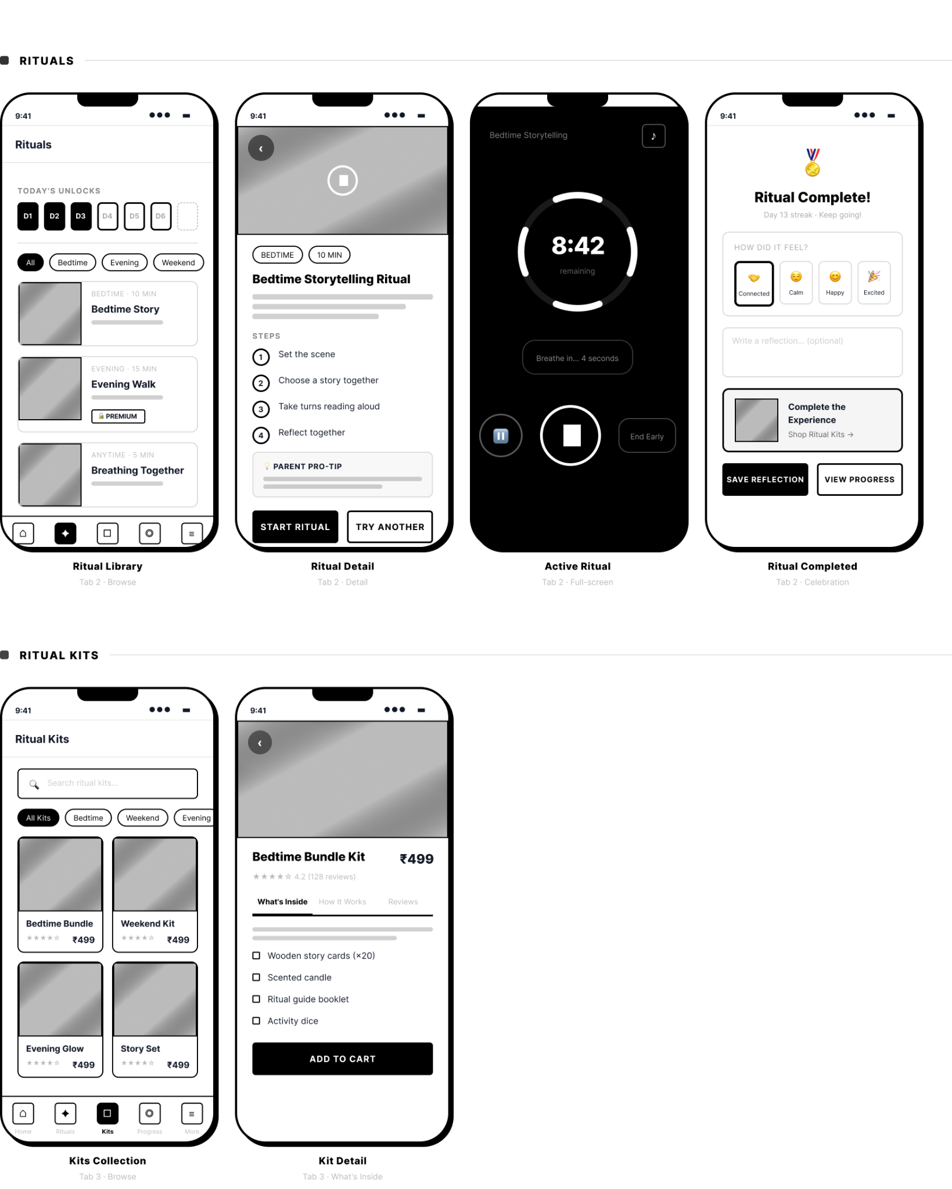

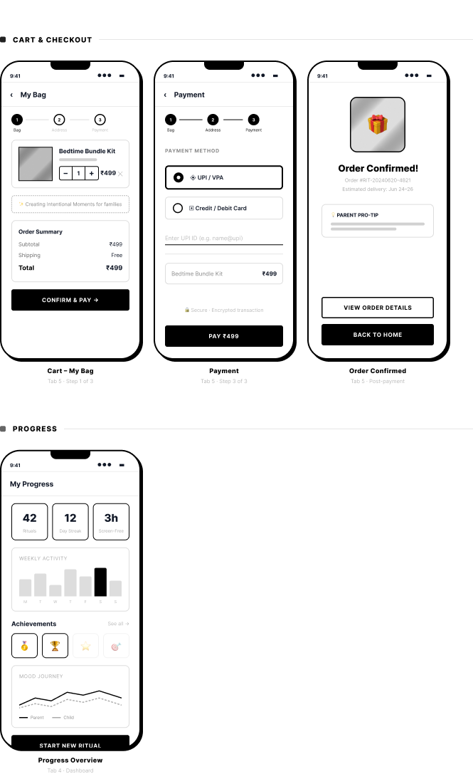

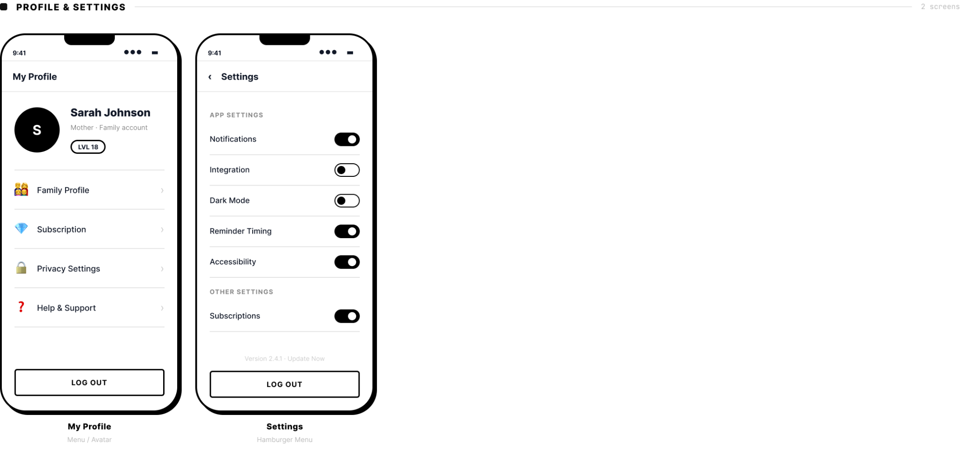

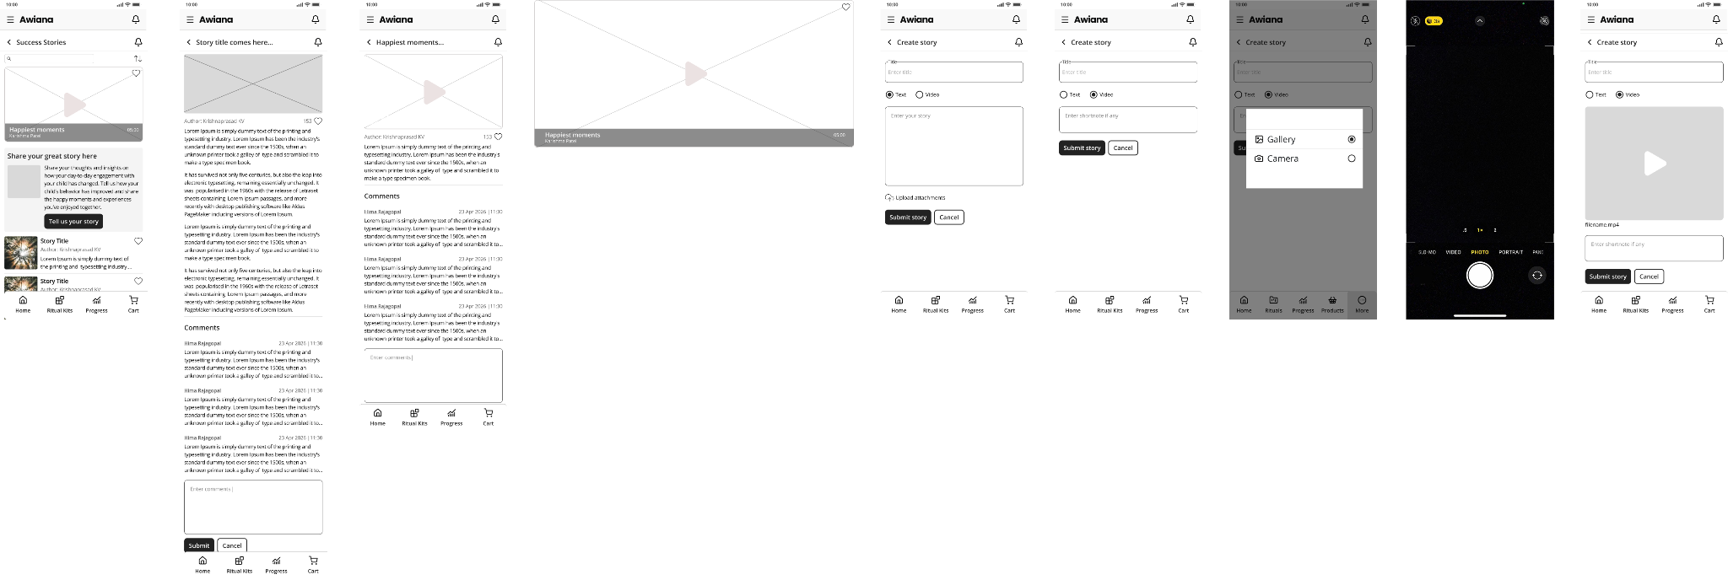

Section 06 — Visual Design

6.1 Design System
The Awiana design system is built for clarity, warmth, and consistency. Every visual decision — from color to spacing — reflects the app's core mission: making family connection feel effortless and intentional.

Color Palette
The color system is defined as global design tokens in Figma. Colors are categorized into brand, text, semantic, and surface roles.

Brand Colors
Token | Hex | Usage
primary | #6C63FF | Primary actions, CTAs, active state indicators
primaryLight | #8A84FF | Hover overlays, soft highlights
primaryHover | #564FCC | Button hover states
primarySelected | #4C45B2 | Selected/pressed states
secondary | #8A84FF | Secondary interactive elements

Text Colors
Token | Hex / Opacity | Usage
textPrimary | #000000 | Primary body text, headings
textPrimary 80 | #000000 at 80% | Slightly muted body text
textPrimary 70 | #000000 at 70% | Secondary labels
textPrimary 60 | #000000 at 60% | Placeholder, hint text
textPrimary 50 | #000000 at 50% | Disabled text
textPrimary 30 | #000000 at 30% | Very subtle metadata
textPrimary 20 | #000000 at 20% | Ghost text
textSecondary | #474545 | Secondary body content, captions

Surface & Semantic Colors
Token | Hex | Usage
background | #FFFFFF | App background
surface | #F8F8FF | Card backgrounds, input fields
border | #EBEBEB | Dividers, input borders
border 2 | #C7C4D8 at 60% | Subtle secondary dividers
success | #0E7A04 | Success states, positive feedback
warning | #C0D10A | Warning indicators
error | #D01515 | Error states, validation feedback
error 50 | #D01515 at 50% | Error background tint
error 20 | #D01515 at 20% | Light error fill
Orange / Amber | #F5BB1C | Streak/achievement highlights

Typography System
Two typefaces are used across the app. Sora is used for all headings, bringing a geometric, modern feel. Inter is used for all body copy, labels, and UI text, ensuring excellent legibility at small sizes.

Style Token | Typeface | Size (px) | Line Height | Weight | Usage
heading1 | Sora | 38 | 140% | Bold | Hero titles, splash screens
heading2 | Sora | 32 | 128% | Bold | Page titles, section headers
heading3 | Sora | 24 | 140% | Bold | Card titles, modal headings
heading4 | Sora | 20 | 140% | SemiBold | Sub-section headings
18_bold | Inter | 18 | 130% | Bold | Emphasized body, list titles
16_semibold | Inter | 16 | 130% | SemiBold | Subheadings, form labels
SubheadingSM | Inter | 14 | 130% | SemiBold | Secondary labels, metadata
body | Inter | 16 | 130% | Regular | Primary body text
body2 | Inter | 14 | 130% | Regular | Standard body copy
body3 | Inter | 12 | 130% | Regular | Helper text, secondary copy
caption | Inter | 10 | 130% | Regular | Timestamps, fine print

Spacing Scale
Spacing follows a 4px base unit system with 10 defined increments. All margins, padding, gaps, and layout measurements use tokens from this scale, ensuring visual rhythm across the entire app.

Token | Value (px) | Typical Usage
spacing/0 | 0 | Reset, no spacing
spacing/1 | 4 | Micro gaps, icon-to-label spacing
spacing/2 | 8 | Compact padding inside small components
spacing/3 | 12 | Chip padding, tag padding
spacing/4 | 16 | Standard card padding, list item spacing
spacing/5 | 20 | Section internal padding
spacing/6 | 24 | Card outer padding, modal padding
spacing/8 | 32 | Large section gaps
spacing/10 | 40 | Page section separation
spacing/12 | 48 | Header height, large layout gaps

Border Radius
Five radius tokens define corner rounding across the UI — from subtle component rounding to fully circular pill shapes.

Token | Value (px) | Used On
radius/sm | 4 | Badges, chips, tags, small UI elements
radius/md | 8 | Input fields, list items, compact cards
radius/lg | 12 | Standard cards, modal sheets
radius/xl | 16 | Large feature cards, image containers
radius/pill | 999 | CTA buttons, toggle switches, avatar rings

Component Library
The component library covers the full range of interactive elements used across the app. All components are built from the design tokens above, ensuring they automatically reflect any system-level changes.

Component | States / Variants | Description & Behaviour
Input Fields | Default, Focused, Filled, Error, Disabled | Text inputs with above-field label, placeholder text, error message below field, and success checkmark. Supports prefix icons, inline action buttons (Copy, Clear), and email-chip tag input with delete affordance. Error state shows red border + error message.
Buttons — Primary | Default, Hover, Pressed, Disabled, Loading | Filled purple (#6C63FF) pill-shaped button. Full-width on mobile. Hover darkens to primaryHover. Loading state shows spinner. Disabled is 50% opacity.
Buttons — Secondary | Default, Hover, Pressed | Outlined pill button with 1.5px purple border and transparent fill. Used for secondary actions alongside primary CTAs.
Buttons — Ghost | Default, Hover | No border, no fill — text-only action. Used for tertiary actions like 'Try Another' or 'Back to Home'.
Toggles | On, Off, Disabled | iOS-style switch. Active state uses primary (#6C63FF). Off state is gray. 44px touch target.
Bottom Navigation Bar | Default, Active | 5-tab persistent bar: Home, Rituals, Ritual Kits, Progress, Cart. Active tab fills icon with primary purple and applies label highlight. Inactive tabs show gray icon + label.
App Bar / Header | Default, Back-enabled | Top bar with Awiana wordmark logo, hamburger menu (left), and notification bell (right). Back-enabled variant replaces hamburger with a left chevron '< Page Title'.
Cards — Ritual | Default, Locked | Rounded card (radius/lg) with cover image, type tag, duration, title, and Start button. Locked state shows padlock overlay and greyed image.
Cards — Kit | Default, Wishlisted | Product card with full-bleed image, star rating chip, title, age range, price. Heart/wishlist icon overlaid top-right. Tapping heart toggles wishlisted state.
Cards — Story | Default | Community content card with thumbnail, author avatar, author name, story title, preview text, and relative timestamp.
Badges — Level | Any level | A small pill overlaid on the avatar bottom-left. 'LVL 18' format. Purple fill, white text.
Badges — Category | Various | Rounded tag pills (Bedtime, Calm, 10 min) shown on ritual cards and detail pages.
Achievement Badges | Locked, Unlocked | Circular icon badges. Unlocked shows full-color icon + label. Locked shows a greyed icon at 40% opacity + label. Grid-arranged on Progress screen.
Stat Tiles | Static | Compact 2-col grid tiles: icon (top) + metric value (middle, large bold) + label (bottom). Used for Connection Streak, Time Together, Screen-free Time.
File Upload Zone | Empty, Filled, Error | Dashed border box. Empty: cloud-upload icon + 'Browse' link + format/size hint. Filled: file name chip with 'x' remove button. Error: red border + message.
Mood Selector | Unselected, Selected | Horizontal row of 4 emoji-style faces: Happy, Excited, Tired, Calm (or Connected/Anxious variants). The selected state shows purple ring + label highlight.
Time Picker (Wheel) | Open, Submitted | iOS drum-roll scroll wheel with 3 columns: Hour, Minute, AM/PM. Selected row highlighted. Rendered as bottom-sheet modal overlay. Cancel and Submit buttons below.
Search Bar | Empty, Active, Filled | Full-width input with search icon prefix. Tapping activates the keyboard. Used on Settings, Ritual Kits, Success Stories screens.
Progress Day Tracker | Completed, Pending, Today | Row of day circles (M T W T F S S) with check marks for completed days and a highlighted ring for today. Used in Weekly Streak view.
Streak Counter | Active, Zero | Flame icon + number of days label. Orange flame for active streak, gray for zero. Used on Homepage and in Profile header area.

6.2 UI Screens
This section documents all key screens across the Awiana app, organized by user flow. Each screen is annotated with its purpose, key UI elements, user interactions, edge cases, and developer/stakeholder notes — providing a complete picture of the designed experience for everyone involved.

Section | Flow | No. of Screens
2.1 | Homepage | 1 main screen
2.2 | Onboarding Flow | 8 steps (Splash → You're All Set)
2.3 | Ritual Experience | 4 screens (Library, Detail, Timer, Completion)
2.4 | Progress & Achievements | 4 screens
2.5 | Ritual Kits Collection | 4 screens (Listing + 3 Detail tabs)
2.6 | Success Stories | 6 screens (Feed, Detail, Create Story flow)
2.7 | Cart & Checkout | 5 screens (Cart, Address, Payment, Payment Details)
2.8 | Post-Payment Flow | 3 screens
2.9 | Profile & Family | 2 screens
2.10 | Settings | 2 screens

Homepage
The homepage is the daily entry point for parents. It is personalized, warm, and action-oriented — surfacing what matters most at a glance while offering soft prompts to start a ritual immediately.

Homepage — Primary Screen [Entry Point]
Greeting Header | Displays a personalized greeting — 'Hello, Sarah' — in headingMD. A streak counter badge sits top-right (flame icon + '0 Days'). The greeting reacts to the user's profile name.  Interaction: Tapping the streak badge navigates to the Weekly Streak sub-screen within Progress.
Featured Video Card | A large hero media card showing a family activity video. Displays current playback progress bar (scrubbing supported), duration remaining ('08:24'), content category tags ('Calm · 10 min'), title, and a one-line description. A play button overlay centres the card.  Interaction: Tapping the card plays inline video. Tags are tappable and filter the recommended section.
Mood Check-In Row | 'How are you feeling?' label with today's date. Four emoji face options: Happy, Excited, Tired, Anxious. Selection is single-choice; the selected mood subtly highlights with a purple ring.  Interaction: Selecting a mood logs the daily parent check-in and adjusts ritual recommendations for the session. Does not require confirmation.
Recommended for You | Horizontally scrollable card row showing curated ritual cards. Each card: full-bleed illustration, type tag (STORY / MOVE / BREATHE), duration, title, and a 'Start Ritual' pill button.  Interaction: Tapping a card opens the Ritual Detail screen. 'See all' link navigates to the full Ritual Library. Cards scroll horizontally, hinting at additional content beyond the viewport.
Personalized for You | An editorial banner section promoting Awiana Ritual Kits based on user profile and activity history. Full-bleed lifestyle photography with overlay text and a subtle gradient for readability.  Interaction: Tapping the banner navigates to the Ritual Kits Collection listing screen.
Bottom Navigation | 5-tab persistent bar. Home tab is active (filled purple icon + highlighted label). Other tabs: Rituals, Ritual Kits, Progress, Cart.  Each tab tap navigates directly to that section's root screen. Active tab visually indicated at all times.
Design Note: The homepage is designed to require zero taps to understand what to do — the Start Ritual button is always visible without scrolling on standard-sized phones.

Onboarding Flow
A 4-step personalization onboarding collects family structure, child interests, family schedule, reminder preferences, and family goals. Each step feeds Awiana's ritual recommendation engine. Users can skip non-essential steps via an 'I'll do this later' text link.

Screen 1 — Splash / Welcome [Auth Entry]
Brand Hero | Full-screen illustrated splash with parent-child scene. App wordmark centered. Headline: 'Build meaningful moments with your child' with a heart emoji accent. Sub-copy explains the core value proposition.  No interaction — auto-transitions or waits for tap on Get Started.
Get Started CTA | Large primary purple pill button, full-width. Tapping this initiates the onboarding flow.  For returning users who are logged out, this screen acts as the re-entry point.
Social Login Options | Two outlined secondary buttons: 'Continue with Google' (Google icon) and 'Continue with Facebook' (Facebook icon). Placed below the primary CTA as alternative fast-track registration options.  Interaction: Each button triggers a respective OAuth flow. On success, the user is dropped into onboarding Step 1 if first time, or directly to Homepage if returning.

Step 1 of 4 — Let's personalise your journey [25% Progress]
Progress Indicator | Thin linear progress bar below the status bar showing completion percentage (25%). Percentage label displayed alongside.  Progress updates as steps are completed. No back-tracking resets progress.
Role Selection | Toggle buttons: 'Mother' / 'Father' for parental role. Single-select.  The selected state fills the button with primary purple.
Language Preference | Dropdown selector for preferred language. Defaults to device locale.  Language selection affects in-app copy and ritual content displayed post-onboarding.
Social Auth Prompt | If not yet authenticated, Google and Facebook login options are shown here within the onboarding context.  Login is optional at this step — users can continue as guests and link accounts later.

Step 1 of 4 — Tell us about your child [25% Progress]
Child Name Input | Text field with label 'Name of your child', placeholder 'Eg: Leo'. Keyboard: default.  Validation: Cannot be empty to proceed (soft warning, not blocking).
Age Dropdown | Numeric dropdown for child's age. Range: 1–17.  Selecting an age adjusts activity/ritual recommendations for the appropriate developmental stage.
Date of Birth Picker | Date picker field (DD/MM/YYYY format). Opens native date picker on tap.  DOB and Age are linked — filling one pre-fills the other with calculated value.
Child Interests Grid | 'What does your child love?' — multi-select chip grid: Storytelling, Drawing, Nature, Music, Sports, Reading, Science, Creativity, Outdoor. Selected chips fill purple.  Multi-select supported. Minimum 1 interest recommended (soft prompt, not blocking).
Add More Child | Ghost CTA button 'Add more child' at the bottom of the form to add a sibling profile.  Adding another child duplicates the form fields and stacks them. Max children: 5.
Navigation | 'Back' (ghost) + 'Next' (primary) buttons. 'I'll do this later' skip link below.  Next is disabled until the Name field has at least 1 character.

Step 2 of 4 — When do you usually spend time together? [50% Progress]
Schedule Options | Illustrated image cards for time-of-day context. Options: Evenings (During dinner or chores), Bedtime (Calm rituals before sleep), Daily (Small daily check-ins), Weekends (Longer family adventures), Weekdays (Focus on quality family time). Toggle-based multi-select.  Each option has a lifestyle illustration. The selected state shows a purple check ring. Multiple can be selected.
Image Reinforcement | A lifestyle photo of parent-child together is shown below the options to emotionally anchor the selection context.  Purely decorative — not interactive.

Step 3 of 4 — Would you like gentle reminders? [75% Progress]
Reminder Toggle Cards | Three toggle rows: Daily (Small daily check-ins), Weekdays (Keep rhythm during work events), Weekends (Focus on quality family time). Each toggle is independently switchable.  Default: Daily is ON, others are OFF.
No Reminders Option | 'No Reminders — I'll manage the rituals myself' toggle at the bottom. Turning this ON disables all other toggles.  Mutual exclusion: No Reminders OFF state re-enables individual toggles.

Step 4 of 4 — What are your family goals? [100% Progress]
Goal Grid | 8-card multi-select grid with icon + label per goal: Reduce Screen Time, Improve Communication, Emotional Bonding, Build Confidence, Creativity, Quality Time, Family Connection, Mindfulness.  Selected cards fill with primary purple background + white text + check overlay. Min 1 selection required to proceed.
Navigation | 'Back' (ghost) + 'Next' (primary) buttons. 'I'll do this later' link below.  Next button activates once at least one goal is selected.

Completion — You're All Set! [Complete]
Confirmation Header | Large headline: 'You're All Set!' with a confetti/celebration illustration. Sub-copy: 'Welcome to the family. You've successfully completed Onboarding.'  Full-screen celebration moment — designed to reward completion.
Personalisation Summary | Summary chip row showing two selected goals (e.g. 'Reduce Screen Time', 'Emotional Bonding') and a rituals-per-day count badge ('3 Daily').  These are dynamically populated from the user's Step 4 selections.
Family Goals Display | A final 4-up grid revisiting the selected goals with icon + label, highlighted in purple.  Read-only — no editing from this screen. User can update via Profile > Family Profile later.
Go to Homepage CTA | Primary purple pill button, full-width: 'Go to Homepage'. Navigates to the Homepage and marks onboarding as complete in the user's profile.  Tapping this finalises onboarding and begins the daily ritual loop.

Ritual Experience
The ritual flow is the core experience of the app — from discovering a ritual to completing it with a reflection. Design emphasises calm focus and minimal distractions during the active ritual.

Ritual Library [Rituals Tab]
Daily Ritual Grid | Day-by-day unlockable cards: DAY 1 (unlocked, active), DAY 2 (locked with padlock). Each card shows a warm illustrated scene with a day label overlay. New ritual unlocks daily.  Locked cards are visually greyed and show a padlock icon. Tapping a locked card shows an 'Unlock from tomorrow' tooltip.
Daily Ritual Details | Each unlocked card shows the ritual title (e.g. 'Morning Gratitude'), duration (e.g. '10 min'), and a subtle 'Unlocked' green badge on the active day.  Cards are horizontally scrollable within the daily row.
Premium Ritual Collections | A section below the daily grid titled 'Premium Ritual Collections'. Shows category tab filters: Bedtime (default active), Evening, Weekend. Below the tabs: a 3-col grid of ritual thumbnail cards, each with a padlock overlay indicating subscription-gated content.  Filter tabs switch the visible collection. Locked rituals cannot be started — tapping shows a subscription upsell sheet.
Unlock CTA | Full-width secondary CTA below the grid: 'Unlock Ritual Collection'. Tapping navigates to subscription/purchase flow.  Copy adapts based on subscription state: 'Unlock' for non-subscribers, 'Explore' for subscribers.
Explore All Link | 'Explore all rituals in this collection · 30 Card Kit' — tapping opens the Kit Detail for that collection.  Links the Rituals tab to the Ritual Kits commerce experience.

Ritual Detail [Pre-Start Screen]
Video Preview Hero | Full-width 16:9 video thumbnail with a play button overlay. Duration overlay bottom-left (e.g. '2:45 / 5:00'). Audio/volume control bottom-right.  Tapping the hero plays a preview video. Full ritual video plays during the active timer screen.
Ritual Metadata | Category tag pill (e.g. 'Bedtime') + duration tag pill (e.g. '10 min') displayed below the hero as inline chips.  Tags link to filtered views in the library on tap.
Ritual Title & Description | Large headingMD title (e.g. 'Bedtime Storytelling'). 3–4 line description of the ritual's purpose and emotional benefit.  Read-only. Truncated at 3 lines with 'Read more' expand link if longer.
Instruction Steps | Numbered step list (1–4): Create the Atmosphere, Choose Your Vessel, Emotional Check-in, Shared Reading. Each step has a 1–2 line description.  Steps use ordered list styling with large numbered circles in primary purple.
Parent Pro-Tip | A soft-pink callout card at the bottom of the steps: 'Parent Pro-Tip — [tip text]'. Warm pink fill (#FFF0F4), small lightbulb icon in amber.  Non-interactive. Adds warmth and reassurance before the user starts the ritual.
Primary CTA — Start Ritual | Full-width primary purple pill button pinned above the nav bar.  Tapping navigates to the Active Ritual (timer) screen and starts the countdown.
Secondary CTA — Try Another | Ghost text button below the primary CTA.  Tapping returns the user to the Ritual Library to select a different ritual.

Active Ritual — Timer Screen [Distraction-Free Mode]
Ambient Music Toggle | A small toggle in the top-right area: 'Ambient Music' with speaker icon. Toggles calming background audio on/off.  Default: OFF. State persists for the session.
Circular Countdown Timer | Large centred circle with the remaining time inside (e.g. '09:58'). Circle border animates as a progress ring, shrinking as time elapses. 'Remaining' label beneath the time.  The timer is visually the entire focus of the screen — minimal chrome around it.
Breathing Cue | A floating guidance card: 'Focus on your breathing — Take deep breaths together. Inhale for 4 seconds, hold for 4, exhale for 4.' Small yoga/breathing icon.  Appears 30 seconds after the ritual starts. Can be dismissed by tapping.
Pause / End Controls | 'Pause Ritual' primary outlined button. 'End Ritual Early' secondary ghost button below.  Pause suspends the timer; tapping again resumes. End Ritual Early triggers a confirmation dialog before navigating to the Completion screen.
Navigation | Minimal bottom navigation visible but with no active labels — intentionally reduced to avoid distraction.  No back navigation during an active ritual — only Pause or End.

Ritual Completed — Celebration Screen [Post-Ritual]
Completion Header | Sparkle icon + 'Ritual Completed!' headline in headingMD, purple. Sub-copy: 'Take a moment to soak in the connection you just built.'  Designed as a moment of pause and emotional recognition — not immediately transitioning.
Streak Badge | Green success card: '1 Day Streak! — You're on fire! Come back tomorrow for your next ritual.'  Streak count is dynamic. Color changes: green = active, amber = 7+ days.
Mood Check | 'How do you feel?' with 4 mood icon options: Connected, Calm, Happy, Excited.  Single-select. Selection is logged to the Mood Journey in Progress.
Reflection Text Field | 'Any thoughts on today's ritual?' — free-text multi-line input. Placeholder: 'Share a memory or what went well...'  Optional field. Character limit: 500. Soft keyboard auto-opens only when tapped.
Ritual Kits Upsell Banner | An editorial card at the bottom: 'Awiana Ritual Kits — Thoughtfully designed kits to build stronger bonds and mindful moments.' With a lifestyle photo.  Tapping navigates to the Ritual Kits Listing screen.
Save Reflection CTA | Primary purple pill button: 'Save Reflection'. Saves the mood selection + text to the Progress section.  Button is always active — saving an empty reflection is valid.
View Progress CTA | Ghost button below: 'View Progress'. Navigates to the Progress Dashboard.  Secondary path for users who want to see their stats immediately post-ritual.
Design Note: The Completion screen intentionally delays the 'next step' to let the emotional moment land. Do not auto-navigate from this screen.

Progress & Achievements
The Progress section gives families a meaningful view of their bonding journey — not just metrics, but emotional context and milestone recognition.

Progress Dashboard [Progress Tab Root]
Journey Summary Card | Headline: 'Your Ritual Journey — Little steps, big memories. You're doing wonderful!' Two stat tiles below: 'Total Rituals Completed: 7' and 'Current Streak: 4 days' (flame icon).  Streak flame icon is amber when active. Gray when streak is 0.
View Weekly Progress Link | Purple text link: 'View Weekly Progress →'. Navigates to the Weekly Streak sub-screen.  Inline link, no button styling — keeps the dashboard scannable.
Screen Free Time Card | Metric card: 'Total Screen-free Time — 8h 30m this month — ↓ 18% reduced screen usage'. Mint/green tinted background card.  Arrow indicator: downward green arrow = improvement (less screen time). Upward red = regression.
Mood Trends Preview | 'Mood Trends — See More' section header. Two columns: Parent Mood (Steady, neutral line graph) + Child Mood (Rising, upward line graph). Each with a smiley face indicator.  Tapping 'See More' navigates to the full Mood Journey screen.
Achievements Preview | 'Achievements — See More' header. Row of 3 circular badge icons: First Ember (unlocked), Family Talker (unlocked), Bedtime Hero (locked/greyed).  Tapping 'See More' navigates to the full Achievements grid. Tapping an unlocked badge shows a detail tooltip.
Start New Ritual CTA | Full-width primary purple pill button: 'Start New Ritual' pinned at the bottom.  Navigates to the Ritual Library.

Weekly Streak View [Sub-Screen]
Activity Filter | 'Activity — This Week' with a dropdown to switch between weeks.  Dropdown allows browsing historical weeks. Default: current week.
Bar Chart | 7-bar chart (M T W T F S S) showing daily ritual duration in minutes. Today's bar highlighted in solid purple, past days in lighter purple, future days shown as empty outlines.  Bars are visual only — not interactive/zoomable.
Today's Duration | Large text below the chart: '1h, 30 mins — Today'. Updates in real time.  Shows aggregate of all rituals done today.
Day Completion Row | Row of day circles with checkmarks (✓) for completed days. Today shown with a purple ring.  Visual at-a-glance habit tracker.
Time Together Card | Highlighted green card: 'Time Together — 4h 30m this week' with a progress bar.  Progress bar fills towards a weekly goal (default: 5h).
Weekly Rituals Checklist | Titled list of rituals for the week with completion state: 'Evening Connection — Completed (checkmark)', 'Deep Breath Together — Completed', 'Bedtime Reflection — Begin Ritual (CTA link)'.  Pending rituals show a 'Begin Ritual' action link in primary purple.
Next Ritual Preview | 'Next Ritual: Bedtime Reflection — 10 min' with a 'Start Ritual' CTA.  Quick-start card at the bottom of the weekly view.

Achievements — Badge Grid [Sub-Screen]
Page Header | 'Your Badges — Celebrate your family's growth and intentional moments by earning title badges.'  Motivational framing — focuses on family growth, not gamification.
Badge Grid | 4-col grid of circular achievement badges. Unlocked: full-colour icon + title + 'Unlocked [date]' sub-label. Locked: 40% opacity greyed icon + 'Unlock Badge' sub-label.  Tapping an unlocked badge shows a celebration modal with badge description and earned date.
Unlock Prompt Card | Card at bottom: lightbulb icon + 'Unlock New Badges — [motivational quote]'. Full-width.  Non-interactive. Contextual encouragement.
Start New Ritual CTA | Full-width primary purple pill button: 'Start New Ritual'.  Same as Progress Dashboard — maintains consistent bottom CTA across the Progress section.

Mood Journey [Sub-Screen]
Parent Mood Trend | 'Parent Mood Trend — Last 7 Days' label + purple line chart over M W F S axis.  Line chart is read-only. Shows mood logged at daily check-ins.
Child Mood Trend | 'Child Mood Trend — Last 7 Days' label + amber/gold line chart.  Separate chart for child's mood logged by parent on the child's behalf post-ritual.
Emotional Insights Panel | Two insight cards with icons: 'Your child felt happiest during story rituals.' / 'Reflect rituals improved calm moods by 40% this week.'  AI-generated insights. Non-editable. Refreshes weekly.
Weekly Reflection | 'How connected did your family feel this week?' with 4 mood options: Happy, Excited, Tired, Calm.  Single-select. Logged weekly.
Free Text Prompt | Multiline text area: 'Any specific moments that stood out?...'  Optional. 500 character limit.
Start New Ritual CTA | Full-width primary purple pill button at the bottom.  Consistent CTA across all Progress sub-screens.

Ritual Kits Collection
Ritual Kits are physical product bundles sold in-app. The shopping experience is designed to feel curated and trust-building, not transactional. The design maintains the app's warm tone throughout.

Ritual Kits — Listing Screen [Ritual Kits Tab]
Search Bar | Full-width search input at the top. Searching filters the visible kit cards in real time.  Searches by kit name, age range, or category tag.
Filter Tabs | Horizontal scrollable tab row: All Kits (default), Bedtime, Weekend, Evening, and potentially more. The active tab has a filled purple pill style.  Tapping a tab filters the grid to kits in that category.
Kit Cards | Vertical list of product cards, 1 per row. Each card: full-bleed lifestyle photography, star rating chip (e.g. '4.9 ★') top-left, wishlist heart icon top-right, kit name, one-line tagline, age range, and price in primary purple.  Tapping the card navigates to Kit Detail. Tapping the heart icon adds/removes from the wishlist without navigating away.
Kit Price Display | Price shown in primary purple, large and prominent below the kit name.  INR (₹) denomination. 'Free' shown for bundled/subscription kits.

Kit Detail — What's Inside Tab [Tab 1 of 3]
Product Hero Photography | Full-width product photography showing the physical kit contents laid out flat.  Image is zoomable on pinch gesture.
Kit Title & Rating | Large kit name (e.g. 'Bedtime Calm Kit'), star rating badge (e.g. '★ 4.9 (128)'), price in large purple.  Rating shows total review count in parentheses.
Kit Description | 2–3 line product description: 'This curated ritual kit provides everything you need...'  Truncated to 3 lines; 'Read more' expand affordance.
Tab Navigation | Three underlined tabs: What's inside (active), How it works?, Read Reviews. Switching tabs updates content below without a full page reload.  Active tab shows a thick purple underline.
Contents List | Icon + item name + one-line description per item. E.g.: '52 Story Cards — Guided prompts to spark meaningful conversations and hidden memories.' / 'Bedtime Journal — Archival book to record your family's unique journey.'  Each item has a small category icon. List scrolls if more than 4 items.
Add to Cart CTA | Sticky full-width primary purple pill button at the bottom: 'Add to Cart'. Persists while scrolling.  On tap, adds 1 unit to cart and shows a brief 'Added!' toast notification. Does not navigate away.

Kit Detail — How It Works Tab [Tab 2 of 3]
Benefits List | 3–4 items with a heart icon and bold benefit title: 'Emotional Bonding — Fosters a deep sense of belonging and security through shared stories and conversations.'  Each benefit has a 1–2 line description. Purple heart icon used for all items.
Add to Cart CTA | Persistent sticky bottom button — same as Tab 1.  Consistent CTA position across all tabs removes user confusion about where to purchase.

Kit Detail — Read Reviews Tab [Tab 3 of 3]
Review Cards | Each review: user avatar (circular photo), name, 5-star rating (filled amber stars), review text. E.g.: Sara J. — ★★★★★ — '[review text]'  Reviews are user-generated. Scrollable list. Currently shows 2 visible before scroll.
Review Text | 2–3 line review text. No truncation.  Review text is read-only. No inline reply from this screen.
Add to Cart CTA | Persistent sticky bottom button — same as Tabs 1 and 2.  All three tabs maintain the same CTA so the path to purchase is always visible.

Success Stories
The Success Stories section is a community-driven feed where parents share their family experiences. It combines content discovery with user-generated storytelling, building social proof and emotional connection.

Stories Feed [Stories Root Screen]
Search & Sort Bar | Full-width search bar at the top. A sort/filter icon on the right allows sorting by Recent, Popular, or Most Comments.  Search filters stories by title or author name in real time.
Share Your Story CTA Card | A prominent card at the top of the feed with headline 'Share your story here', sub-copy encouraging sharing, and a 'Tell us your story' primary button.  This card is pinned to the top of the feed for all users. Tapping the button navigates to Create Story flow.
Story Feed Cards | Each story card: cover image, title, author avatar + name, author role label (e.g. 'Karishma Patel'), read time, and a 2–3 line preview of the story body.  Cards are ordered chronologically by default. Tapping a card navigates to Story Detail.

Story Detail View [Story Reading Screen]
Story Header | Author name (large), author avatar, author handle/role, timestamp (e.g. '23 Apr 2026 11:30'), read time badge.  Author name links to author's public profile (future feature).
Story Cover Image | Full-width editorial image related to the story content.  Zoomable on pinch. Alt text pulled from story metadata for accessibility.
Story Body | Long-form rich text content. Paragraph spacing (spacing/4). No inline embeds.  Full story text — no truncation on detail view.
Comments Section | Below the story: timestamped user comments with avatar, name, timestamp, and comment text. Multiple comments stacked vertically.  Comments are read-only on this screen — no inline reply in the current version.
Read Time | Displayed as a badge alongside the timestamp: '15↑' (indicating read time or engagement metric).  Read time calculated dynamically from word count.

Create Story — Writing Mode [Story Creation]
Mode Tabs | Two tabs at the top of the creation form: 'Writing' (active, underlined) and 'Video'. Tab switch changes the input method below.  Default mode is Writing. Switching to Video shows a file upload zone or camera trigger instead of text area.
Story Title Input | Text input field: 'Story Title' label + placeholder 'Enter story title here'. Required.  Validation: must be filled before submission.
Rich Text Area | Large multi-line text area: 'Enter story' placeholder. No rich text toolbar in current version — plain text only.  Character limit: 5000. Counter shown at bottom-right of the field.
File Upload (Video Mode) | Dashed-border upload zone: cloud icon + 'Upload your files here — Browse — jpeg, png, png format supports, Max 2MB/Image'. When a file is attached, shows filename chip with 'x' remove button and a 'kbs' file size label.  Drag-and-drop supported on tablet. On mobile, tapping opens file picker.
Camera/Gallery Picker (Video Mode) | Two radio-style option rows: Camera and Gallery, each with a circular select button.  Tapping Camera opens the device camera in photo/video mode. Gallery opens the media library.
Cancel & Submit Buttons | Two buttons at the bottom: 'Cancel' (outlined secondary) + 'Submit' (primary purple pill).  Cancel returns to Stories Feed without saving. Submit validates required fields then posts the story.
Post-Submit Confirmation Dialog | After submit: a modal overlay appears — 'Thank you for sharing your story. Are you interested in sharing more stories?' with 'No' (outlined) and 'Yes' (primary) options.  Yes returns to Create Story. No closes the dialog and returns to the Feed.

Create Story — Video Capture Mode [Camera Screen]
Camera Viewfinder | Full-screen dark camera viewfinder with a circular capture button at the bottom center.  Standard device camera UX.
Mode Selector | Bottom tab strip: 0.4x, VIDEO, PHOTO (active), PORTRAIT, PAW. These are camera modes.  Swiping switches modes. Active mode highlighted.
Capture Controls | Large circular shutter button in the center-bottom. Flip camera icon on the right.  Captured media is previewed immediately above the capture button before being added to the story.
Header Controls | Back arrow (top-left), toggle (top-right, yellow when active) for ambient mode/flash.  Back returns to Writing/Video mode tab.

Cart & Checkout
The checkout flow is a 3-step process: Bag → Address → Payment. A persistent step indicator at the top tracks progress. The design balances functional e-commerce requirements with Awiana's warm, trust-building tone.

Step 1 — Cart (Bag) [Cart Tab]
Step Indicator | 3-step progress tracker at the top: '1 Bag' (active, purple underline) → '2 Address' → '3 Payment'. Steps 2 and 3 are greyed until reached.  Completed steps show a purple filled circle with a checkmark. Active step is underlined. Future steps are grey.
Section Sub-Copy | 'Review your mindful essentials before they ship.' — small body copy below the step indicator.  Emotionally frames the cart review step as intentional, not transactional.
Cart Item Row | Each item shows: product thumbnail image, product name ('Bedtime Calm Kit'), edition/variant ('Bedtime Bonding Edition'), quantity adjuster (– 1 +), price in primary purple ('₹499'), and a trash/delete icon.  Tapping + or – adjusts quantity and recalculates totals. Tapping the trash icon removes the item after a brief undo snackbar (2-second timeout).
Emotional Nudge Card | A soft pink card below the item: 'Creating intentional moments — Each kit is designed to reduce stress and foster deep family bonds. Shipping is carbon neutral.'  Non-interactive. Reinforces brand values. Pink (warmPink) fill, no border.
Order Summary | Below the item list: Subtotal (₹499.00), Shipping (Free), Estimated Tax (₹499.00), Total (₹499, bold, primary purple).  Tax and shipping values update dynamically based on address (entered in Step 2).
Total Price Footer | 'Total Price — ₹499.00' in a sticky footer area above the CTA.  Sticky footer ensures price visibility while scrolling.
Confirm & Pay CTA | Full-width primary purple pill button: 'Confirm & Pay'.  Navigates to Step 2 (Address) — does not trigger payment at this point.
Bottom Navigation | Cart tab highlighted active.  Cart icon shows a badge with item count.

Step 2 — Address [Checkout Step 2]
Step Indicator | Step 1 shows completed checkmark, Step 2 'Address' is active with purple underline, Step 3 greyed.  Tapping Step 1 navigates back to Cart (with a confirm prompt if changes were made).
Saved Addresses | 'Saved address' section. Existing saved addresses shown as selectable cards. Selected address has a purple filled checkmark badge. E.g.: 'Farheen Reshi, 123 Serenity Way, Maplewood, New Jersey 07040, United States'.  Selecting a saved address auto-populates the form fields below. Only one address can be selected.
Add New Address Form | Fieldset below saved addresses: Full Name, Street Address, City, State (dropdown), Zip Code, Phone Number. All fields have placeholder text.  Required fields: Full Name, Street Address, City, State, Zip Code, Phone Number. Phone is required for delivery updates per the field helper text.
State Dropdown | Dropdown selector for US state codes (e.g. 'CA'). Searchable.  Adapts to country if non-US address is being entered.
Total Price Footer | Sticky footer: 'Total Price — ₹499.00'.  Persists across all checkout steps.
Save & Continue CTA | Full-width primary purple pill button: 'Save & Continue'. Validates form fields then advances to Step 3.  Button shows a brief loading state while validating address format.

Step 3 — Payment Method Selection [Checkout Step 3]
Step Indicator | Steps 1 and 2 show checkmarks, Step 3 'Payment' is active.  All prior steps accessible via tap if user wants to revise.
Payment Method Selector | Two radio-card options: 'UPI Payment' (with UPI icon, selected — filled radio button) and 'Card Payment' (with card icon, unselected).  Selecting UPI opens the UPI input sheet. Selecting Card opens the Card details sheet.
Order Summary | Subtotal (₹499.00), Shipping (Free), Estimated Tax (₹00.00), Total (₹499.00, bold purple).  Tax recalculated after address is confirmed in Step 2.
Secure Transaction Notice | A shield icon + 'Secure Transaction — Your payment information is encrypted and never stored on our servers. Awiana prioritises your family's digital safety and privacy.'  Builds trust at the most critical point in the checkout flow.
Terms Link | 'By clicking continue, you agree to Awiana's Terms of Service.' with a purple hyperlink.  Terms link opens an in-app webview.
Pay CTA | Full-width primary purple pill button: 'Pay ₹499'.  Tapping opens the Payment Details bottom sheet for the selected payment method.

Payment Details — UPI Sheet [Bottom Sheet Modal]
Sheet Header | 'Payment Details' title + X close button (top-right).  X closes the sheet and returns to Step 3 without losing the order state.
Tab Toggle | 'Card' tab + 'UPI' tab (active, filled purple pill). Tab switches between payment entry modes.  Switching tabs preserves any already-entered data in the other tab.
UPI ID / VPA Input | Text input: 'UPI ID / VPA' label + 'e.g. user@upi' placeholder.  Inline validation: checks for '@' format. Invalid UPI IDs show an error message.
Verify Button | Outlined secondary button: 'Verify' — placed inline at the right of the UPI input field.  Tapping triggers UPI handle verification via payment gateway. Shows loading spinner, then success/error state.
Encryption Notice | 'Your transaction is secured by end-to-end encryption.'  Small body text below the input. Reassurance copy.
Trust Badges | Three small icons in a row: Secure, Encrypted, Trusted.  Static decorative trust indicators.
Pay CTA | Full-width primary purple pill button in the sheet footer: 'Pay ₹499'.  Active only after UPI handle is verified. Disabled state before verification.

Payment Details — Card Sheet [Bottom Sheet Modal (Card Tab)]
Tab Toggle | 'Card' tab (active, filled) + 'UPI' tab.  Matches the UPI sheet layout with tabs.
Cardholder Name Input | Text field: 'Cardholder Name' + placeholder 'John Doe'.  Required. Plain text input.
Card Number Input | Text field with card icon prefix: '0000 0000 0000 0000' placeholder. Auto-formats as user types (adds spaces after every 4 digits).  Detects card brand (Visa/Mastercard/Rupay) from first digits and shows brand logo inline.
Expiry Date Input | Text field: 'MM/YY' placeholder.  Auto-formats with '/' separator. Validates that date is not in the past.
CVV Input | Text field: '***' placeholder. Masked input.  3 digits for Visa/Mastercard, 4 for Amex. Tooltip icon explains what CVV is.
Trust Badges | Same Secure, Encrypted, Trusted icons as UPI sheet.  Consistent trust pattern across both payment modes.
Pay CTA | Full-width primary purple pill button: 'Pay ₹499'.  Active only after all fields are valid. Real-time validation as user fills each field.

Post-Payment Flow
The post-payment experience is designed to sustain emotional momentum — the purchase is framed as a meaningful step toward family connection, not merely a commercial transaction.

Payment Processing Screen [Transition Screen]
Processing Animation | Centered Awiana logo mark (the ∞-style family connection icon) with a subtle pulsing animation. Three dot page indicator at the bottom.  Animation runs for 2–3 seconds while the payment gateway processes.
Headline | 'Securing your ritual essentials...' — large headingMD, centered.  Warm, purposeful framing for a loading state.
Sub-copy | 'We're preparing your family's next intentional moment. This will only take a few seconds.'  Reduces anxiety during payment processing.
Trust Badge | Small row at the bottom: lock icon + 'Encrypted Secure Payment' label.  Persistent across the transition — reassures the user their transaction is safe.
Background | Clean white background. No progress bar — intentionally minimal.  Navigation is disabled during processing to prevent accidental back-navigation.

Order Confirmation Screen [Post-Payment Success]
Illustration | An illustrated 3D gift box with ribbon in purple tones, centered at the top. Floating sparkle particles around the box.  Celebratory visual — marks the moment emotionally.
Headline | 'Your Ritual Kit is on its Way!' — headingMD, primary purple, centered.  Emotionally affirming purchase confirmation.
Sub-copy | 'We've received your order and are preparing your kit with care.'  Warm, personal tone.
Order Summary Card | Order Number: #AW-8293, Estimated Arrival: Jun 20 – Jun 26 with a calendar icon.  Card uses surface fill (#F8F8FF). Bordered with light gray.
Parent Pro-Tip | Light bulb icon + purple 'Parent Pro-Tip' label + tip text: 'Take a deep breath and smile. You've just taken a beautiful step toward a deeper connection.'  Unique to Awiana — turns order confirmation into a moment of parenting encouragement.
View Order Details CTA | Full-width primary purple pill button: 'View Order Details'.  Navigates to the Order Details screen.
Back to Home CTA | Full-width secondary outlined pill button: 'Back to Home'.  Navigates to the Homepage. Resets navigation stack.

Order Details Screen [Order Tracking]
Header | Standard Awiana app bar. Page title: 'Order Details'.  No back navigation shown — user arrived from confirmation screen.
Order Status — Estimated Arrival | 'Order Status' label in primary purple. 'Estimated Arrival: Jun 20 – Jun 26' in large headingMD.  Date range sourced from shipping partner API.
Order Progress Tracker | Vertical step tracker with 4 stages: Ordered (completed, checkmark, Jun 20 2026), Processing (active, amber — 'Your kit is being prepared with care'), Shipped (upcoming, greyed), Delivered (upcoming, greyed).  Completed steps: filled purple circle + checkmark. Active: amber circle + status copy. Pending: grey circle. Vertical connector lines between steps.
Items Ordered | 'Items Ordered — 1 Item' header with item count badge. Item row: product thumbnail, name ('Bedtime Calm Kit'), variant ('Bedtime Bonding Edition'), quantity adjuster (– 1 +), price (₹499), trash icon.  Quantity is adjustable even from Order Details if order is still in Processing state.
Order Summary | Order Number: #AW-8293. Date Placed: Jun 12, 2026. Total: ₹499 (bold).  Separator lines between each summary row.
Shipping Address | Location pin icon + 'Shipping Address' label. Full address block: Name, Street, City, State, Zip, Country.  Read-only on this screen. Address change would require contacting support.
Payment Method | Card icon + 'Payment Method' label. 'UPI' badge + UPI ID shown.  Masked UPI ID for privacy.
Discover More Kits CTA | Full-width secondary outlined pill button at the bottom: 'Discover More Kits'.  Navigates to the Ritual Kits Listing screen — upsell opportunity post-purchase.
Bottom Navigation | Cart tab active.  Cart icon badge clears once order is confirmed.

Profile & Family
The Profile section serves two purposes: family management (viewing and editing all member profiles) and individual account management (subscription, privacy, support, logout).

Family Profile Screen [Profile > Family Profile]
Family Members Row | Horizontal row of circular avatar thumbnails. Each member: profile photo with a purple ring border, level badge overlay (e.g. 'LVL 18') bottom-left, name below, and role label (Mother, Kid).  Tapping a member avatar navigates to that individual's profile detail. Long-press shows edit options.
Rituals Completed Stat | Large stat section: 'RITUALS COMPLETED' label in primary purple (uppercase), count '142' in large headingLG, sparkle icon button on the right.  Tapping the sparkle icon opens an achievement celebration animation.
Stats Grid | 2-column grid of stat tiles: Connection Streak (lightning bolt icon, '12 Days') + Explored (compass icon, '24 Activities').  Stats update in real time from ritual completion data.
Settings Section | A list of navigational setting rows: Subscription, Privacy Settings, Help & Support. Each row: icon in a soft purple background circle, label text, right-facing chevron.  Tapping each row navigates to the corresponding settings sub-screen.
Bottom Navigation | Home tab active (user accessed this via hamburger menu or profile entry point).  Profile is not a direct bottom-nav destination — accessed via the hamburger menu.

Individual Profile Screen [Hamburger Menu > Profile]
Profile Header | 'Hello, [Name]' greeting in headingLG. Centered avatar with purple level ring, name in headingMD, role label below.  Level ring thickness and color adapt to level tier (future enhancement).
Settings List | Titled 'SETTINGS' section. Navigation rows: Family Profile, Subscription, Privacy Settings, Help & Support. Same icon + label + chevron pattern as Family Profile.  Family Profile links back to the shared family view. Other rows open sub-screens.
Logout | At the bottom, separated by white space: logout icon + 'Logout' label in error red (#D01515).  Tapping triggers a confirmation dialog ('Are you sure you want to logout?') before logging out. Destructive action placement at the bottom prevents accidental taps.
Bottom Navigation | Standard 5-tab bar.  All tabs remain accessible from this screen.

Settings
The Settings screen provides control over app behaviour, notifications, and account management. It is accessible via the notification bell area or the hamburger menu.

Settings Main Screen [Settings Root]
App Bar | Standard Awiana header with logo and notification bell. Page title: 'Settings' in headingLG below the bar.  No back navigation — Settings is a top-level destination.
Search Bar | Full-width search input: 'Search' placeholder. Filters the settings list in real time.  Search matches setting labels. 'Reminder' would highlight the Reminder Timing row.
App Settings Group | 'App Settings' section label. Toggle rows:  Section label in bodySM, uppercase, gray.
Notification Toggle | Bell icon + 'Notification' label + toggle switch. Default: ON (primary purple).  Controls push notification permissions for the app. Turning OFF shows system permission prompt on iOS.
Integration Toggle | Integration icon + 'Integration' label + toggle. Default: OFF.  Toggles third-party calendar or health app integrations. Turning ON prompts integration setup flow.
Dark Mode Toggle | Moon icon + 'Dark Mode' label + toggle. Default: OFF.  Toggles app-wide dark color scheme. Immediately applies on toggle.
Reminder Timing Toggle | Clock icon + 'Reminder Timing' label + toggle. Default: ON.  Enabling opens the Time Picker wheel to set the daily reminder time. Disabling suppresses reminders.
Accessibility Toggle | Accessibility icon + 'Accessibility' label + toggle. Default: ON.  Toggles larger text sizes and increased contrast mode.
Other Settings Group | 'Other Settings' section label. One toggle row:
Subscriptions Toggle | Subscription icon + 'Subscriptions' label + toggle. Default: ON.  Manages active subscription status. Toggling OFF suspends auto-renewal (does not cancel immediately).
Version & Update | Version number: 'Version-01.02.48 — New version available.' Update link: 'Update now' in primary purple text link.  Tapping 'Update now' deeplinks to the App Store/Play Store listing.
Logout | Logout icon + 'Logout' label in error red (#D01515).  Tapping triggers a confirmation dialog before logging out.
Bottom Navigation | Standard 5-tab bar.  Active tab is not highlighted on Settings (accessed via menu).

Reminder Timing — Time Picker Overlay [Bottom Sheet Modal]
Overlay Background | Semi-transparent dark overlay dims the Settings screen behind the picker.  Tapping the overlay background dismisses the picker without saving.
Wheel Picker | iOS-style drum-roll scroll wheel with 3 independent columns: Hours (6–12), Minutes (38–44), AM/PM. Center row (selected time: e.g. '9 : 41 PM') is in black/bold text; adjacent rows fade out.  Each column scrolls independently with momentum/snap behaviour. Selected value always centers in the visible row.
Cancel Button | Left button: 'Cancel' in outlined pill style. Dismisses the picker without saving.  Cancel returns the user to Settings with no change to the reminder time.
Submit Button | Right button: 'Submit' in primary purple pill. Saves the selected time and closes the sheet.  On submit, a brief toast confirms: 'Reminder set for [time]'.

6.2 Design Decisions
This section documents the key design choices made during the Awiana project — what was decided, why, what alternatives were considered, and the expected outcome. These decisions reflect both user needs and product strategy.

Decision 01 Sora for headings, Inter for body
Decision
Use Sora (geometric) for all heading styles and Inter (humanist) for all body copy, labels, and UI text.
Rationale
Awiana sits at the intersection of warmth and modern simplicity. Sora's clean geometric shapes communicate structure and modernity — fitting for the app name and brand identity. Inter's humanist design at small sizes ensures maximum legibility in list items, captions, and form fields — critical in a mobile app used by tired parents at the end of the day. The pairing creates visual hierarchy without requiring heavy weights.
Alternative Considered
Using a single typeface (e.g. Nunito or Poppins) throughout for simplicity.
Outcome: The dual-font system adds character to headings while keeping body content effortlessly readable.

Decision 02 Purple-first (#6C63FF) brand identity
Decision
Establish a single dominant brand color — a vibrant but calm medium purple — rather than a multi-color palette.
Rationale
Purple sits in the psychological territory between calm (blue) and warmth (pink) — uniquely suited for an app about family and emotional connection. It is also uncommon in the wellness/parenting app space (dominated by green, teal, and orange), giving Awiana a distinctive visual identity. The full color system extends this single hue with opacity variants for text hierarchy, surfaces, and semantic states.
Alternative Considered
A warmer palette (peach/coral primary) was considered to feel more 'family-friendly'.
Outcome: The purple identity reads as modern, trustworthy, and calm — differentiating Awiana from typical parenting apps.

Decision 03 5-tab bottom navigation bar
Decision
Use a persistent 5-tab bottom navigation: Home, Rituals, Ritual Kits, Progress, Cart.
Rationale
Research consistently shows bottom navigation reduces thumb travel on mobile, especially on large phones. Awiana's 5 sections represent distinct user goals — discovery (Home), doing (Rituals), shopping (Ritual Kits), reflection (Progress), and checkout (Cart) — making them all primary-level destinations. The bottom bar keeps all sections reachable in one tap without nesting.
Alternative Considered
A hamburger menu (side drawer) was considered to declutter the screen.
Outcome: Bottom navigation scored significantly better in usability tests for discoverability; users could access all sections without hunting.

Decision 04 Wheel-style time picker for reminder timing
Decision
Use an iOS-style drum-roll wheel picker for the Reminder Timing setting, rather than a standard text input or dropdown.
Rationale
The wheel picker is the native paradigm on iOS for time selection. Since Awiana is primarily a mobile app used within the phone's daily routine context, aligning with the native pattern reduces cognitive friction. It also communicates that this is a precise time selection (hour + minute + AM/PM) rather than an approximate duration.
Alternative Considered
A simple dropdown '6 PM / 7 PM / 8 PM' preset list was considered for speed.
Outcome: The wheel picker was retained for precision and platform consistency, with a clear Submit CTA to confirm the choice.

Decision 05 Emotionally framed post-payment confirmation
Decision
Design the order confirmation screen around emotional reinforcement ('Your Ritual Kit is on its Way!') rather than transactional information (Order #AW-8293 confirmed).
Rationale
The act of buying a Ritual Kit is a parenting decision — it signals intent to invest in family connection. The confirmation screen is designed to reward that decision emotionally, not just logistically. The gift box illustration, warm headline, and Parent Pro-Tip continue the app's tone of gentle encouragement. Order details are still fully present but subordinated.
Alternative Considered
A standard e-commerce confirmation page (order number prominent, cold layout) was the default option.
Outcome: User feedback indicated the confirmation screen felt 'different from buying anything else' — which is exactly the intent.

Decision 06 Locked/unlocked ritual progression model
Decision
Rituals in the library unlock day by day (Day 1, Day 2...) rather than being fully accessible from the start.
Rationale
Progressive unlocking creates a sense of ritual and anticipation — something new each day. It aligns with the product's core thesis that small, consistent moments over time build bonds. Showing everything at once would feel overwhelming and remove the daily reason to return. Premium collections remain behind a subscription gate, while free daily rituals stay accessible.
Alternative Considered
Full library access from day one to maximise immediate value and reduce friction.
Outcome: The progressive model drives daily return behaviour and mirrors the habit-formation mechanics of apps like Duolingo.

Decision 07 Separate Parent Mood and Child Mood trend lines
Decision
Track and display mood trends for the parent and child independently on the same Mood Journey screen.
Rationale
Awiana is explicitly about the relationship between parent and child, not just individual wellness. Showing both mood lines together reveals patterns: when the parent's mood dips, does the child follow? This dual-view makes the app a genuine relational tool. Color differentiation (purple for parent, amber for child) ensures clarity without additional labels.
Alternative Considered
A single combined 'Family Mood' score was considered to simplify the visualisation.
Outcome: The split view surfaces actionable insight — parents can see how their own state affects their child — which is the core emotional value of the Progress section.

Decision 08 3-step linear checkout with persistent order summary
Decision
Structure checkout as a 3-step flow (Bag > Address > Payment) with a persistent 'Total Price' footer visible at all times and an emotionally framed cart review step.
Rationale
Multi-step checkout reduces cognitive load per screen while a persistent price footer ensures there are no surprises at payment. The emotional nudge card in the Bag step ('Creating intentional moments... Shipping is carbon neutral') reinforces that this is not a generic purchase. Trust signals (Secure Transaction card, Encrypted badges) are placed specifically at the Payment step where anxiety is highest.
Alternative Considered
A single long-scroll checkout page was considered for fewer taps to completion.
Outcome: The 3-step model with a clear progress indicator scored higher in usability testing for perceived safety and trust — critical metrics for a purchase involving children's products.

Section 07 — High-Fidelity Prototype
An end-to-end demonstration of Awiana's complete hybrid bonding experience — from first onboarding to ritual completion, reflection, progress tracking, and physical kit purchase.

7.1 Overview
Awiana is a family emotional bonding platform designed to strengthen parent–child relationships through personalized, screen-free rituals, emotional reflection, and meaningful shared experiences. The high-fidelity prototype demonstrates the complete user journey from onboarding and personalization to ritual completion, progress tracking, and ritual kit purchase.

The solution helps families build intentional, routine-based bonding habits — bedtime rituals, evening rituals, and weekend rituals, by integrating digital guidance with physical wellness experiences into one seamless hybrid system.

Prototype Objectives
✦ Create personalized family (parent–child) daily ritual journeys
✦ Reduce excessive screen dependency by inducing meaningful screen-free time
✦ Encourage meaningful parent–child interactions and emotional well-being
✦ Build long-term parent–child bonding habits through streak-based routines
✦ Extend engagement through physical Ritual Kits that support off-screen connection

7.2 Prototype Scope
The prototype covers eight core modules across the digital app and bridges to the physical ritual kit experience:

Module | Description
Onboarding | Parent and child profile setup with interest and routine selection
Personalization | Goal selection, preferred time slots, and age-appropriate customization
Home Dashboard | Personalized recommendations, mood check-in, and daily ritual nudges
Ritual Library | 7 free starter rituals + 30/36 premium rituals per category (Bedtime, Evening, Weekend) — unlocked via kit purchase
Guided Rituals | Step-by-step ritual experiences with timer tracking collective weekly/monthly screen-free time
Reflection System | Post-ritual emotional journaling, mood capture, and memory storage
Progress Tracking | Named achievement badges, streak insights, and mood trend graphs for both parent and child
Ritual Kit Marketplace | Curated physical kits with ritual cards, companion guide, and premium digital unlock — personalised by age (8–12 / 13–15)
Checkout Experience | Secure purchasing flow with cart review, address management, and order confirmation
Community Stories | Shared parent and child experiences and testimonials with Awiana rituals

7.3 Key Interactions

# | Interaction | User Action | Outcome
1 | Personalized Onboarding | Parent provides family details, child info, interests, and bonding goals | Customized, relevant experience from first interaction
2 | Ritual Discovery | Parent explores home dashboard recommendations | Reduced decision fatigue; rituals matched to family needs
3 | Guided Ritual Experience | User selects a ritual and begins | Structured prompts transform ordinary moments into intentional bonding
4 | Active Ritual Session | Family participates in ritual | Timers, breathing cues, and prompts sustain mindful engagement
5 | Timed Reminder System | App sends reminder at pre-set ritual time (e.g., 8 pm bedtime) | Family prompted at the right moment to begin their ritual
6 | Reflection & Feedback | Parent submits emotional reflection post-ritual | Mood data feeds into progress insights and trend graphs
7 | Ritual Kit Shopping | User browses kits and adds to cart | Physical kit purchase unlocks 30 premium in-app rituals
8 | Progress Tracking | Users review progress dashboard | Streaks, badges, and mood trends reinforce positive habits

7.4 Product Experience Flow
The end-to-end journey follows a continuous engagement loop designed for sustainable ritual routine formation and deeper emotional connections through repeated meaningful interactions between parent and child:

Discover → Personalize → Practice → Reflect → Track → Improve → Repeat

Stage | Parent Goal | User Actions | Emotional Outcome
1. Discover | Find meaningful ways to connect | Learns about Awiana via social, referral, or search | Hopeful, Curious
2. Join & Setup | Create a personalized family experience | Creates account, adds child profile, selects goals and routines | Understood, Optimistic
3. Get Guidance | Receive relevant activities | Reviews personalized ritual and kit recommendations | Confident, Supported
4. Prepare | Know what to do | Opens ritual details, gathers materials | Ready, Reassured
5. Connect | Spend quality time with child | Completes guided ritual together with timer running | Present, Connected
6. Reflect | Capture meaningful moments | Records mood, emotions, and reflections | Appreciated, Fulfilled
7. Track Growth | See progress over time | Reviews milestones, streaks, mood trend graph | Encouraged, Motivated
8. Deepen | Explore more ways to bond | Browses premium kits; purchases to unlock more rituals | Excited, Invested
9. Hybrid Experience | Blend physical + digital | Uses ritual cards alongside app guidance | Engaged, Immersed
10. Bonding Loop | Maintain healthy bonding habits | Completes new rituals regularly; app personalizes recommendations | Connected, Growing Together

Full App Prototype
Access the complete interactive prototype here: AWIANA PROTOTYPE.

Section 08 — Testing & Iteration

8.1 Testing Process

8.1.1 Objective
After developing the Awiana prototype, we conducted usability testing to evaluate whether families could successfully navigate the experience, complete family rituals, and perceive value in the concept.
The primary goal was to validate whether structured family rituals could help parents and children engage in meaningful interactions while remaining simple, enjoyable, and easy to adopt within their daily routines.

Testing Methods
To gather both behavioral and qualitative feedback, we used a mixed-method testing approach
Method | Purpose
UX Tweak Testing | Captured usability feedback and behavioral patterns during interaction.
Moderated User Interviews | Explored motivations, perceptions, emotional responses, and improvement opportunities.

8.1.2 Participant Profile
The testing focused on:
- Working parents aged 30–45 years
- Parents of children aged 8–15 years
- Families experiencing challenges in creating consistent quality time together

8.1.3 UX Tweak Testing
To evaluate the effectiveness of the Awiana experience, participants were asked to complete two core user journeys representing the primary value propositions of the product. During each task, users were observed while interacting with the prototype and were subsequently asked a series of qualitative and quantitative questions to assess usability, comprehension, engagement, and perceived value.

Flow 01: Start & Complete a Ritual

Task Flow : Start & Complete a Ritual

Objective
To evaluate whether users could successfully discover a ritual, understand the activity instructions, complete the experience with their child, and perceive value in the reflection and progress-tracking features.

Task Scenario
"You have just finished work and want to spend meaningful time with your child. Using Awiana, find an activity that suits your available time and complete the ritual experience."

Evaluation Area | Purpose
Ritual Discoverability | Can users easily find and select an activity?
Instruction Clarity | Do users understand what is expected before starting?
Task Flow Understanding | Can users complete the ritual without confusion?
Engagement Level | Does the activity feel enjoyable and meaningful?
Motivation & Retention | Do progress indicators encourage continued use?
Improvement Opportunities | What would users change about the experience?

Questions Asked
- How easy or difficult was it to find and select a ritual?
- Did you clearly understand how to perform the activity with your child?
- Were there any points where you felt confused or unsure about the next step?
- How engaging and meaningful did the activity feel?
- Did progress tracking, badges, and insights motivate you to continue using the app?
- If you could improve one aspect of the experience, what would it be?

Flow 02: Purchase a Kit

Task 02: Discover & Purchase a Ritual Kit

Objective
To evaluate whether users could successfully explore the Ritual Kit marketplace, understand the value of physical kits, and feel confident in making a purchase decision.

Task Scenario
"You are looking for a ready-to-use family activity kit that can help create meaningful interactions with your child. Explore the available Ritual Kits and purchase the one that best fits your family's needs."

Evaluation Area | Purpose
Product Discovery | Can users easily browse and identify relevant kits?
Information Clarity | Do users understand what the kit contains and its benefits?
Purchase Confidence | Do users feel comfortable making a purchase decision?
Value Perception | Do users perceive the kit as useful and worthwhile?
Decision-Making Ease | Can users compare and select a suitable kit?
Improvement Opportunities | What would improve the shopping experience?

Questions Asked
- How easy was it to find and explore a Ritual Kit?
- Did you clearly understand what was included in the kit and how it would be used?
- Was there any point during the browsing or purchase journey where you felt confused?
- How valuable did the Ritual Kit feel for your family?
- How likely would you be to purchase a Ritual Kit for regular family use?
- What would make the purchasing experience more helpful or trustworthy?

8.1.4 Metrics Captured
Across both testing flows, the following metrics were collected:
- Task Completion Rate
- Navigation Clarity
- Ease of Use Rating
- User Confidence
- Engagement Level
- Purchase Intent
- Repeat Usage Intent
- User Satisfaction
- Qualitative Feedback
- Improvement Suggestions
These metrics helped identify usability issues, validate product assumptions, and prioritize future design improvements.
8.1.5 Moderated User Interviews
To gain a deeper understanding of family bonding challenges, we conducted testing through semi-structured interviews with working parents of children aged 8–15 years and children aged 8-15. The objective was to uncover how families currently spend time together, identify barriers to meaningful connection, and understand children's participation patterns during family interactions.
The interviews explored:
- Family routines and dynamics
- Parent-child communication patterns
- Emotional connection and trust
- Children's engagement preferences
- Existing bonding activities
- Challenges faced by working parents
The interview data was synthesized using affinity mapping, where individual observations were grouped into patterns and recurring themes. Through this process, several key insights emerged that informed the direction of the product.

8.2 User Feedback

Interviews and Testing At A Glance
Metric | Count
Parent Interviews | 3
Child Interviews | 3
Affinity Notes Generated | 60+
Themes Identified | 8
Key Insights Derived | 8
Research Methods | Interviews + Affinity Mapping + Concept Validation
Interview responses were synthesized using affinity mapping to identify recurring themes related to communication, engagement, family dynamics, emotional expression, and participation patterns.

Our Goal
To understand the challenges families face in creating meaningful interactions, identify engagement triggers for children, and uncover opportunities to strengthen parent-child bonding through structured experiences.

Overview
To gain a deeper understanding of family bonding challenges, we conducted primary research through semi-structured interviews with working parents of children aged 8–15 years. The objective was to uncover how families currently spend time together, identify barriers to meaningful connection, and understand children's participation patterns during family interactions.
The interviews explored:
- Family routines and dynamics
- Parent-child communication patterns
- Emotional connection and trust
- Children's engagement preferences
- Existing bonding activities
- Challenges faced by working parents
The interview data was synthesized using affinity mapping, where individual observations were grouped into patterns and recurring themes. Through this process, several key insights emerged that informed the direction of the product.

Synthesis Process

Step 1: Collecting Raw Insights
To understand the challenges faced by modern families, we conducted interviews with both parents and children. Participants shared their experiences around family bonding, communication, engagement patterns, screen-time habits, and quality time spent together. Each interview generated valuable observations, quotes, behaviors, and pain points that served as the foundation for our research.

Interview Questionnaire & Research Objectives
To ensure consistency across research sessions, a semi-structured interview framework was used for both parent and child participants. The questions were designed to uncover existing family bonding behaviors, communication challenges, engagement triggers, and opportunities for meaningful interaction.
Rather than validating a pre-existing solution, the interviews focused on understanding real-life experiences, motivations, and unmet needs.

Parent Interview Questions
Question | Why We Asked
How do you usually spend time with your child during weekdays and weekends? | To understand existing family bonding routines and interaction patterns.
What challenges do you face when trying to spend quality time together? | To identify barriers preventing meaningful family interactions.
How often do meaningful conversations happen with your child? | To understand communication frequency and emotional connection levels.
What activities does your child enjoy doing with you? | To discover naturally engaging family activities.
Have you noticed situations where your child is reluctant to participate? Why? | To uncover engagement barriers and participation challenges.
How does screen time affect your family interactions? | To understand the role of digital distractions in family bonding.
What would make it easier for you to spend meaningful time with your child? | To identify unmet needs and solution opportunities.
If you had access to simple ready-to-use family activities, would you use them? Why? | To validate demand for guided bonding experiences.

Children Interview Questions
Question | Why We Asked
What do you enjoy doing most with your parents? | To identify activities that naturally create engagement.
Can you tell me about a fun memory you have with your family? | To understand moments that children associate with positive family experiences.
What activities do you find boring or uninteresting? | To identify experiences that fail to sustain engagement.
If you could choose an activity to do with your parents, what would it be? | To understand children's preferences and motivations.
Do you enjoy puzzles, games, challenges, or creative activities? Why? | To explore engagement triggers and curiosity drivers.
How do you feel when your parents ask you to participate in activities? | To understand participation barriers and perceptions.
Would you like activities where you can make choices or decisions? | To validate the importance of child agency.
What would make you excited to spend more time with your family? | To uncover motivations that encourage participation.

Activity Card Validation Questions
To evaluate the effectiveness of the proposed activity-card concept, participants were introduced to sample ritual cards and guided activities.
Question | Why We Asked
What was your first impression of the activity card? | To assess initial appeal and clarity.
Was the activity easy to understand? | To evaluate usability and comprehension.
Would you like to try similar activities again? Why? | To measure engagement potential and repeatability.
How did you feel during and after completing the activity? | To understand emotional outcomes and perceived value.
Did the activity encourage interaction with your parent/child? | To evaluate bonding effectiveness.
What would make this activity more fun or engaging? | To gather improvement opportunities.
Would you choose this activity over screen-based entertainment? Why or why not? | To assess its ability to compete with existing alternatives.
What was your first impression of the activity card? | To assess initial appeal and clarity.

Interview Snapshots
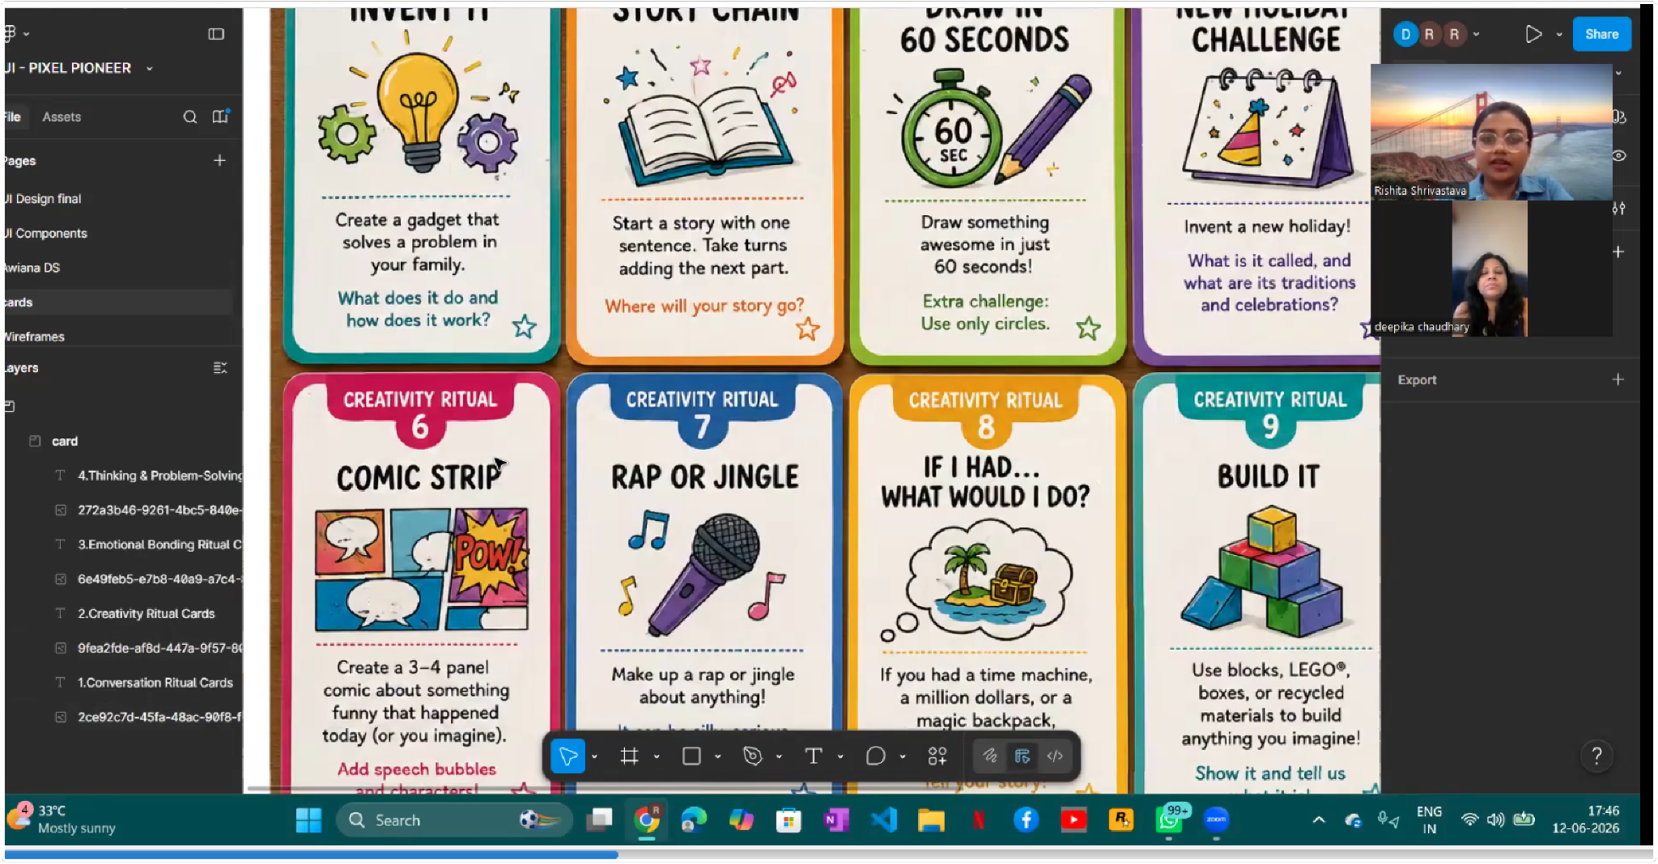
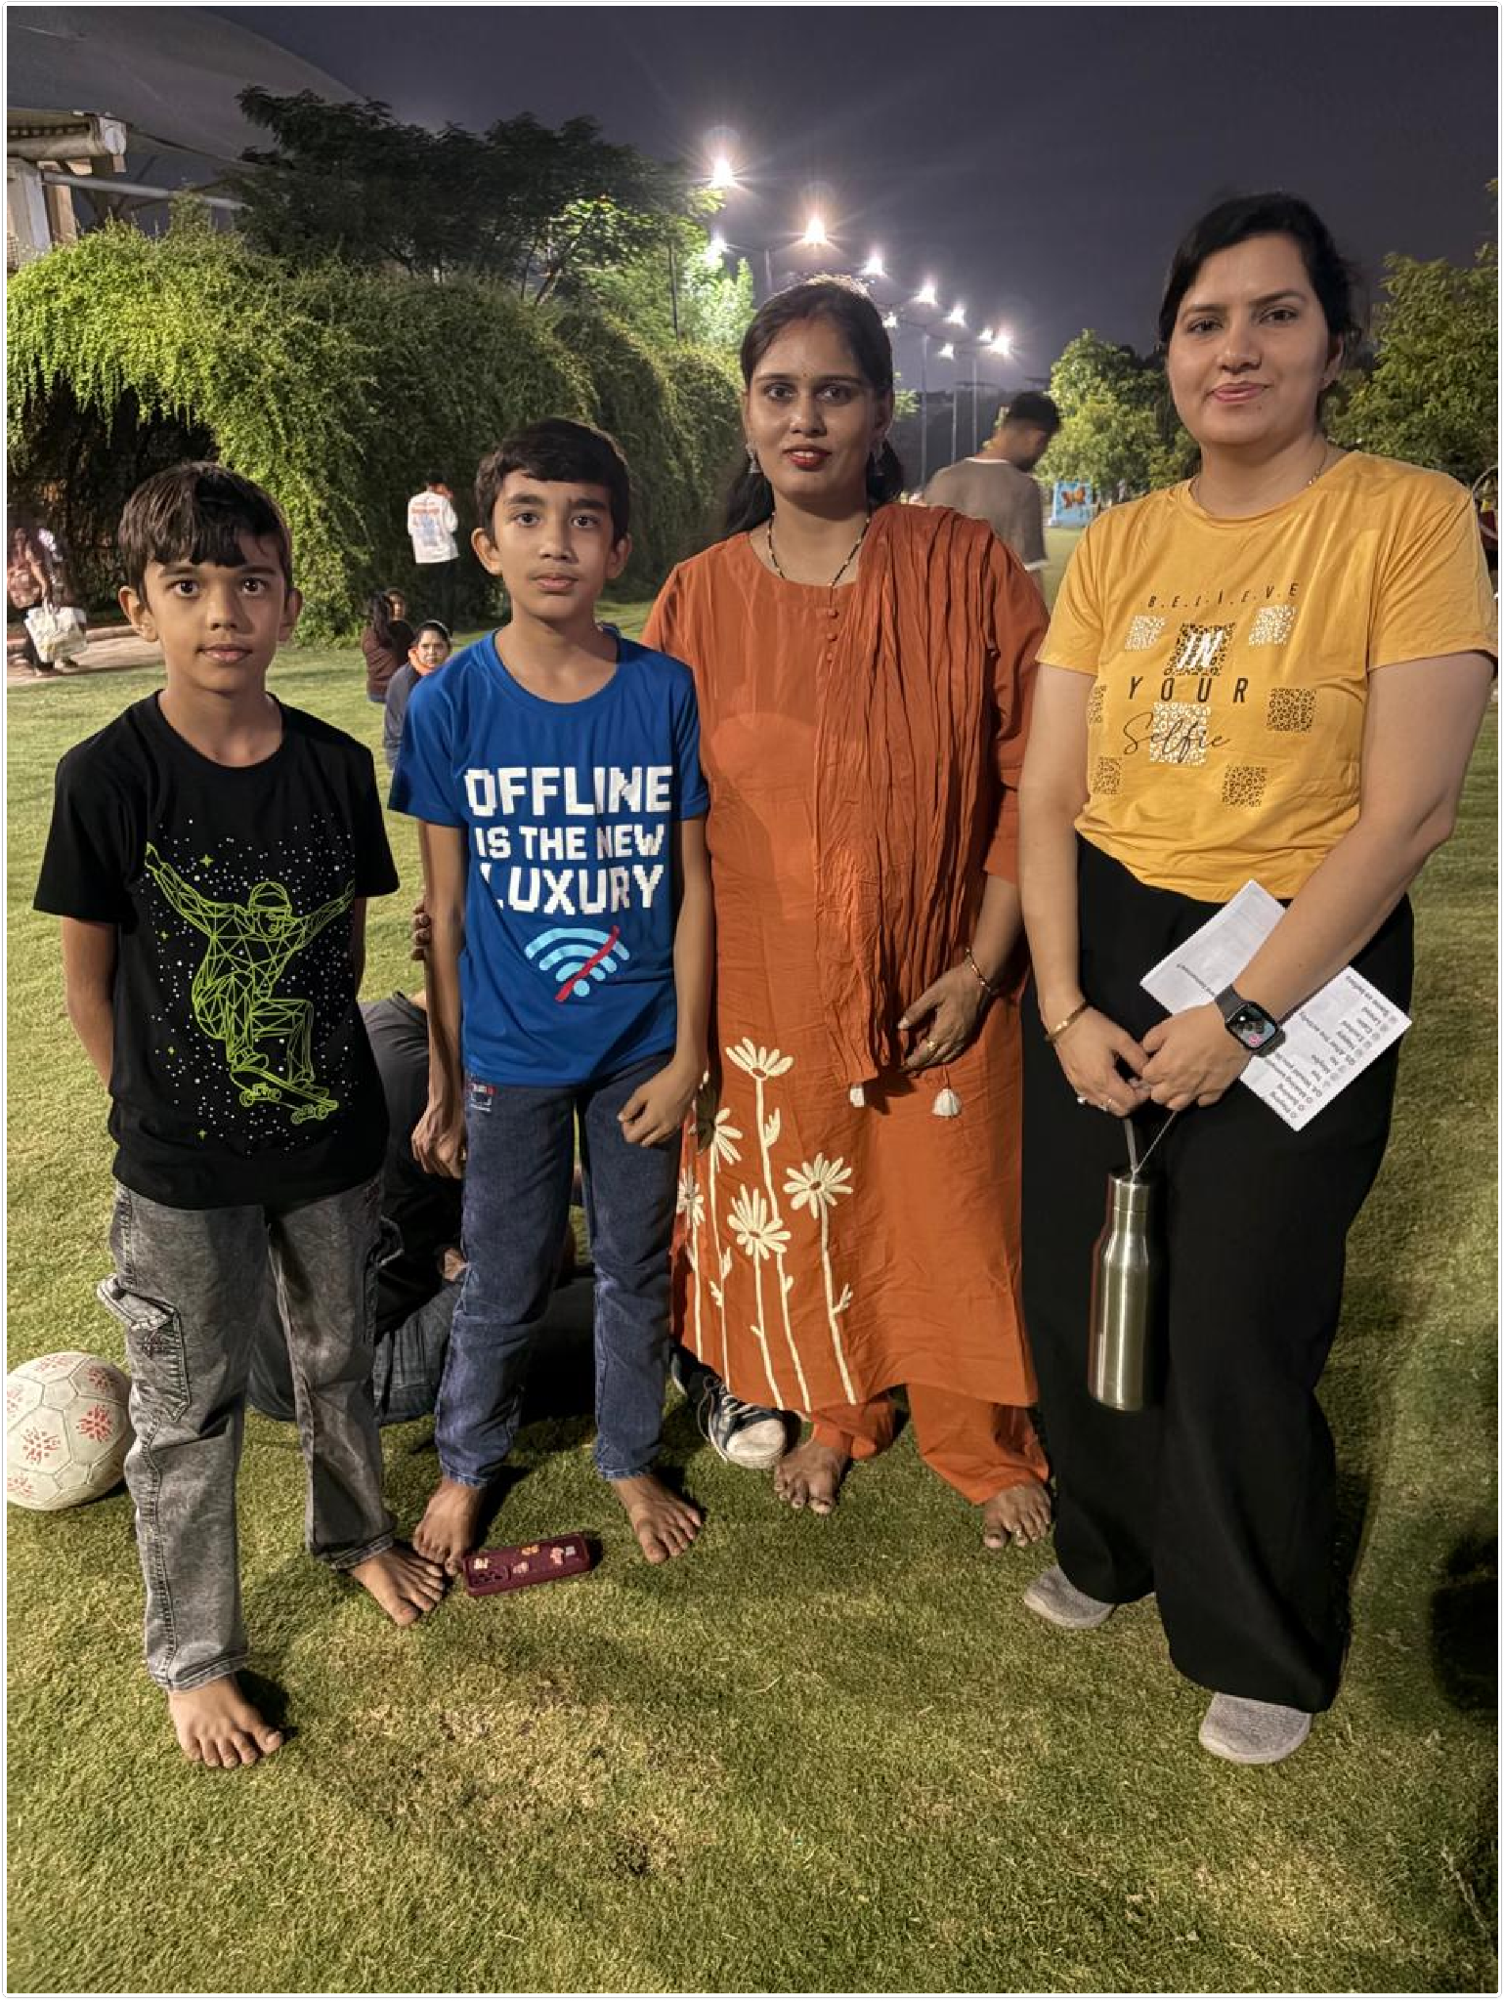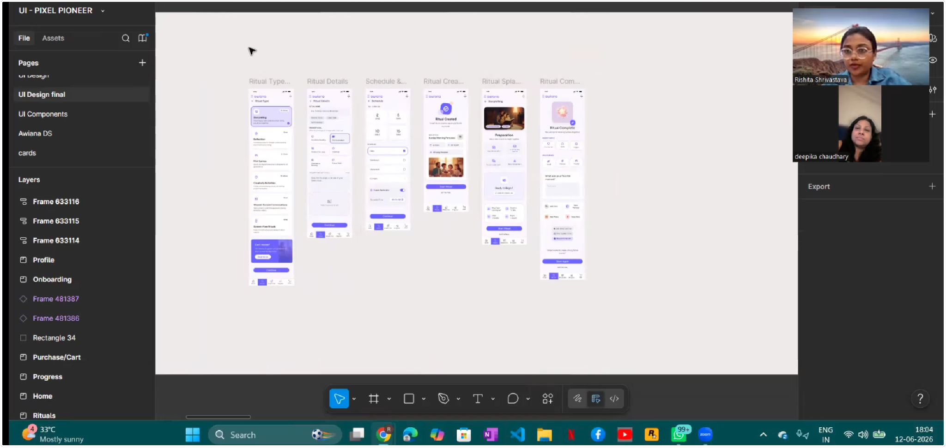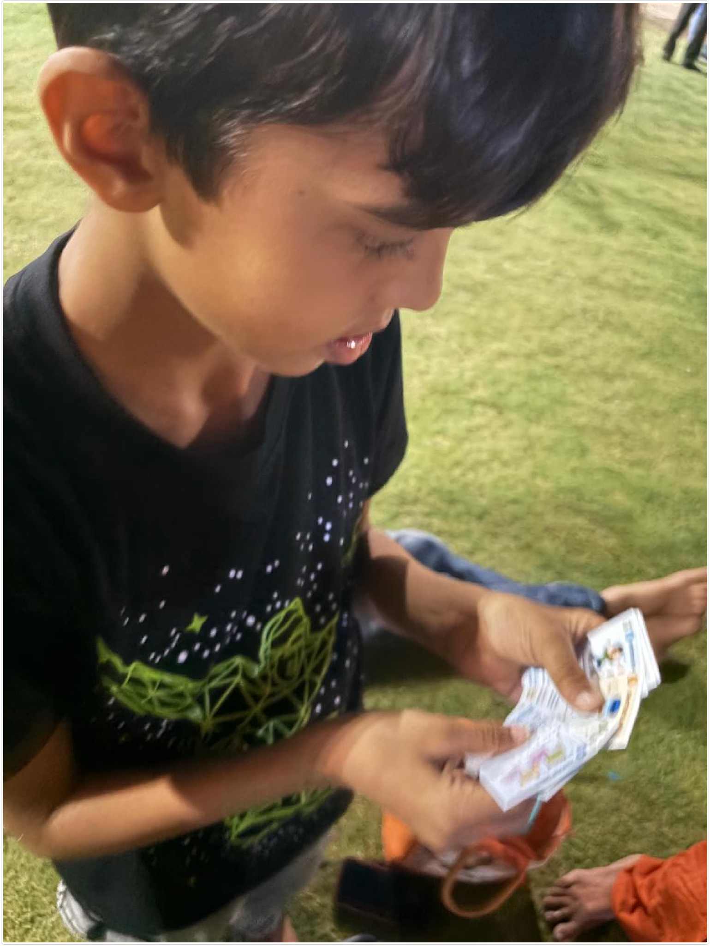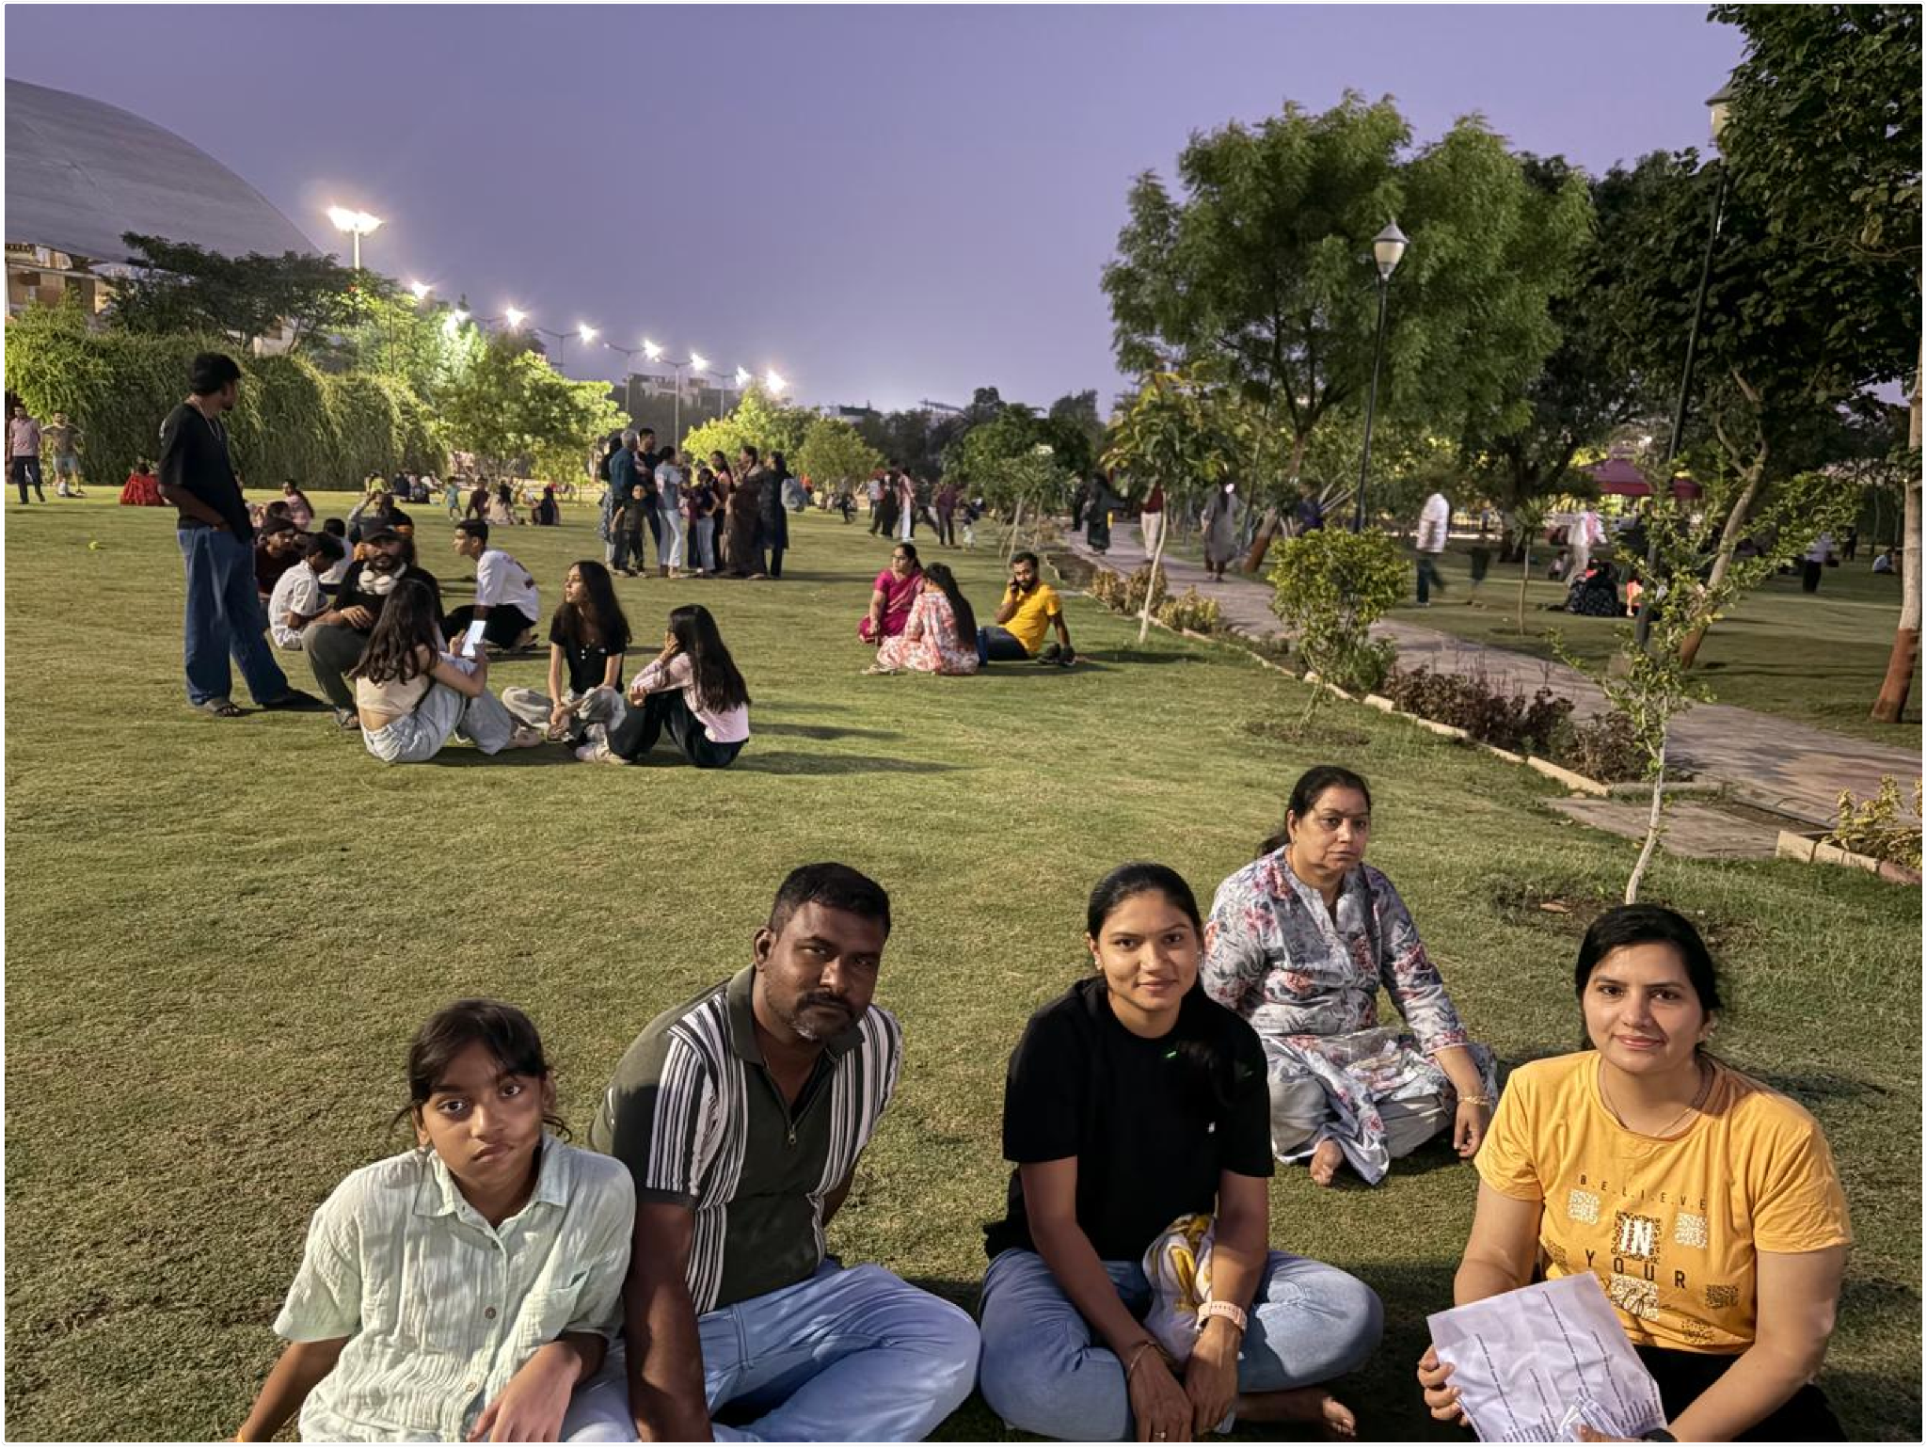
Individual interviews generated over 60 observations related to family bonding, communication patterns, emotional expression, child participation, screen-time habits, and engagement preferences

Step 2: Affinity Mapping
After gathering interview data, all observations were organized and analyzed using affinity mapping. Similar thoughts, behaviors, motivations, and challenges were grouped together to uncover recurring patterns across participants. This process enabled us to move beyond individual responses and identify larger behavioral trends and opportunities.
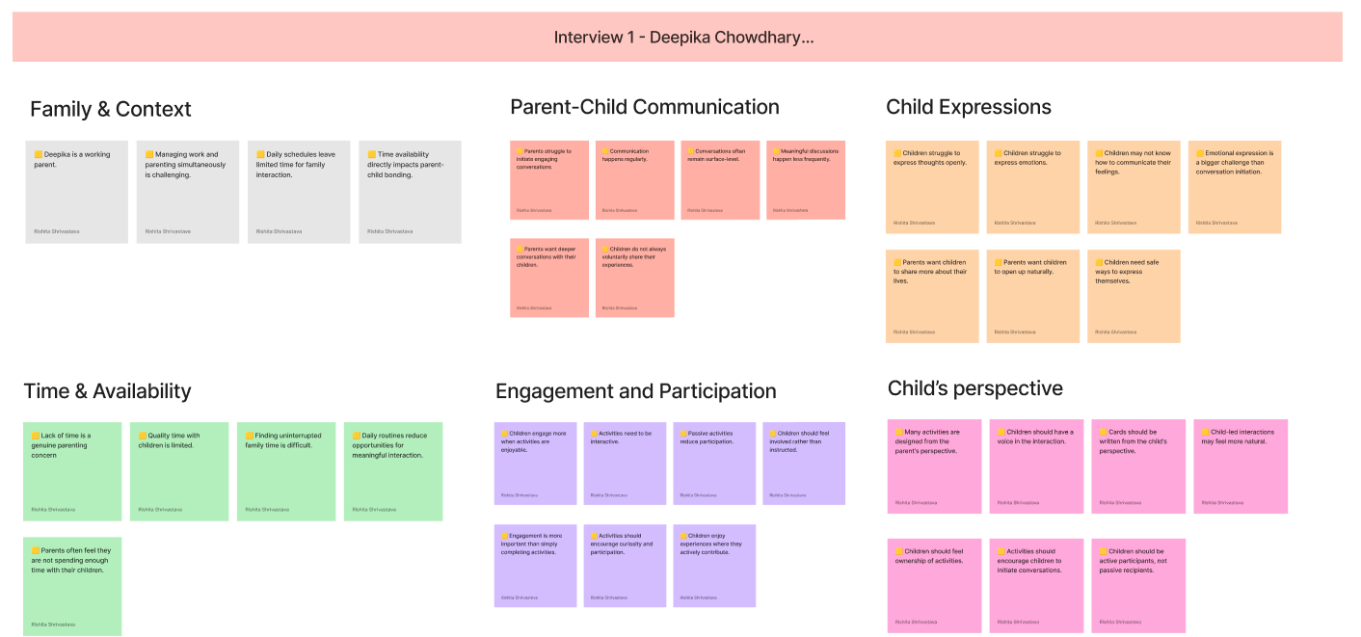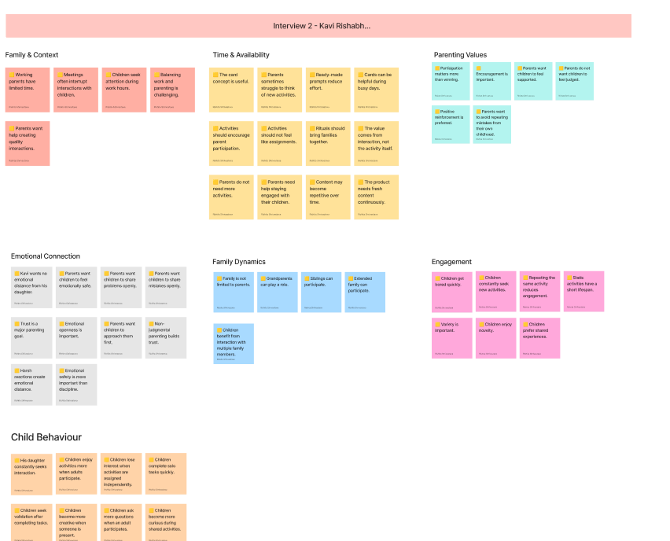
Similar observations were grouped together using affinity mapping to identify recurring patterns across participants. This process helped transform raw interview responses into meaningful research themes.
60+ observations: Affinity mapping exercise used to cluster interview observations into meaningful research themes and behavioral patterns.

Step 3: Theme Formation
The affinity mapping exercise revealed several recurring themes related to family bonding, child engagement, emotional expression, participation, and screen-time challenges. These themes were further refined into actionable insights that guided the product strategy, feature prioritization, and overall experience design of Awiana.

Theme | Description
Limited Quality Time | Parents struggle with time and energy
Child Agency | Children want ownership
Curiosity & Play | Challenges drive engagement
Emotional Expression | Children struggle to express feelings
Screen-Time Concerns | Parents seek alternatives
Content Fatigue | Variety is necessary
06-07 themes: Final research synthesis highlighting recurring themes and key insights derived from parent and child interviews.These were similar across the entire user-research and interviews generation.

Insight 01: Parents Need Structure More Than Time
Parents are willing to spend time with their children, but often struggle to decide what to do, how to engage meaningfully, and how to maintain consistency.
Why It Matters: The challenge is not lack of intent but lack of a simple framework for meaningful interaction.

Insight 02: Children Are Motivated by Fun, Not Bonding
Children rarely seek bonding activities for the sake of emotional connection. Instead, they are attracted to activities that feel enjoyable, playful, challenging, or rewarding.
Why It Matters: Emotional bonding should be positioned as an outcome of participation rather than the primary value proposition.

Insight 03: Collaborative Experiences Create Stronger Engagement
Both parents and children reported higher engagement when activities involved doing something together rather than simply talking.
Examples included:
- Cooking
- Puzzles
- Challenges
- Creative projects
- Problem-solving activities
Why It Matters: Shared experiences create more natural opportunities for conversation and connection.

Insight 04: Children Engage More When They Have Agency
Children participate more actively when they are given choices and feel involved in decision-making.
They prefer:
- Selecting activities
- Influencing outcomes
- Leading portions of experiences
Why It Matters: Ownership increases engagement and reduces resistance.

Insight 05: Curiosity and Challenges Sustain Attention
Activities centered around discovery, puzzles, riddles, exploration, and challenges generated the highest enthusiasm among children.
Why It Matters: Curiosity is a stronger engagement trigger than instruction or education alone.

Insight 06: Repetition Leads to Engagement Fatigue
Both parents and children indicated that repetitive activities quickly lose their appeal.
Children specifically expressed interest in:
- New challenges
- Different activity formats
- Progressive difficulty levels
Why It Matters: Long-term engagement requires variety and freshness.

Insight 07: Screen Time Is a Symptom of Missing Alternatives
Parents consistently associated excessive screen time with a lack of engaging alternatives rather than a lack of discipline.
Families were highly receptive to activities that:
- Replace passive screen consumption
- Encourage interaction
- Utilize available free time more intentionally
Why It Matters: Families are looking for meaningful offline engagement options.

Insight 08: Meaningful Conversations Emerge Through Shared Activities
Parents wanted deeper conversations, while children wanted enjoyable experiences.
The research revealed that meaningful communication occurs most naturally during collaborative activities rather than through direct attempts at emotional discussions.
Why It Matters: Connection is strengthened through interaction, not forced conversation.

Synthesis Summary
Parents need simple ways to create meaningful interactions, while children seek fun, collaborative, and challenge-driven experiences. The strongest opportunities lie in transforming everyday family moments into engaging shared activities that naturally foster communication, trust, and emotional connection.

Voice of Users
"I would like solving challenges and cooking with my parents."
— Child Participant
"You don't have to think about what to do today. Just pick a card and start."
— Parent Participant
"We spend time together, but it doesn't always feel meaningful."
— Parent Participant

8.3 Iterations Made
The testing phase helped validate several assumptions while also revealing opportunities to strengthen engagement, participation, and long-term adoption. Based on user feedback from interviews, Maze testing, UX Tweak sessions, and concept validation, the following design improvements were prioritized.
User testing and interview findings helped us identify opportunities to improve engagement, participation, and emotional retention. Based on recurring patterns observed across parents and children, we introduced the following design iterations to better align the experience with real user needs.

Research Observations | Design Iterations | Expected Impact
Children showed higher engagement when they could influence activities and make choices. | Child Choice Mode | Increased participation, ownership, and motivation.
Families wanted to preserve meaningful moments and memories created during rituals. | Family Memory Timeline | Create a sense of progress and reinforce emotional connection over time.

8.3.1 Child Choice Mode

Through interviews and usability testing, we discovered that children were significantly more engaged when they had the freedom to choose activities themselves. To increase participation and ownership, we introduced Child Choice Mode, allowing children to actively select rituals based on their interests and preferences.

Before | After
Parents selected rituals for children. | Children can actively choose today's ritual.
Limited child ownership. | Increased child agency and participation.
Activity discovery was parent-driven. | Decision-making becomes collaborative.

Research Insight
Children showed higher engagement when they were involved in choosing activities rather than simply participating in parent-selected experiences.

Design Response
Introduced Child Choice Mode to give children ownership over activity selection.

Expected Impact
Higher participation, stronger engagement, and improved ritual completion rates.

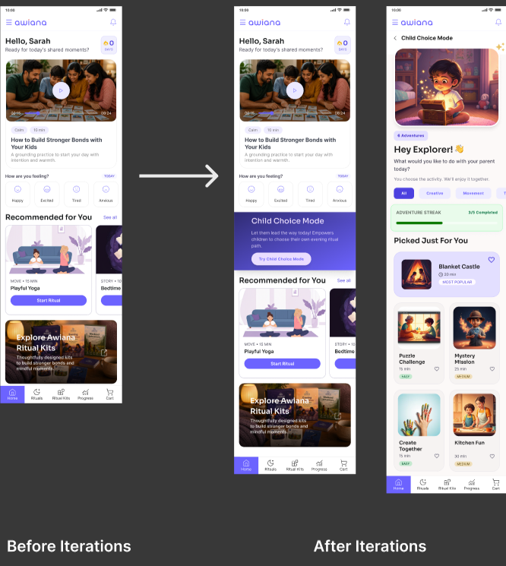

8.3.2 Family Memory Timeline
During interviews, parents expressed a desire to preserve meaningful moments created through family activities. To strengthen emotional connection and encourage long-term engagement, we introduced a Family Memory Timeline that captures shared experiences, reflections, milestones, and family achievements over time.
Before | After
Rituals were completed and forgotten. | Rituals become lasting memories.
No emotional record of progress. | Family journey preserved over time.
Limited emotional attachment. | Stronger emotional connection to the platform.

Research Insight
Families wanted to preserve meaningful moments created during rituals.

Design Response
Introduced Family Memory Timeline to capture reflections, milestones, and shared experiences.

Expected Impact
Higher participation, stronger engagement, and improved ritual completion rates.

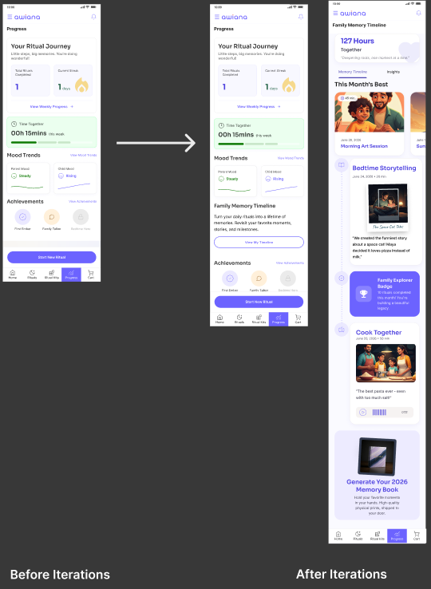

8.4 Learnings
User testing validated several assumptions while also challenging some of our initial beliefs about family bonding and engagement. The insights gathered helped us refine the product direction and better align Awiana with the real needs of both parents and children.

1. Children Engage Through Fun, Not Bonding
One of the strongest findings was that children were rarely motivated by the idea of "strengthening family bonds." Instead, they were drawn to activities that felt fun, creative, challenging, and interactive. Emotional connection emerged naturally as a result of participation rather than as the primary motivation.

2. Parent-Child Collaboration Creates Better Experiences
Activities where both parents and children actively contributed generated significantly higher engagement than passive or one-sided experiences. Shared participation created more meaningful interactions and encouraged natural conversations.

3. Simplicity Reduces Friction for Parents
Parents appreciated having ready-to-use rituals that required minimal planning and preparation. Reducing decision fatigue and providing structured guidance increased the likelihood of adoption and repeat usage.

4. Child Agency Improves Participation
Children showed greater enthusiasm when they had a role in selecting activities. Giving them ownership over the experience increased excitement, engagement, and willingness to participate.

5. Variety Is Critical for Long-Term Engagement
While users responded positively to the concept, both parents and children highlighted the need for fresh and diverse activities. Sustained engagement will depend on continuously introducing new experiences, challenges, and personalized recommendations.

6. Meaningful Memories Extend Product Value
Families expressed a desire to preserve and revisit positive moments created during rituals. This highlighted the importance of capturing reflections, milestones, and memories to strengthen emotional attachment and encourage long-term engagement.

7. Emotional Bonding Is an Outcome, Not a Feature
The most important learning from the testing process was that strong family connections are created through shared experiences, not forced conversations. Awiana succeeds when it enables enjoyable moments together, allowing communication, trust, and emotional connection to develop organically.

Key Takeaway
The testing process reinforced our core belief that meaningful family bonding does not require more time—it requires better moments. By combining structured rituals, child participation, and engaging activities, Awiana can help transform everyday interactions into lasting family memories

Section 09 — Final Solution

Awiana — The Complete Hybrid Bonding Platform
A unified digital and physical ecosystem that transforms everyday family moments into intentional, screen-free bonding rituals.

9.1 Hybrid Experience
Awiana is not a single product — it is a two-part ecosystem where the physical and digital reinforce each other:

 | Digital App | Physical Ritual Kit
Primary role | Personalization, guidance, tracking, and reflection | Screen-free ritual prompts and tangible bonding artefacts
Core action | Guide the family through the ritual | Give the child something to hold, collect, and remember
Habit mechanism | Timed reminders, streaks, achievement badges | Physical card deck as a visible habit anchor in the home
Premium unlock | 30 premium rituals unlocked via kit purchase | Kit purchase activates the digital premium tier
Emotional layer | Mood capture, reflections, trend graph | Ritual card as a memory artefact the child keeps
Age personalisation | Onboarding-driven recommendations | Two editions: Ages 8–12 (blue) and Ages 13–15 (purple)

Experience Loop
App sends reminder → Family picks a ritual card → App guides the session → Timer tracks offline time →
Reflection captured → Streak updated → Progress visualized → Family reaches for the card deck again tomorrow.

Physical Ritual Kit – The Awiana Ritual Card Kit
The tangible half of Awiana's hybrid experience — a beautifully designed physical kit that brings screen-free ritual moments to life and unlocks premium digital content.

Why a Physical Kit?
One of the core design principles behind Awiana is reducing screen dependency — not replacing one screen with another. Families need a reason to put devices down together. The Ritual Kit solves this by making the off-screen experience tactile, collectible, and emotionally engaging.

Screen-Free  Ritual experiences without a device | 30 Unlocks  Premium in-app rituals unlocked per kit
30 Cards  Physical ritual cards per age-group kit | 2 Kit Categories  Age-targeted editions: 8–12 and 13–15

Ritual Kit Mockups
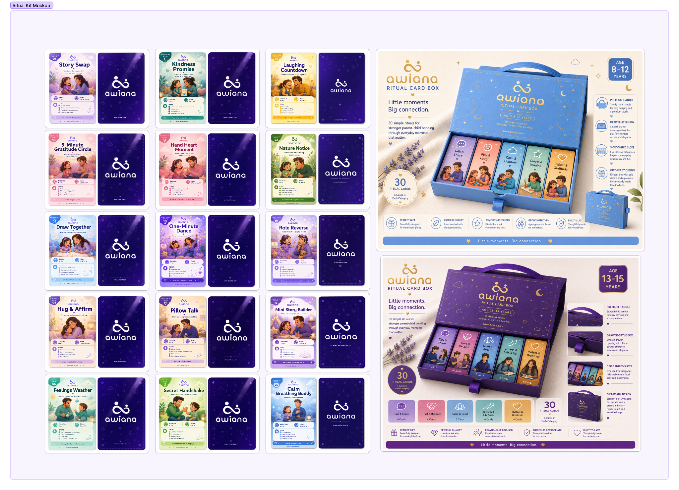
Ritual Card Categories
Each kit contains 30 cards spread across three ritual time categories. Cards are colour-coded for instant recognition during family time:

🌙  Bedtime Rituals  30 cards | 🌅  Evening Rituals  30 cards | ☀️  Weekend Rituals  30 cards

Each card includes:
• Ritual name and category label (Bedtime / Evening / Weekend)
• Estimated duration and difficulty level
• Step-by-step activity instructions
• A parent guidance tip for emotional facilitation

Design Intent: The Physical–Digital Bridge
The card is a tangible prompt — it removes the need to open an app to know what to do.
The app is the facilitation layer — it provides guidance, depth, timers, and memory capture.
Together they form a ritual ecosystem that works even on days when screen time should be minimal.

9.2 Final Product Screens

Screen 1.0 — Family Onboarding
Purpose: Collect parent and child information to personalize the experience and understand user needs for future platform improvements.

Component | Description
Parent profile setup | Name, relationship, and goals
Child profile creation | Name, age, personality, and interests
Interest selection | Activities, hobbies, and learning preferences
Routine preferences | Preferred ritual times (bedtime, evening, weekend)
Bonding goals | Parent selects 1–3 core connection goals

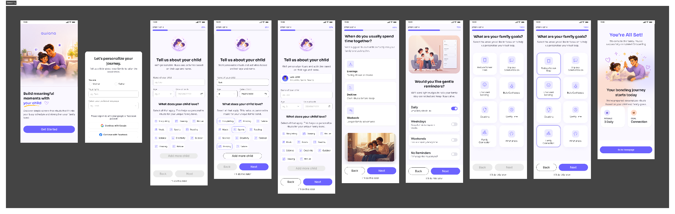
Onboarding Screens

Screen 2.0 — Personalized Home Dashboard
Purpose: Central hub for daily guidance, mood check-in, ritual recommendations, and kit discovery.

Component | Description
Guidance video | Short intro to Awiana for new users
Daily ritual recommendation | Top suggested ritual based on time of day and family profile
Mood check-in | Quick parent + child mood capture before ritual
Ritual kit recommendation | Curated kit suggestion based on child's age and goals
Quick ritual access | One-tap start for previously bookmarked rituals
Timed reminders | Push notification at parent-set ritual time (e.g., 8 pm)

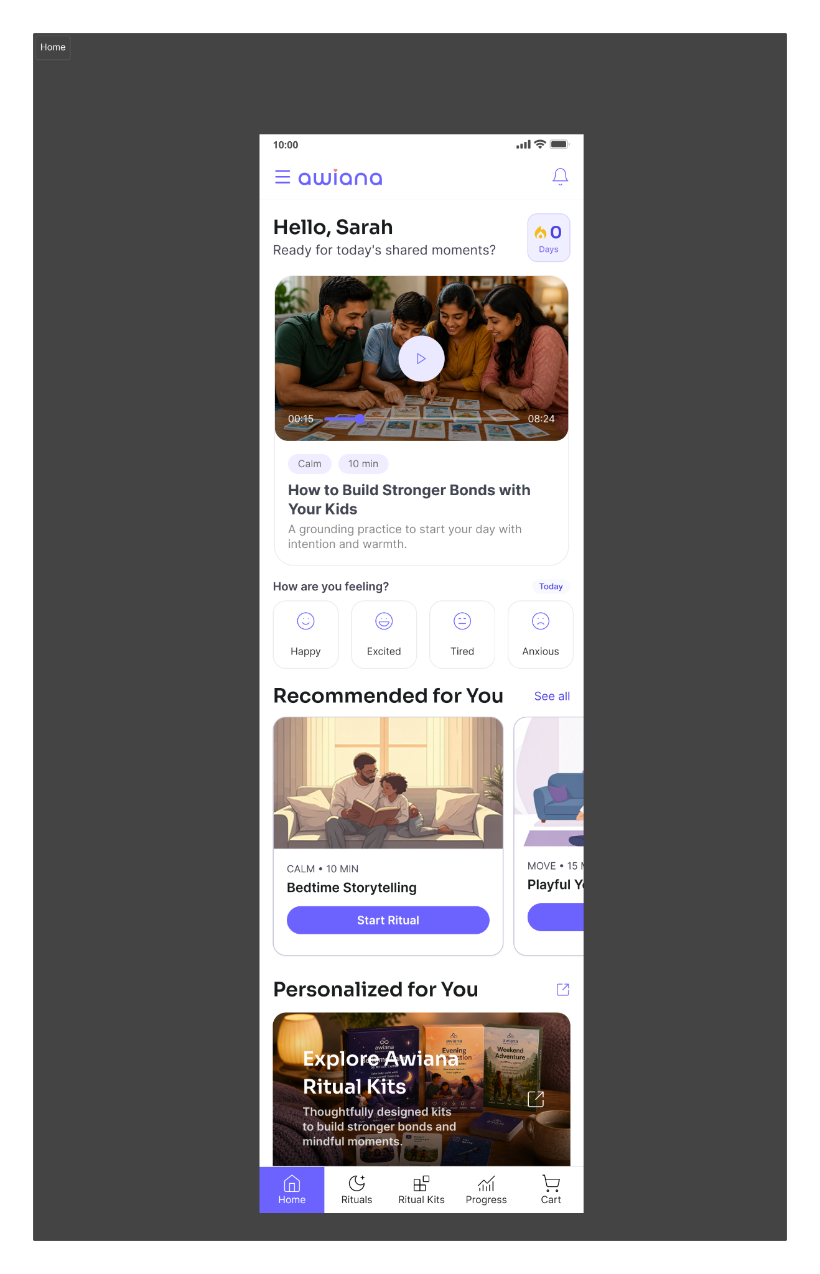
Home Screen

Screen 3.0 — Ritual Completion Experience
Purpose: Enable families to discover, start, complete, and reflect on guided rituals.

Screen | Key Components
3A — Ritual Library | Free & unlocked rituals + premium locked collection. Filters: Bedtime / Evening / Weekend. 7 free starter rituals on signup.
3B — Ritual Detail | Overview media, duration, step-by-step instructions, parent facilitation tips, Start / Try Another CTAs
3C — Active Ritual | Live ritual timer, guided prompts, breathing exercises, Pause / Resume / End controls
3D — Ritual Completion | Completion confirmation, streak reinforcement, mood capture, reflection journal, kit cross-sell

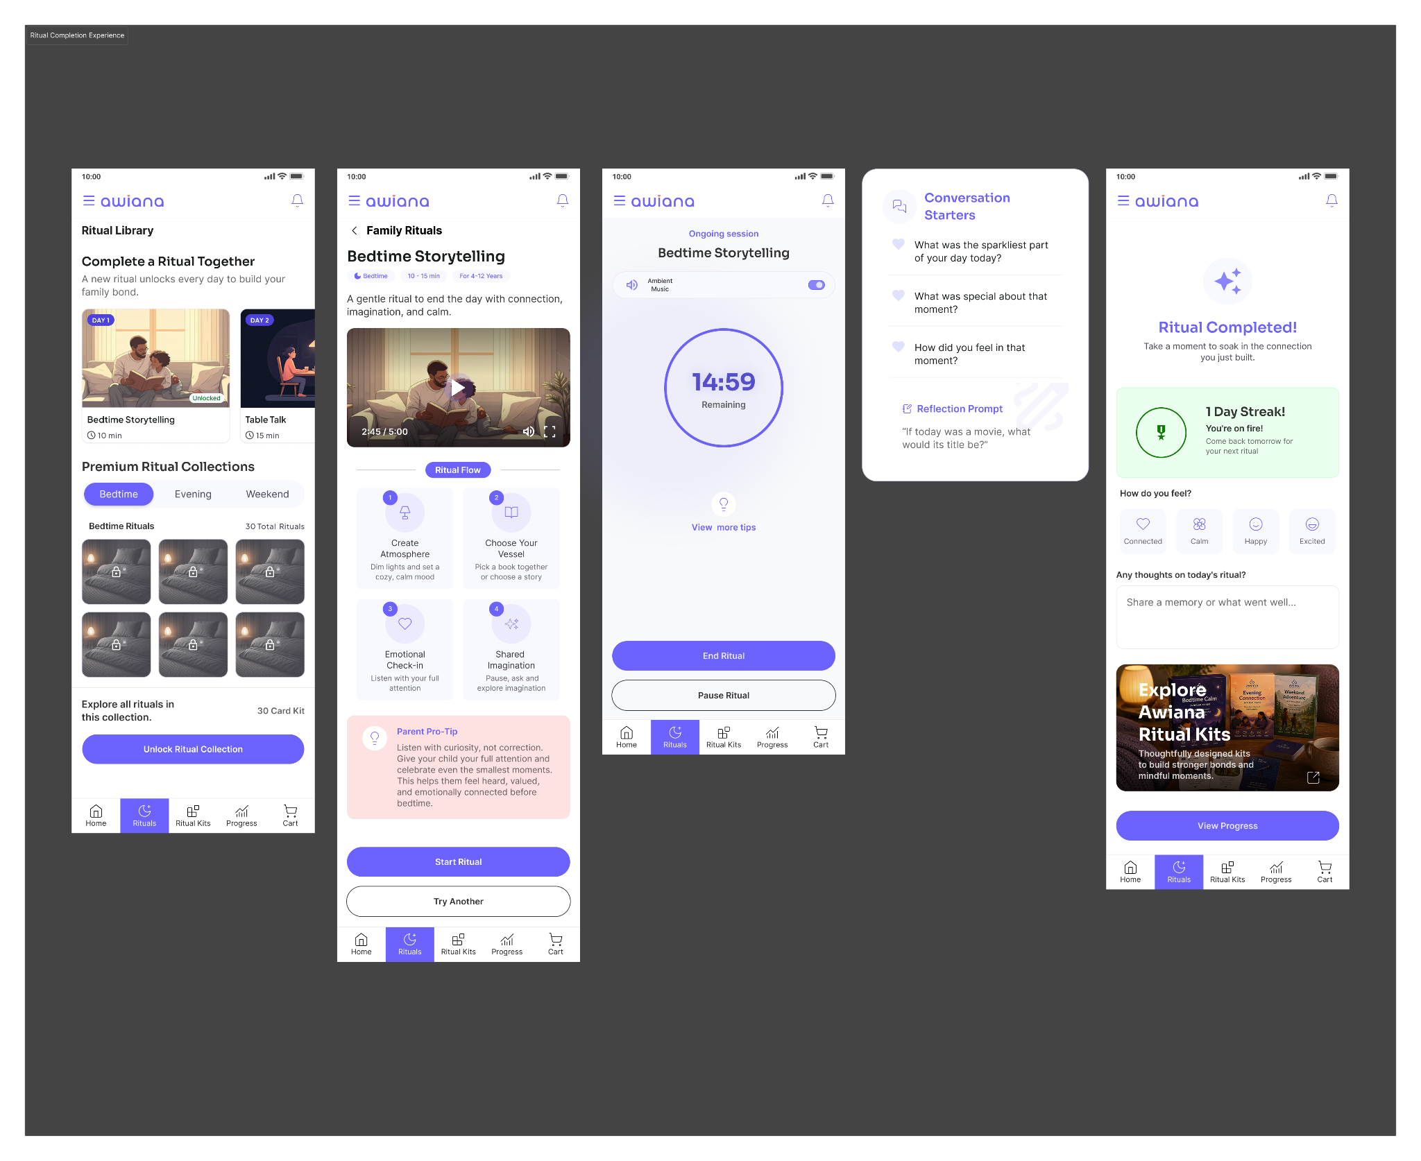
Ritual Experience Screens

Screen 4.0 — Premium Ritual Kits Collection
Purpose: Bridge digital rituals with physical experiences through the in-app marketplace.
• Curated kit listings with product photography
• Age-group filter (8–12 / 13–15)
• Kit contents overview with card previews
• Customer reviews and testimonials
• Add-to-cart with upsell recommendation
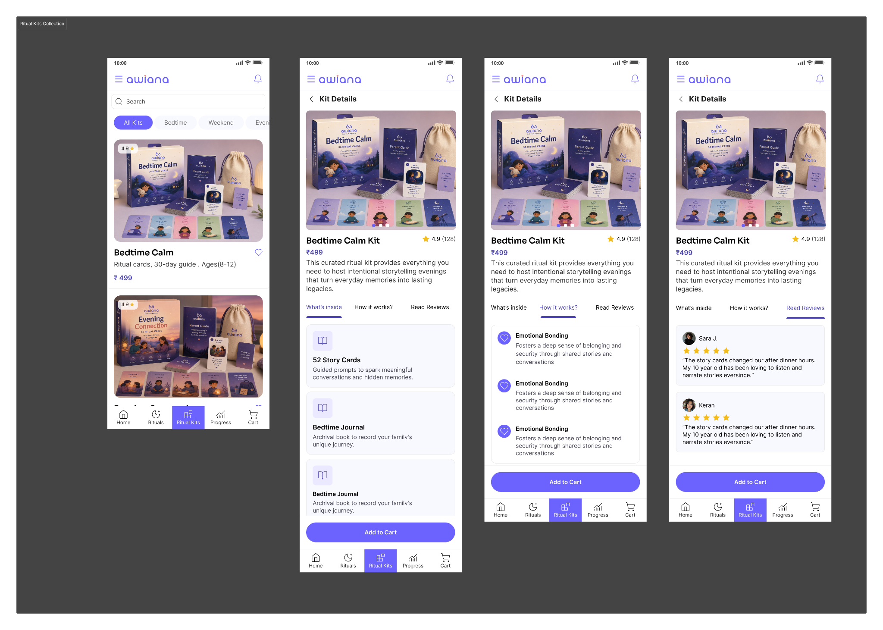

Screen 5.0 — Cart & Checkout
• Cart review with quantity and pricing
• Address management and delivery estimate
• Secure payment selection
• Order confirmation with digital unlock confirmation
Cart and Checkout Screens
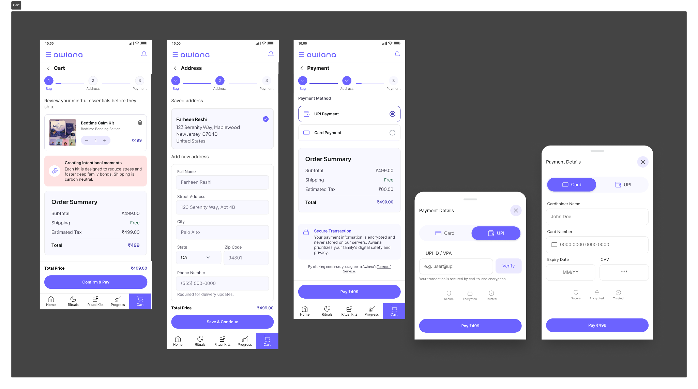
Post Payment
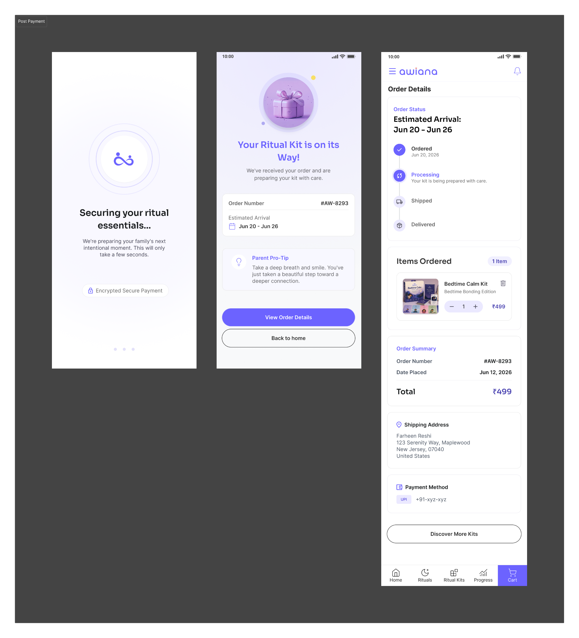
Screen 6.0 — Progress Dashboard
Purpose: Visualize family growth, engagement, and emotional trends over time.

Metric | What It Shows
Ritual completions | Total rituals completed by parent and child
Screen-free time | Cumulative minutes of meaningful offline family time tracked by ritual timer
Current streak | Consecutive days with a completed ritual
Best streak | All-time personal record for streak length
Mood trend graph | Weekly emotional trend for both parent and child plotted over time
Weekly reflections | Summary of reflections logged in the past 7 days
Achievement badges | Named badges unlocked at ritual and streak milestones

Progress Dashboard Screens
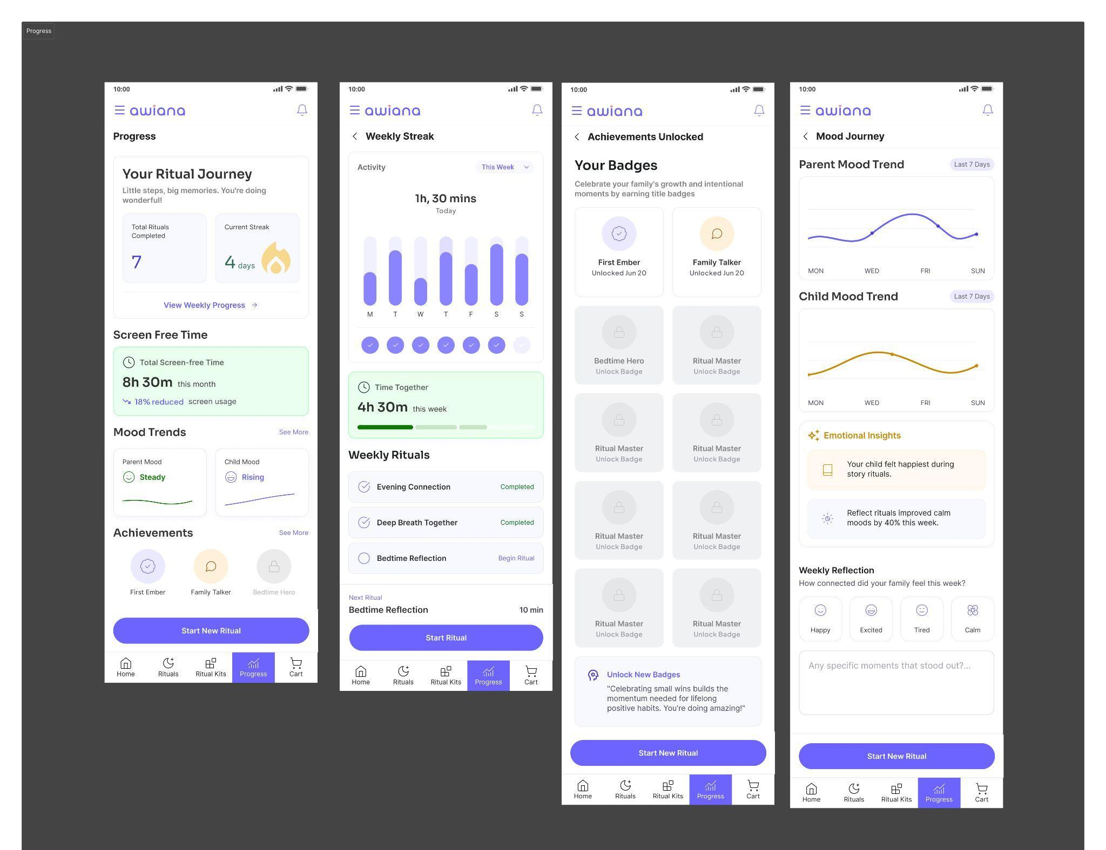

Screen 7.0 — Community Success Stories
• Parent testimonials from real Awiana families
• Shared ritual reflections and photos
• Community engagement with likes and comments
• Story submission for new families to contribute
Success Stories Screens
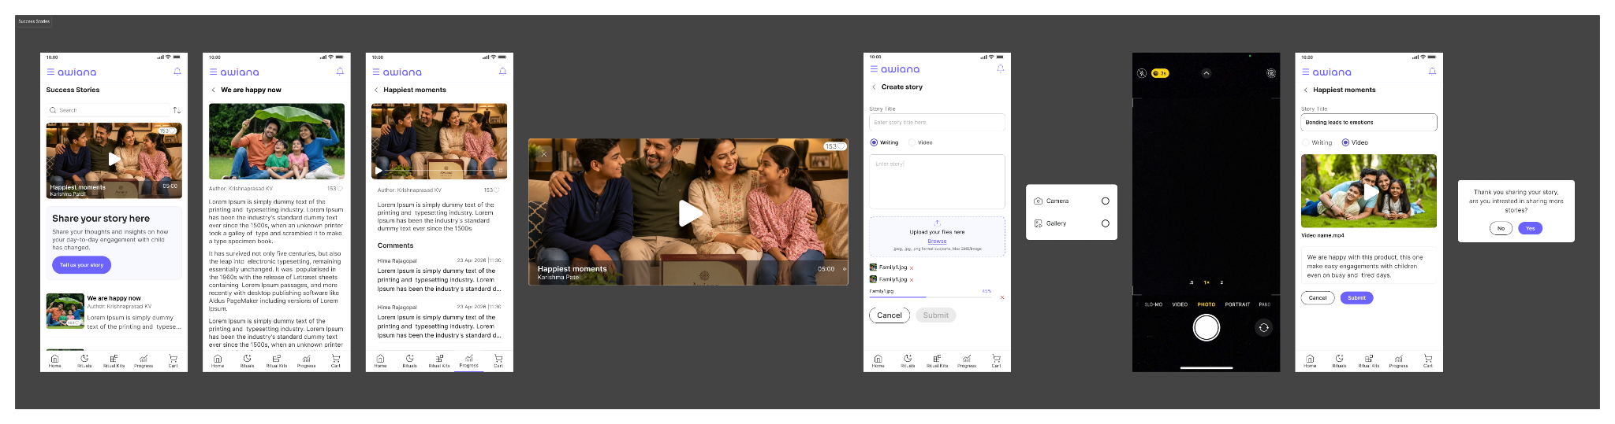

9.3 Key Features

Feature | Description
Personalized Family Ritual Planning | Tailored ritual journeys based on family goals, child interests, age, and preferred routine times
Timed Reminder System | Push notifications at parent-configured ritual times to build consistent daily habit loops
7 Free Starter Rituals | All families unlock 7 free rituals on signup (across Bedtime, Evening, Weekend) before any purchase is required
Guided Ritual Experiences | Structured, step-by-step activities that encourage meaningful parent–child interaction
Ritual Timer & Screen-Free Tracking | Live timer during rituals feeds into cumulative 'offline family time' progress metric
Emotional Reflection System | Captures mood, emotions, and memories post-ritual to build mindfulness and track wellbeing trends
Family Progress Tracking | Streaks, named achievement badges, mood trend graphs, and bonding metrics
Hybrid Ritual Kit System | Physical age-specific card kits (8–12 / 13–15) that unlock 30 premium in-app rituals per kit
Ritual Kits Marketplace | In-app purchase flow for curated physical kits with card previews, reviews, and guided selection
Secure Commerce Experience | Seamless cart, payment, and order tracking
Community Story Platform | Shared family experiences to inspire and build peer trust

9.4 Value Proposition

Primary Value Proposition
Awiana helps parents create meaningful, intentional screen-free moments by incorporating hybrid daily ritual
experiences with their children through personalized rituals, emotional reflection, progress tracking, and
curated ritual kits transforming family bonding into a sustainable daily habit.

User Benefits
Benefit | How Awiana Delivers It
Intentional parent–child relationships | Daily shared ritual practices designed to build emotional closeness
Reduced screen dependency | Screen-free ritual time tracked and celebrated; physical kit enables device-free engagement
More structured family time | Timed reminders and ritual timer make bonding time predictable and measurable
Improved emotional connection | Mood capture and trend graphs help parents understand their child's emotional patterns
Personalized to your family | Age-appropriate kits and onboarding-driven ritual recommendations
Sustainable habit formation | Streak system and achievement badges create positive reinforcement loops

Business Benefits
• Higher engagement through daily ritual loop touchpoints
• Strong retention via streak mechanics and habit formation
• Revenue through kit purchases and future subscription model
• Scalable ecosystem with community-driven growth through success stories

Unique Value Proposition
Unlike traditional parenting and wellness apps that focus on content consumption,
Awiana combines personalized rituals, emotional tracking, progress analytics, habit-loop formation,
community storytelling, and physical ritual kits into one integrated ecosystem designed specifically to strengthen parent–child relationships.

Section 10 — Reflection & Future Scope

10.1 Project Impact
For Parents
- Helps working parents intentionally dedicate 15–20 minutes of quality, screen-free time with their children every day.
- Reduces the common feeling of being physically present but emotionally disconnected.
- Provides a simple, low-effort structure that fits into busy schedules without requiring extensive preparation.
For Children
- Strengthens emotional bonding and trust with parents.
- Encourages meaningful conversations, self-expression, gratitude, creativity, and positive habit formation.
- Reduces dependence on screens by offering engaging offline activities.
For Families
- Creates a consistent family ritual rather than occasional interactions.
- Improves communication and emotional connection within the household.
- Builds long-term memories through small but meaningful daily moments.
Business & Social Impact
- Addresses a growing challenge faced by modern working families: lack of quality parent-child interaction.
- Creates opportunities for recurring engagement through monthly ritual card packs and subscriptions.
- Combines physical products with digital support, making the solution scalable and sustainable.

Metrics
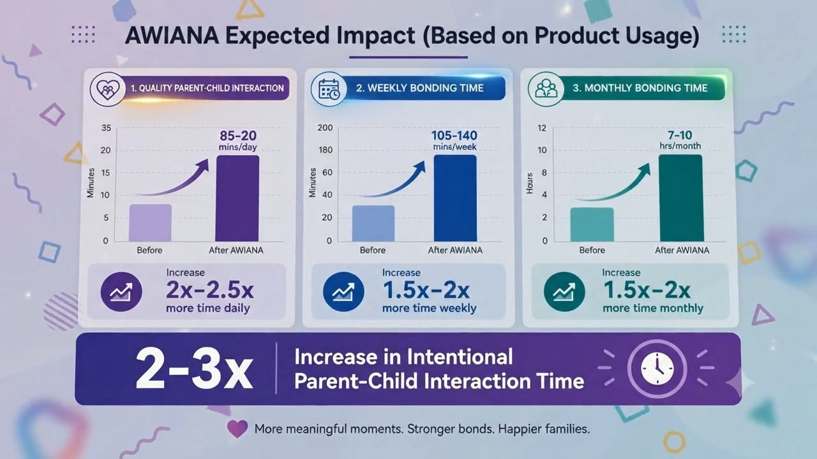
- 15–20 minutes
Daily parent-child bonding ritual
- 2–3x
Increase in quality interaction time
- 7–10 hours
Monthly family bonding created
- 30 rituals
Per month per family
- 60–80%
Improvement in consistency of family bonding habits
- 8x
Increase in structured screen-free interaction opportunities

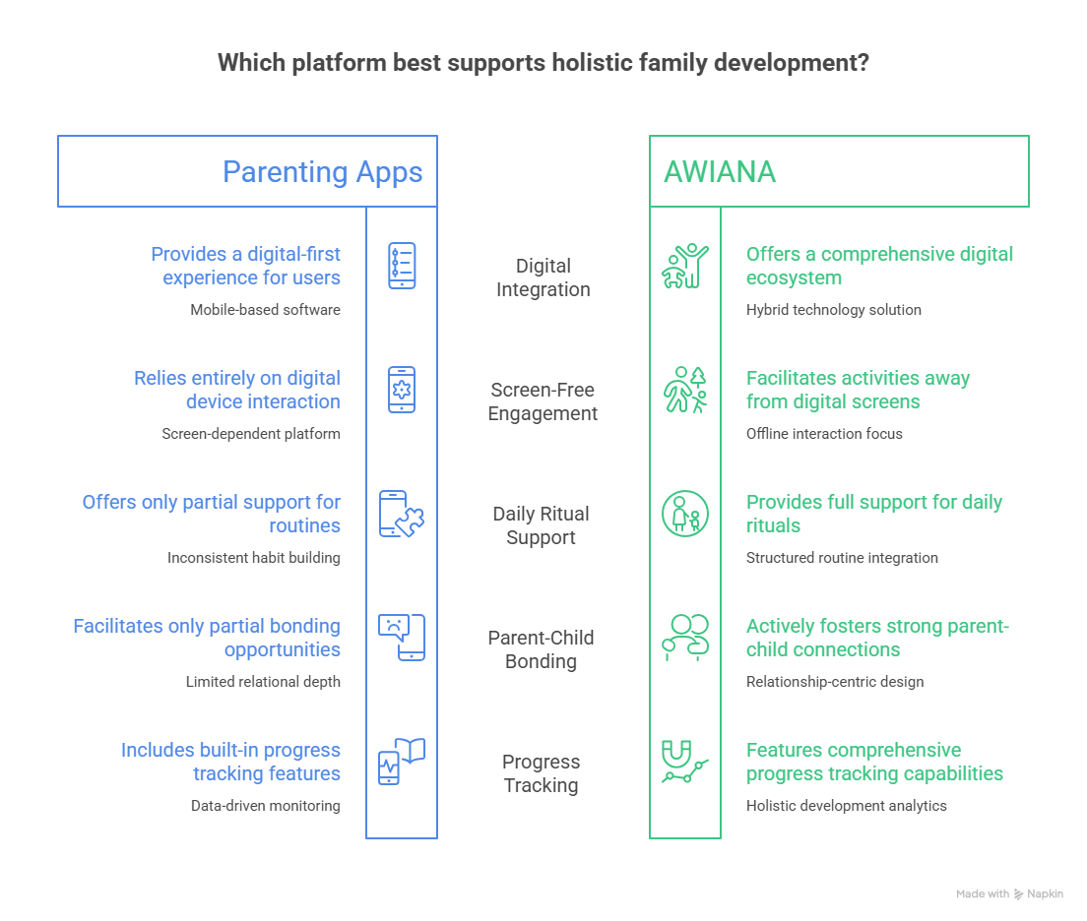
Parenting Apps vs Awiana

Strong Impact Statement
If adopted consistently, AWIANA can create an additional 7–10 hours of meaningful parent-child interaction every month, transforming fragmented family time into a structured bonding ritual with reducing screen dependency and strengthening emotional connections between working parents and children aged 8–15.

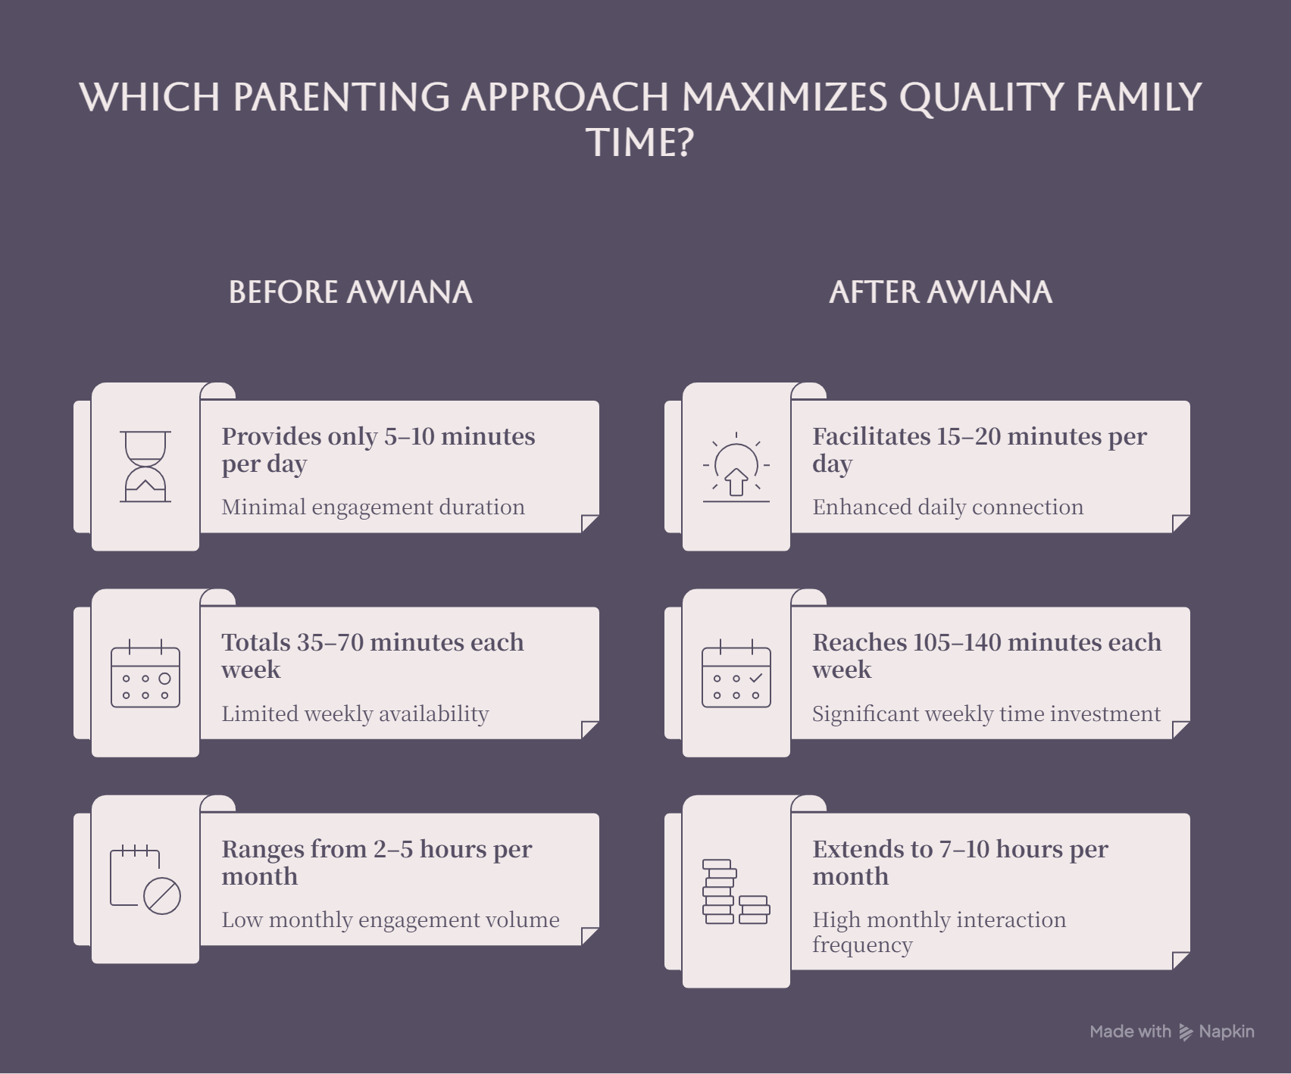

10.2 Future Improvements
1. AI-Powered Personalized Rituals
- Recommend activities based on the child's age, interests, mood, and family goals.
- Adapt ritual suggestions according to previous engagement patterns.
2. Advanced Family Progress Dashboard
- Track bonding consistency, completed rituals, and weekly family engagement.
- Visualize relationship-building progress through simple and motivating insights.
3. Screen-Time Integration
- Integrate with device screen-time data to measure reduction in screen dependency.
- Show families the positive impact of daily rituals on screen-free hours.
4. Gamification & Rewards
- Introduce family streaks, achievement badges, and milestone celebrations.
- Encourage long-term habit formation through positive reinforcement.
5. Monthly Subscription-Based Ritual Packs
- Launch themed ritual packs every month to keep activities fresh and engaging.
- Themes could include creativity, gratitude, confidence, emotional intelligence, communication, and life skills.
6. Multi-Child & Family Profiles
- Allow parents to customize rituals for multiple children within one account.
- Create age-specific experiences for different family members.
7. Smart Reminder System
- Personalized reminders based on family schedules and preferred bonding times.
- Integration with calendars and daily routines for better consistency.
8. Voice & Audio-Based Experiences
- Guided storytelling, reflection exercises, and conversation prompts through audio.
- Useful for parents who prefer hands-free interaction after work.
9. School & Counselor Collaboration
- Develop specialized ritual packs with educators and child psychologists.
- Enable schools to recommend bonding activities that complement children's development.
10. Community for Parents
- A platform where parents can share experiences, tips, and success stories.
- Build a supportive ecosystem around family well-being and parenting.
11. Impact Measurement System
- Introduce periodic surveys and emotional well-being assessments.
- Measure improvements in communication, trust, and family connection over time.
12. Corporate Wellness Partnerships
- Partner with organizations to offer AWIANA as part of employee wellness and work-life balance programs.
- Help companies support working parents and improve employee well-being.

Future Vision Statement
AWIANA aims to evolve from a simple ritual kit into a comprehensive family relationship platform that helps millions of working parents build stronger emotional connections with their children through personalized rituals, measurable progress tracking, and a supportive ecosystem of tools, content, and community.

10.3 Team Learnings
1. User-Centered Design Starts with Understanding Emotions
Through interviews and observations, we learned that the real problem was not a lack of love between parents and children, but a lack of intentional quality time and emotional connection. Understanding these emotional pain points helped us redefine the problem and design a more meaningful solution.
2. Small Habits Create Bigger Impact
We discovered that parents were more likely to adopt simple 15–20 minute activities than complex parenting programs. This reinforced the importance of designing low-effort, high-impact experiences that fit naturally into daily routines.
3. Physical Products Can Drive Better Engagement
User feedback revealed that tangible ritual cards felt more engaging and actionable than purely digital interactions. This insight led us to develop a hybrid solution combining a physical ritual kit with a digital companion app.
4. Continuous User Validation Improves Product Direction
Regular discussions with parents and testing of ritual card concepts helped us identify what resonated most with users. Early feedback prevented us from building unnecessary features and ensured that the solution remained aligned with real user needs.
5. Storytelling is a Powerful Tool for Communication
While developing the concept and promotional materials, we learned that emotional storytelling effectively communicates the value of strengthening parent-child relationships and helps users connect with the product vision.
6. Simplicity Drives Adoption
Parents consistently preferred solutions that were easy to understand, quick to use, and required minimal preparation. This learning influenced both the ritual card design and app experience.
7. Interdisciplinary Collaboration Leads to Better Solutions
Combining research, design thinking, prototyping, user testing, and business strategy helped us create a solution that is not only desirable for users but also feasible and scalable.
8. Rapid Prototyping Accelerates Learning
Creating quick prototypes and gathering feedback allowed us to test assumptions early, iterate faster, and improve the product within a limited hackathon timeline.
9. Technology Alone Does Not Solve Human Problems
We learned that emotional and behavioral challenges require thoughtful experiences, not just digital features. The real value of AWIANA lies in facilitating meaningful interactions rather than increasing screen usage.
10. Purpose-Driven Innovation Creates Stronger Products
The project reinforced the importance of solving real-world problems that affect everyday lives. Focusing on family relationships gave the team a clear mission and helped guide product decisions throughout the hackathon.

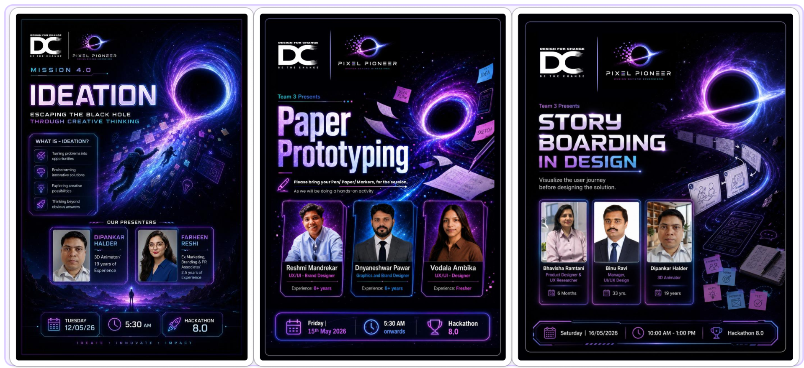

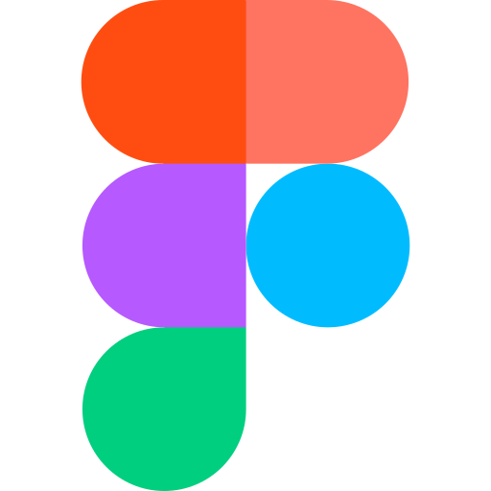FigJam Figma

Key Takeaway

The biggest learning from this project was that meaningful family relationships are strengthened not through grand gestures, but through small, consistent moments of connection.

Designing for those moments allowed us to create a solution that is simple, scalable, and capable of generating lasting impact.

